Using IBM® Lotus® Symphony™ Documents: Power User
Student Guide

Using IBM® Lotus® Symphony™ Documents: Power User
Part Number: Y1300
Course Edition: 1.0

Notices
DISCLAIMER: You may not copy, reproduce, translate, or reduce to any electronic medium or machine-readable form, in whole or in part, any documents, software, or files provided to you without prior written consent of IBM Corporation, except in the manner described in the documentation. While every reasonable precaution has been taken in the preparation of this manual, the author and publishers assume no responsibility for errors or omissions, nor for the uses made of the material contained herein and the decisions based on such use. Neither the author nor the publishers make any representations, warranties, or guarantees of any kind, either express or implied (including, without limitation, any warranties of merchantability, fitness for a particular purpose, or title). Neither the author nor the publishers shall be liable for any indirect, special, incidental, or consequential damages arising out of the use or inability to use the contents of this book, and each of their total liability for monetary damages shall not exceed the total amount paid to such party for this book.

TRADEMARK NOTICES The following terms are trademarks or service marks of International Business
Machines Corporation in the United States, other countries, or both: DB2®, Domino®, Domino® Designer,
Everyplace, ibm.com®, LearningSpace®, Lotus®, Lotus Enterprise Integrator®, Lotus Notes®, Lotus Workflow, Quickr™, Rational®, Sametime®, Symphony™, Tivoli®, VisualAge®, and WebSphere®.

Java and all Java-based trademarks and logos are trademarks of Sun Microsystems, Inc., in the United
States, other countries, or both.

Microsoft, Windows, Windows NT, and the Windows logo are trademarks of Microsoft Corporation in the
United States, other countries, or both.

Intel, Intel Inside (logos), MMX and Pentium are trademarks of Intel Corporation in the United States, other countries, or both.

UNIX is a registered trademark of The Open Group United States and other countries.

Linux is a trademark of Linus Torvalds in the United States, other countries, or both.

Copyright © 2008 IBM Corporation.
Lotus software, IBM Software Group, One Rogers Street, Cambridge, MA 02142

Under the copyright laws, neither the documentation nor the software may be copied, photocopied, reproduced, translated, or reduced to any electronic medium or machine-readable form, in whole or in part, without the prior written consent of IBM, except in the manner described in the documentation or the applicable licensing agreement governing the use of the software.

All rights reserved.

Licensed Materials - Property of IBM

U.S. Government Users Restricted Rights - Use, duplication, or disclosure restricted by GSAADP Schedule Contract with IBM Corporation.

You must purchase one copy of the appropriate kit for each student and each instructor. For all other education products you must acquire one copy for each user or you must acquire a license for each copy provided to a user.

Using IBM® Lotus® Symphony™ Documents: Power User
Lesson 1: Formatting Documents 11
Introduction 12
Topic A: Specifying Page Properties 13
Importing a File 13
Exporting a File 14
Inserting Calculations in a Document 15
Inserting Footnotes or Endnotes 16
Creating a Table of Contents 18
Creating an Index 19
Securing a Document 22
Installing and Using Plug-ins 23
Topic B: Using Styles 25
Recording Changes 25
Accepting and Rejecting Changes 26
Using Comments 27
Merging Document Versions 28
Performing a Mail Merge 28
Topic C: Using Styles 32
Navigate Through a Document 32
The Form Navigator 33
Activity 1-1: Working with Large Documents 35
Lesson Summary 37
Follow-up 38
What’s Next? 38
Additional Resources 39
Available Plug-Ins 39

About This Course
As your documents increase in length, they begin to get harder to manage for both you and your readers. Imagine trying to use a textbook that has no table of contents, no chapter titles, no index, and no page numbers. This would certainly make the book more difficult to use for both the teacher and the students. These same features that are used to label and quickly locate specific information in a document are available in IBM® Lotus® Symphony™ Documents, so that you can make larger sized documents much easier to navigate.

Larger documents can also make the collaboration process challenging. People who review your document will likely want to make revisions to the text or provide feedback within your document. What happens when multiple people are reviewing your document at the same time? Doing this the old-fashioned way, with hard copies and red ink, could be a long and tedious process. Imagine sitting at your desk and comparing your original document page by page against the hard copies marked up by each reviewer. Lotus Symphony Documents allows this review process to happen electronically, and eliminates the need to search for comments and changes, thus making document collaboration a breeze. In this course, you will become familiar with the features you can use to save time and effort when dealing with larger sized documents.

Course Description
Target Student
This course is designed for IBM® Lotus® Symphony™ end users who will use these materials to learn the basic tasks associated with the Lotus Symphony Documents editor.

Course Prerequisites
This course assumes that students have some experience with using word processing software.

How to Use This Book

As a Learning Guide
Each lesson covers one broad topic or set of related topics. Lessons are arranged in order of increasing proficiency with IBM Lotus Symphony Documents; skills you practice in one lesson are used and developed in subsequent lessons. For this reason, you should work through the lessons in sequence.

Each lesson is organized into results-oriented topics. Topics include all the relevant and supporting information you need to master Lotus Symphony Documents, and activities allow you to apply this information to practical hands-on examples.

As a Review Tool
Some of the information covered in class may not be relevant to your environment immediately, but it may become important later on. For this reason, we encourage you to spend some time reviewing the topics and activities after the course.

As a Reference
The organization and layout of the book make it easy to use as a learning tool and as an after-class reference. You can use this book as a first source for definitions of terms, background information on given topics, and summaries of procedures.

Course Objectives
After completing this course, you should be able to:
- Explore features for making large documents easier to use.

Course Requirements

Hardware
This course assumes users will be using their personal computer to take this course. The following are the system requirements to support an installation of IBM® Lotus® Symphony™ 1.1:
- At least 750 MB of free disk space on Linux and at least 540 MB of free disk space on Microsoft® Windows®.
- At least 512 MB of memory.

Software
The following list identifies the software requirements for installing Lotus Symphony 1.1. Please note that proper licensing for all software is required and is the responsibility of the training organization.
- Microsoft® Windows® XP + SP2 or Microsoft® Windows Vista®
- IBM Lotus Symphony 1.1

Class Setup

Course Files
The following table describes the course files.
Title | File name | Description
Annual Report with Tables | Annual Report with Tables.doc | Document to be used in the activity for this course.

Course Setup Tasks
Complete the tasks in the following table to set up the course prior to the
start of class. Detailed procedures for each task appear on the following
pages.

Task | Procedure
1 | Uninstall any previously installed version of IBM Lotus Symphony.
2 | Install Lotus Symphony 1.1.
3 | Install the course data files.

Task 1: Uninstall Previous Versions of IBM Lotus Symphony
If you currently have an earlier version of Lotus Symphony installed, you will need to uninstall it prior to installing Lotus Symphony 1.1. Follow these steps to uninstall any previously installed versions of Lotus Symphony.

Step | Action
1 | Verify that Lotus Symphony is closed
2 | Click Start→Control Panel→Add or Remove Programs.
3 | In the Add or Remove Programs dialog box, click IBM Lotus Symphony  and then click Remove.  Note: It may take a few minutes for the program to uninstall.

Task 2: Install Lotus Symphony 1.1
If you have not yet installed Lotus Symphony 1.1, you will need to do so before taking this course. Follow these steps to install Lotus Symphony 1.1.

Step | Action
1 | In a Web browser, go to http://symphony.lotus.com/software/lotus/symphony/home.nsf/home and click Download to download the Lotus Symphony 1.1 installation files. A new window opens and lists the IBM Lotus Symphony installation types. Click the version for the Windows operating system. In the next window, the product information is displayed. Select a language and click Continue. Select I agree after viewing the licensing information, and then click I confirm.
2 | In the Download using Download Director dialog box, select Lotus Symphony Setup for Windows, and click Download now.
3 | After the files have finished downloading, click Launch in the Download Director.
4 | The Installation Wizard for IBM Lotus Symphony is displayed. On the Welcome to IBM Lotus Symphony 1.1 page, click Next.
5 | On the Software License Agreement page, select I accept the terms in the license agreement, and click Next.
6 | On the next page, leave the default install location or browse to and select a custom location, and then click Next.
7 | On the File Type Associations page, verify that the Open Document Format file types and OpenOffice.org 1.1 file types are selected by default. Click Next.
8 | On the next page, click Install.
9 | On the IBM Lotus Symphony Install Complete page, verify that Open Lotus Symphony is selected, and then click Finish.

Task 3: Install the Course Data Files
Data files for students to use during the course activities are provided and installed as part of course setup. Follow these steps to install the course data files.

Step | Action
1 | Open the Y1300labfiles.zip file and run the Y1300labfiles.exe self-extracting file. This executable will create the \lotus_ed\ folder and install sub-folders named \Documents, \Spreadsheets, and \Presentations.  Note: These course files apply to all Lotus Symphony training modules, so you will only need to install these files once.

Course Icons
The following table explains the icons used in this course.

Step | Action
 | An activity is a student-centered learning process that allows students to learn by performing a task. Activities can be instructor-led or completed independently.
 | Scenario information is used to introduce an activity problem or goal. Scenarios use fictitious people and organizations to present details, problem statements, and parameters that are used to complete the activity or lab exercise.
 | Caution statements are included in the courseware to make students aware of potential negative consequences of an action, setting, or decision, that are not easily known.
 | Tips and notes provide additional information, guidance, or a hint about a topic or task.
 | An Instructor Note is a special comment to the instructor regarding delivery, classroom strategy, classroom tools, exceptions, and other special considerations. The Instructor Note is included in the Instructor Guide only.
 | A Display Slide provides a prompt to the instructor to display a specific slide. The Display Slide icon is included in the Instructor Guide only.


Formatting Documents

- Topic A: Working with Large Documents
- Topic B: Collaborating on Documents
- Topic C: Using Navigators

Introduction
IBM® Lotus® Symphony™ Documents is much more than a word-processing program. It can be used to save documents in a variety of other file formats, to collaborate on complicated business documents, and to manage how documents are accessed and distributed.

When dealing with larger sized documents, the collaboration process can be difficult. How are you to manage revisions that are made to your document when multiple parties are reviewing it at the same time? How can you make your document easier to navigate for other reviewers? Lotus Symphony Documents is equipped with a robust feature set that can allow you to accurately manage revisions to large documents and make documents easier to navigate through.

After completing this lesson, you should be able to:
- Install and use optional plug-ins.
- Explore the mail merge feature of Lotus Symphony Documents.
- Explore the Form Navigator function in Lotus Symphony Documents.


Topic A: Specifying Page Properties
Over the course of completing your document, it is very likely that others will want to review it. As the document gets larger, it can become increasingly difficult to remember where specific sections of text were located within the document. Lotus® Symphony® Documents™ allows you to add features to your document such as an index, a table of contents, and footnotes to make the document easier to navigate and revisit at another time.

Importing a File
IBM® Lotus® Symphony™ is a suite of free, OpenDocument Format (ODF)-based software tools that handle the majority of commonly performed office productivity tasks. One of these core tools is Lotus Symphony Documents. Lotus Symphony Documents is a program designed to let you create, edit, share, and save word-processing documents.

Lotus Symphony Documents is compatible with other word-processing programs, including Microsoft® Word. Files that have been created in Word can be viewed and edited in Lotus Symphony Documents. The process for opening a file not originally written in Lotus Symphony is the same as for opening a normal Lotus Symphony Documents file. Click the Open button on the toolbar, and then in the Open dialog box, verify that All Files is selected in the Files of type drop-down list.

The following figure shows the options available in the Files of type drop-down list.

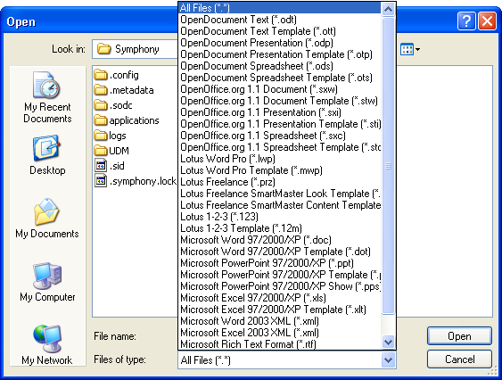
Figure 1-1: Lotus Symphony Documents supported file types

Supported document types
Document types that may be opened with Lotus Symphony Documents include:
- OpenDocument (.odt)
- OpenOffice (.sxw)
- Lotus Word Pro (.lwp)
- Lotus 1–2–3 (.123)
- Microsoft Word 97/2000/XP (.doc)
- Microsoft Rich Text Format (.rtf)
- Text files (.txt)

Opening recently accessed documents
Lotus Symphony Documents has a feature that allows you to quickly access the few most recent files you have opened or edited. This is useful when you wish to view a file that you have recently accessed, without navigating to it again. Click File→Recent Files to view a short list of recently accessed files, and then choose the file you want to open.

Exporting a File
Not only does Lotus Symphony Documents allow you to open files written in other formats, but it permits you to save your file in various formats. When you use the Save As command, the default .odt extension is applied to your file, thereby saving it as a Lotus Symphony Documents file. However, you have the option of saving your document in other formats. In the Save as type drop-down list, click the appropriate format to save your document.

The following figure shows the options in the Save as Type drop-down list.

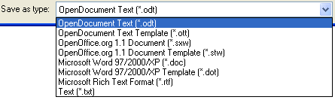
Figure 1-2: The Save as Type drop-down list

Exporting documents to PDF format
A unique feature of the Lotus Symphony suite is the ability to export a document directly to PDF format. No special add-ons, patches, or other tools are required for this. Click File→Export to open the Export dialog box. From here, you can provide a name for your PDF file and provide a location for the exported file.

Inserting Calculations in a Document
Lotus Symphony Documents allows you to perform mathematical calculations in your document and immediately display the results. This is one of the many robust features that differentiates Lotus Symphony Documents from other word-processing programs.

Calculations are performed and entered into your document via the Formula Input toolbar. Click View→Formula Input Line to display the Formula Input toolbar, or press F2 to toggle between showing and hiding the toolbar. Place the cursor to the right of the equals sign on the toolbar, and enter your calculation, for example, 365/7. Click the check mark icon in the toolbar to calculate the result, or press Enter. The toolbar disappears, and the result is placed at the cursor position of your document.

The following figure shows the Formula Input toolbar.

Figure 1-3: The Formula Input toolbar

Using predefined functions
A set of predefined functions is available for you to use. With the Formula Input toolbar open, click and hold the formula icon, and select a formula. For example, you can click Statistical Functions→Mean to have Lotus Symphony Documents calculate the average of several figures for you. This requires you to enter a series of numbers, each separated by a vertical slash | character. The result is placed into your document.

The following figure shows the Mean statistical formula.

Figure 1-4: The Mean statistical function with three values entered

Editing a calculated result
After you have inserted a calculated result into your document, you can make changes to it instead of entering the formula all over again. You can tell that a number is the result of a calculation by rolling the mouse pointer over it. If the number was calculated with the Formula Input toolbar, a tooltip will appear and indicate what numbers were used as input. Double-click the calculated number, and the Edit Fields dialog box appears. In the Formula text box, you can make adjustments to your formula and then click OK to have it re-calculated.
The following figure shows the Edit Fields dialog box.

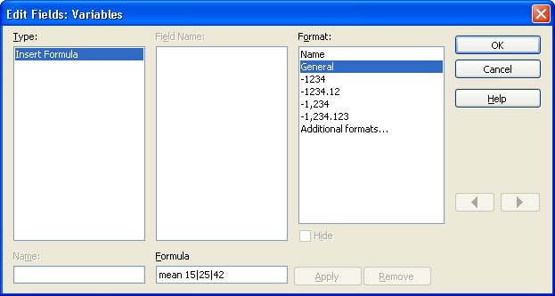
Figure 1-5: The Edit Fields dialog box

Inserting Footnotes or Endnotes
Footnotes refer to additional information about a topic at the bottom of a page, and endnotes refer to supplemental information at the end of the document. To add a footnote or endnote, place the cursor where the text should be flagged in the document body, and then click Create→Footnote. In the Create Footnote dialog box, in the Type section, you can select whether you would like to add a footnote or endnote.

The following figure shows the Create Footnote dialog box.

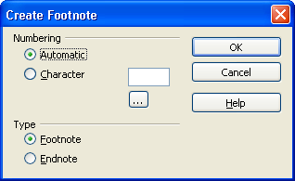
Figure 1-6: The Create Footnote dialog box

Once you have added a footnote or endnote, you will notice two changes to your document. First, a superscript character, or anchor, is placed at the cursor location, indicating that supporting information is location at the bottom of the page or at the end of the document. Second, an area of text is added to your document. Again, this depends on the type of note added. Adding a footnote will create a text region area at the bottom of the page where the anchor was placed. Endnote regions are always added to the end of the document, regardless of the location of the endnote anchor.

The following figure shows a paragraph containing a footnote and endnote.


Figure 1-7: A paragraph containing a footnote and endnote

By default, footnotes are automatically numbered as numerals (1, 2, 3…) while endnotes are lowercase Roman numerals (i, ii, iii…). This can be changed by manually specifying a character in the dialog box when adding the note, but it is recommended that you leave the automatic numbering as default. With automatic numbering enabled, Lotus Symphony Documents will automatically change the anchor numbers and synchronize the numbering to your footnotes and endnotes any time you add or remove a note.

Editing a footnote or endnote
Footnote and endnote text can freely be edited at any time. You can locate the location of the note text itself within your document, click within the note, and make changes to the text. However, you can also click the superscript note anchor to link you directly to the note corresponding to that reference. If you wish to delete a footnote or endnote, locate the note anchor, and then delete it. The note text will automatically be deleted as well.

Creating a Table of Contents
If you are working with a larger document, it may be helpful to add a table of contents at the beginning of the document to help your readers quickly locate the information they are looking for. Lotus Symphony Documents provides a very fast and simple way to automatically generate a table of contents at the current cursor position of your document.

There are a few steps you can take to ensure that the word processor is arranging the hierarchy correctly. A hierarchy is a classification of items according to their relationship to each other and their common characteristics to larger categories. It will benefit you to apply specific heading styles to the various page and section headings throughout your document. Major sections should have a Heading 1 style applied to them, while their subcategories should have a Heading 2 style. Further sub-sections of these sub-categories would have a Heading 3 style, and so forth.

In the following figure, the default Heading 1 style is applied to the To Our Stockholders text, while the default Heading 2 style is applied to Milestones.


Figure 1-8: Default Heading 1 and Heading 2 styles

Once this preparation work is done, you can generate an accurate table of contents within seconds. Place the cursor where you would like the table to be generated. Click Create→Index and Table→Indexes and Tables. In the Insert Index/Table dialog box, verify that Table of Contents is displayed in the Type drop-down list. You can also provide a name for the table of contents, specify the range of pages to cover, and how many levels deep to provide entries.

The following figure shows an example of a table of content with three levels displayed.

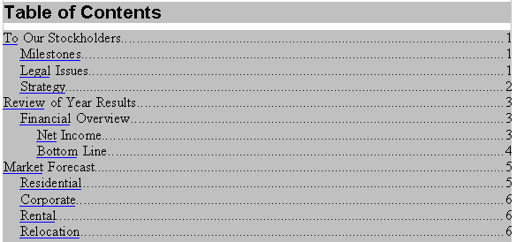
Figure 1-9: Table of contents with three levels shown

Updating the table of contents
By default, the table of contents that you generate is read-only and cannot be manually changed. This can be disabled when you first create the table of contents. In the Insert Index/Table dialog box, clear the Protected against manual changes check box if you would like to be able to make manual edits to the table after it has been generated.

If changes are made to your document, and you have not many any manual changes to the table of contents, Lotus Symphony Documents provides an easy way to update it to reflect the most recent changes to your document. Place the cursor within the table of contents, right-click within the table, and click Update Index/Table. The table of contents is immediately updated.

Deleting the table of contents
If you have set the table of contents to not allow manual changes, you will not be able to delete the table of contents by selecting it and pressing the Backspace or Delete keys. These are considered to be manual changes and are not permitted. Instead, place the cursor within the table of contents, right-click within the table, and click Delete Index/Table. The table of contents is removed.

Creating an Index
Lotus Symphony Documents allows you to create an index for your document. An index is an ordered list of key terms or phrases that appear throughout your document. In larger documents, this helps users to locate a specific term to view information relevant to that term.
As with the table of contents, an index can be generated quickly and easily. Place the cursor where you would like to create an index, and then click Create→Index and Table→Indexes and Tables. In the Type drop-down list, click Alphabetical Index to generate an index that lists all terms alphabetically. You can select whether or not this index may be manually edited as well. If you want the index to ignore the case of the term, clear the Case sensitive check box.

The following figure shows the Insert Index/Table dialog box.

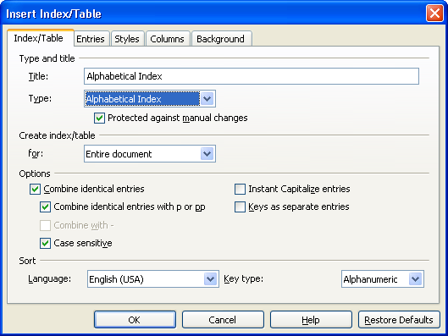
Figure 1-10: The Insert Index/Table dialog box with Alphabetical Index selected

Adding terms to the index
Generating an index will not produce very much for you if you have not first added terms to the index. Prior to creating the index, you must first sift through your document and identify all key terms that you would like to be included in your index. When you have located a term to be added, double-click the word to select it, or highlight the text by clicking and dragging. Click Create→Index and Table→Entry to open the Insert Index Entry dialog box. It is important that you configure these options correctly to ensure that your index is built properly.

The following table describes the options and fields.

Option/Field | Description
Entry | Enters the term in this text box to the index.
1st key | Makes the current selection a subentry of the word that you enter here. For example, if you select cold, and enter weather as the first key, the index entry is weather, cold.
2nd key | Makes the current selection a sub-subentry of the first key. For example, if you select cold, and enter weather as the first key and winter as the second key, the index entry is weather, winter, cold.
Main entry | Makes the selected text the main entry in an alphabetical index. The productivity tools display the page number of the main entry in a different format than the other entries in the index.
Apply to all similar texts | Automatically marks all other occurrences of the selected text in the document. Text in headers, footers, frames, and captions is not included. You cannot use this function for an entry that you entered manually in this dialog.
Match case | Distinguishes between uppercase and lowercase characters.
Whole words  only | Searches for whole words that are identical to the search text.

Editing and deleting index entries
Unless you have enabled manual revisions to your index, you will need to relocate the indexed entries within your document and then edit or delete them. This would be nearly impossible without some mechanism to visually identify the terms you have tagged to be indexed. Fortunately, Lotus Symphony Documents provides such a feature. Click View→Field Shadings to turn on field shading for elements in your document. All terms that are indexed in your document will be shaded with a grey background to make them stand out.

The following figure shows a paragraph with field shadings enabled.
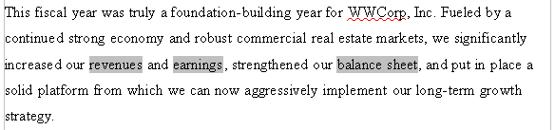
Figure 1-11: Paragraph with field shadings enabled
Place the cursor within the index term that you wish to edit or remove, and then right-click and click Index Entry. In the Edit Index Entry dialog box, you can adjust the properties of the entry, or click Delete to remove it from the index. The back and forward arrows can help you quickly pass between the currently indexed terms in your document.

Note: Deleting a term in this dialog box does not delete it from your document. It will delete it only from the index.

Updating the index
After you have made changes to your index, you can quickly apply all revisions to your index. Right-click within your index and click Update Index/ Table to have Lotus Symphony Documents reflect all revisions you have made to the indexed terms in your document.

Securing a Document
Lotus Symphony Documents provides a feature that lets you assign a password to a document to prevent users from making unauthorized changes to it. When a user attempts to open a document that has been password protected, he or she will be prompted to provide a password. The document is opened only when the password is correctly entered.

To protect a document with a password, click File→Security→Document Protection. You will be prompted to type a password, and then confirm it by typing it a second time. The password must be at least five characters in length. Any time a user (yourself included) wishes to open this document from now on this password must be entered.

The following figure shows the Password dialog box.

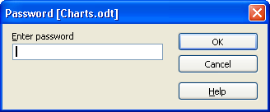
Figure 1-12: The Password dialog box
To remove file protection from your document, open the document and then click File→Security→Document Protection. Delete the text from both password fields and click OK.

Installing and Using Plug-ins
Plug-ins are optional add-ons that are created by IBM, partners, and developers. These plug-ins extend the value of Lotus Symphony by providing additional functions that are not included with the basic Lotus Symphony installation. Follow the steps in the following table to install a plug-in.
- Ensure that Lotus Symphony version 1.1 is installed on your machine, and upgrade if necessary.
- Start Lotus Symphony.
- From the main menu, click File→Application→Install. The Install wizard is displayed.
- On the Feature Updates page, select Search for new features to install, and click Next.
- On the Application Locations page, click Add Zip/Jar Location.
- Navigate to the location of the update (a zipped file, which contains features, plug-ins folders, and one site.xml file), click Open, and then click Finish.
- On the Search Results page, select the feature, and click Next.
- On the Feature License page, select I accept the terms in the license agreements, and click Next.
- Click Finish to begin the installation.
- After the installation is finished, close Lotus Symphony and then restart it.

There are many plug-ins available for IBM Lotus Symphony. Please visit http://symphony.lotus.com/software/lotus/symphony/plugin.nsf/home to see a comprehensive list of available plug-ins. The plug-ins that are recommended for Lotus Symphony Documents include IBM Lotus Symphony Diff and IBM Lotus Symphony Xforms.

Lotus Symphony Diff plug-in
The IBM Lotus Symphony Diff plug-in adds capabilities to compare two document files with simple text, marking differences with different colors. Documents are compared at the paragraph level. A modified paragraph is marked with a blue color, a deleted paragraph is marked with a red color, and an added paragraph is marked with a purple color. The comparison is based on the original file.

The plug-in package name is com.ibm.productivity.tools.sample.diff.updatesite.zip.
It contains the updatesite package ready to be deployed to Lotus Symphony. Refer to the Readme.odt zip file for more information.

Lotus Symphony Xforms plug-in
ODF documents may contain XFORM data, which can be used to embed structured data from a database or XML files. You are able to operate on a specific part of these structured data. The IBM Lotus Symphony Xforms plug-in enables you to directly operate the XFORM data in an ODF document, which increases productivity for users.


Topic B: Using Styles
Your document may go through many rounds of reviews, which could result in the creation of multiple document versions. People who review your document will likely want to offer you feedback by adding comments or making revisions to the text. However, without a system in place to track or manage comments, it can be difficult to determine which changes were made by each reviewer. IBM® Lotus® Symphony™ Documents offers features that help you collaborate with peers. By using change recording, adding comments, and managing revisions, you can ensure that your document is always current and incorporates feedback from all reviewers.

Recording Changes
It is very rare that a document does not get reviewed or revised by another party at some point over the course of its creation. Lotus Symphony Documents allows you to enable the recording of changes as they are made in a document, so that another party can quickly determine what was changed from one version to the next. This eliminates the need to open two separate versions of the same document and compare them line by line in order to discover what was changed.

To enable change recording, click Edit→Revisions→Record. Certain changes in your document are not recorded, such as changing tab stops, page margins, or other document-related properties. Change recording will, however, make note of any text additions, deletions, alterations, and other various formatting. For example, when you delete a word from a document with change recording enabled, the word will not physically be removed. Rather, the word will be highlighted in red with a strikethrough, to indicate that it was deleted. Similarly, text that has been added will be represented with a red underline.

The following figure shows a paragraph with change recording enabled.


Figure 1-13: A paragraph with change recording enabled

The default behavior for displaying changes to the document can be customized. Click File→Preferences, and then navigate to IBM Lotus Symphony→Lotus Symphony Documents→Changes. Here, you can modify the way that Lotus Symphony Documents will flag changes that have been made to your document.

Accepting and Rejecting Changes
The benefit of recording the changes made to a document is the ease in which another person may review these revisions. Instead of comparing documents on a line-by-line basis, Lotus Symphony Documents calls attention to all text and text-formatting changes to the document.

When you are ready to review the changes made by another reviewer, open the document and click Edit→Revisions→Accept or Reject. In the Accept or Reject Changes dialog box, a list of all changes to the document is provided.

The following figure shows the Accept or Reject Changes dialog box.

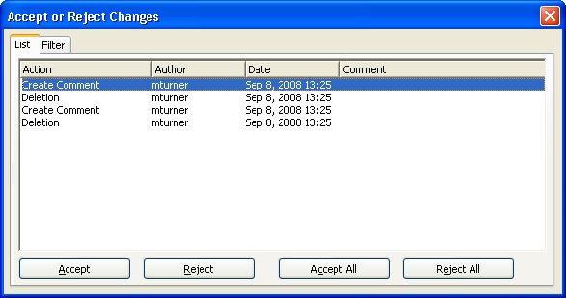
Figure 1-14: The Accept or Reject Changes dialog box

The actions that you can take are provided at the bottom of the dialog box. The following table describes the results of those actions.

Action | Result
Accept | Accepts the currently selected change in the list above and removes the change highlight in the document.
Reject | Rejects the currently selected change in the list above and places the original text in the document.
Accept All | Accepts all changes made to the document at once, and removes all change highlighting.
Reject All | Rejects all changes made to the document, and removes all change highlighting.

On the Filter tab of the dialog box, you can narrow your search of specific changes to the document. This is especially helpful when the document has been through multiple reviews since you last saw it. You can filter the recorded changes by specifying a range of dates, sorting by author, by action, or by any comments that have been entered.

Using Comments
Comments provide a way for you and others to communicate with each other within the document, but without adding text to the content of the document itself. The benefit of this is that the comments travel along with the document itself and are not lost or misplaced in long e-mail chains. Comments are marked with the name of the user who has entered the comment, and they are also time stamped to indicate when the comment was made.

A comment may be added only to text that has been changed in the document, with change recording enabled. The purpose of the comment is to provide an explanation as to why the change was made. You can insert a comment by placing the cursor within the changed text, and click Edit→Revisions→Comment. In the Create Comment dialog box, you may provide a short message about the change. This comment will be visible when another reviewer opens the document and accepts or rejects changes. It will also be displayed any time the mouse is rolled over that particular change.

The following figure shows the Create Comment dialog box.

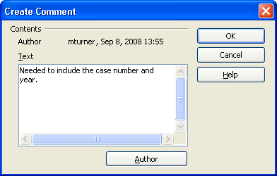
Figure 1-15: The Create Comment dialog box

Comments vs. notes
It is important to be aware of the difference between a comment and a note. A comment may be applied only to a change that has been made to a document with change recording enabled. A note, on the other hand, may be made anywhere in the document and does not need to be associated with any particular changes.
To add a note to your document, place the cursor where you would like to add a note, and click Create→Note. Provide the text to be displayed in your note, and click OK. A small yellow marker will indicate the presence of a note in the document. This note text is visible when a user rolls over the note. You can double-click the note marker at any time to edit it, or click the note and press Delete to remove it.

The following figure shows note text.

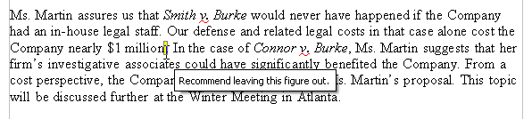
Figure 1-16: The note text is displayed when rolled over

Caution: It is important that you do not highlight text before adding a note. The yellow note marker will overwrite any selected text. Instead, place the cursor to mark the location of the note without highlighting any text.

Merging Document Versions
In order to save time, it is sometimes necessary to have multiple parties review a document and record changes all at the same time. When a document has been edited by more than one person, Lotus Symphony Documents allows you to merge the edited copies into the original. The only requirement is that the documents differ only and exclusively in the recorded changes; all other original text must be identical. This means that multiple people cannot suggest conflicting edits to the same original piece of text.

Open the original document into which you want to merge all copies, and then click Edit→Revisions→Merge Document. A file selection dialog box is displayed. Select the copy of the document to merge into the original. If there have been no subsequent changes to the original document, the copy is merged into the original. If changes have been made to the original document, you cannot merge the copy into the original.

Performing a Mail Merge
Documents that you create may need to be personalized or individually customized per each recipient. This would normally require you to create a separate document for each recipient, and then individually print these documents one by one. As the number of recipients increases, so does the amount of time required to personalize and print all documents.
Lotus Symphony Documents has a feature called mail merge, which transforms this highly mundane project into a quick and easy task. The mail merge feature allows you to enter placeholder fields within a document, which are then populated automatically with values. These values are listed in a separate source file that you can create yourself if necessary or specify within Lotus Symphony Documents.

For example, suppose that you would like to send acceptance letters to 50 people who were accepted into an educational program. Instead of creating and printing 50 separate documents, you can draft a single document and use placeholder variables for each recipient’s name and address. A list of names and addresses can be added from a source file, which can be one of three types:
- Lotus Symphony Spreadsheets (.ods)
- IBM Lotus Notes contacts (.nsf)
- Comma-separated values (.csv)

The following figure shows a sample source file that is an ordinary IBM® Lotus® Symphony™ Spreadsheets file, in which categories have been made for each placeholder that will be needed in the document. Each row of the source file is a recipient for this letter.

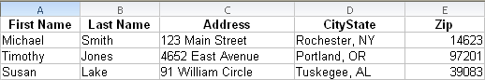
Figure 1-17: A Lotus Symphony Spreadsheets mail merge source file with three entries listed

To begin creating your mail merge batch, you will need to define the source of the data. In Lotus Symphony Documents, click Tools→Mail Merge. A pane appears to the left of your document. Expand the Select Recipients category if necessary, and then click Browse. Navigate to the data source file on your computer that contains the placeholder categories as well as the values. In our example, the Lotus Symphony Spreadsheet file shown in the previous figure has been selected. In the Insert Fields section of the mail merge pane, notice that the placeholder fields listed translate directly to the column headings in the source file.

The following figure shows the Insert Fields placeholders.
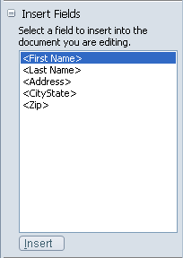
Figure 1-18: The Insert Field placeholders

You can now begin inserting these placeholders into your document. Position the cursor at the desired location, select the placeholder you wish to add, and then click the Insert button. The placeholder is inserted into your document, and is indicated by surrounding brackets. Continue to add each field appropriately. Moving along with our example, each placeholder has been positioned into the document as illustrated in the following figure. Note that fields may be used more than once.

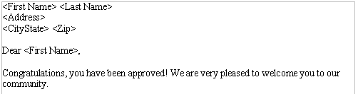
Figure 1-19: Placeholder positioning within a document

Note: Note that any time, you can expand or collapse the mail merge pane by clicking Tools→Mail Merge.

Preview the mail merge
Since your list of recipients is likely to be substantial, you will want to preview your mail merge to confirm that you have correctly mapped each field in the correct location, and that the individual values are being inserted accordingly. Open the mail merge pane if it is not already open, click the Finish Merge button at the bottom of the pane, and then click Preview. Within the preview window, notice that a list of recipients is displayed on the left. You can select or clear any of the check boxes to exclude specific recipients when you print this batch. As you click the Previous Recipient and Next Recipient icons on the toolbar, notice that the document changes automatically to reflect the values of the selected entry.

The following figure shows a mail merge print preview.

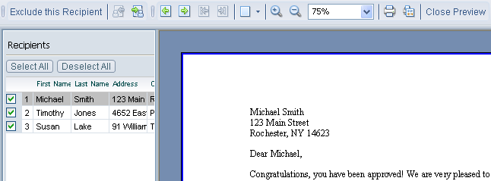
Figure 1-20: The mail merge print preview

Printing a mail merge
When you are satisfied with your mail merge template, click the Finish Merge button at the bottom of the pane, and then click Print. In the Mail Merge – Print dialog box, select which recipients to print documents for, select how to print the document per recipient, and then click OK. Your document will be printed for all selected recipients in a single batch.


Topic C: Using Styles
IBM® Lotus® Symphony™ Documents allows you to create rich documents that contain a variety of visual elements in addition to text. Large documents may include an assortment of text formatting, graphics, tables, lists, and other objects. When reviewing a large document, it may be cumbersome to search through the entire document to locate a specific object that you want to revisit. Lotus Symphony Documents has a built-in Navigator function that sorts all document objects into groups and allows you to quickly locate any element of the document from a single pane.

Navigate Through a Document
Finding specific sections or visual elements in a smaller document is usually never an issue. However, when you are working with large documents, it can be difficult to comb through each page to locate a specific paragraph, table, graphic, note, or hyperlink. Lotus Symphony Documents includes a very useful feature called the Navigator, which can be used to quickly locate such items within a document.

The many tools available within the Navigator can be accessed by clicking Edit→Navigator. This opens the Navigator floating toolbar, which can be freely positioned by default. It may be docked by pressing CTRL and dragging it to any edge of the document, and undocked by pressing CTRL and double-clicking the toolbar.

Inside the Navigator, you can quickly jump to various elements of your document. The icons listed in the content portion of the toolbar describe the components of your document that you can locate. The expand icon indicates that there are components within that category.

For example, in the following figure, there are one or more headings, tables, graphics, OLE objects, indexes, and notes within this particular document.

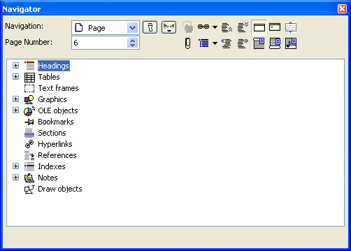
Figure 1-21: The Lotus Symphony Documents Navigator

You can expand any of these categories to view all occurrences of these elements within the document. For instance, expanding the Tables group will show the names of all tables located in your document. Double-clicking a table in this list will take you directly to that table within the document itself. This is very useful for locating the position of notes within a large document, as the indicators are small and easy to miss. Within the Navigator, you can expand the Headings category to view a hierarchy of the document structure. Again, double-clicking any of the items listed here will bring you to the location of that heading within the document.

The Form Navigator
Forms are templates that include special content controls to simplify data entry for a user. Forms can include controls such as check boxes, drop-down lists, or placeholder instruction text that a user can replace with a single click.

Within the Navigator toolbar, there is a built-in function to manage any forms and form controls within your document. Click the Form Navigator button to open the floating Form Navigator toolbar. This toolbar provides a means for viewing the various forms that you are using in your document.
In the following figure, the Standard form has three form controls added to the document: an option button, check box, and time field control.

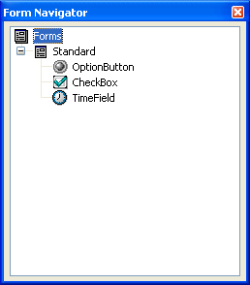
Figure 1-22: The Form Navigator

Provided that you have already manually added these optional form controls to your document, you can manage the properties of these controls in the Form Navigator. The properties can be configured by right-clicking a specific control and clicking Properties in the pop-up menu. On each of the tabs shown of the dialog box for that control, you can configure the control’s parameters. The following table describes these tabs.

Control Properties tab | Description
General | Generic and physical characteristics of the control, including name, label, tab order, text properties, color, and border.
Data | Data-related attributes, including binding, expression, constraint, calculation, and data type.
Events | Any actions that should trigger specific events when the control is interacted with.
Note: The majority of Lotus Symphony Documents users will likely not be adding form controls to documents, and thus do not need to become too familiar with the Form Navigator toolbar. This functionality is intended for those with an advanced background in programming and form controls. All available form controls are accessible in the Form Functions toolbar, and can be viewed by clicking View→Toobar→Form Functions.

Activity 1-1: Working with Large Documents

Data Files:
- Annual Report.doc

Scenario
In order to complete the Annual Report for WWCorp, you need to import a file, create a table of contents and an index, and insert footnotes and endnotes in the document. You will also track changes, accept changes, and add a comment to the document.

To complete this activity:
- Import the Annual Report.doc file.
- Add footnotes and endnotes.
- Create a table of contents.
- Create an index.
- Track and accept changes, and add a comment to the document.

Follow these steps to format your document.

Step | Action
Import the Annual Report.doc file.
1 | Double-click the IBM Lotus Symphony icon on the desktop.
2 | On the Home – IBM Lotus Symphony page, click File→Open→File.
3 | In the Open dialog box, navigate to the directory where the supplied files are stored. Click the file Annual Report.doc, and then click Open. In the Lotus Symphony message box, select the Do not show this warning again check box and click OK.
Add footnotes and endnotes.
4 | Navigate to page 2 and click to place the cursor after the last sentence of the Strategy paragraph. Click Create→Footnote. In the Create Footnote dialog box, make sure that Automatic and Footnote are selected. Click OK. Enter the following text as a footnote: More information about our strategy is found in the fourth-quarter report.  Result:The footnote is added to the page and the footnote reference number is placed after the paragraph.
5 | To add an endnote, click Create→Footnote. In the Create Footnote dialog box, make sure that Automatic and Endnote are selected. Click OK. Enter the following information as an endnote: More Information about our National Affiliate Program can be found on the Company's intranet site.  Result: The endnote is added to the last page of the document and the endnote reference number is placed after the paragraph.
Create a table of contents.
6 | Navigate to page i (before page 1), place the cursor at the top of the page and click Create→Index and Table→Indexes and Tables. In the Insert Index/Table dialog box, verify that Table of Contents is displayed in the Type drop-down list. Click OK. Delete the words Contents, Figures, Tables, and Authorities.
Create an index.
7 | Quickly browse through your document and select at least 10 key terms that will be added to the index. When you find a term that you wish to add, double-click the word and then click Create→Index and Table→Entry to open the Insert Index Entry dialog box. Click Insert. You can leave the Insert Index/Table dialog box open while you look for more terms, and then simply select the new term and click Insert.
8 | Navigate to page 21, select the word Index, and delete it. Click Create→Index and Table→ndexes and Tables. In the Insert Index/Table dialog box, on the Index/Table tab, click the Type drop-down list and select Alphabetical Index. Click OK.
Track and accept changes, and add a comment to the document.
9 | Click Edit→Revisions→Record. Navigate to the Net Income section and replace $10.6 million with $11.6 million, and also replace $1 million with $2 million  Under Bottom Line, replace $18.75 million with $19.75 million
10 | Navigate to the Rental section and delete the last sentence. Go to Relocation Team section and replace Atlanta with New York
11 | Navigate to the beginning of the file, and click Edit→Revisions→Accept or Reject. In the Accept or Reject Changes dialog box, accept all changes except the deletion in the Rental section. Do not reject the change. Close the dialog box, highlight the deleted text, and then click Edit→Revisions→Comment. Add the following text: Not sure if this text should be deleted. Could you please advise? and then click OK.
12 | Save the file as Annual Report Final in OpenDocument Text format and then close the file.


Lesson Summary
As a document increases in size, it becomes more difficult to review and navigate. This can make the process of receiving and managing feedback from multiple reviewers a difficult task. In this lesson, you explored the features available to you in Lotus Symphony Documents that can make large documents easier to work with.

Adding a table of contents, an index of key terms, footnotes, and endnotes can make the document easier to read through. Change tracking and revision management allow you to accurately manage and incorporate all feedback provided to you from reviewers. You also examined the Navigator feature, and how it can help you quickly locate specific items within a large document, eliminating the need to manually search page by page.

Follow-up
In this course, you managed, revised, and distributed long documents. You discovered how Lotus Symphony Documents can be used with other programs for document collaboration, and how to navigate through a document. You made documents and information accessible to specific people and programs. When you utilize these tools, your documents become a source for information and collaboration with other individuals.

What’s Next?
After completing the Using IBM® Lotus® Symphony™ Documents: Power User course, you may want to continue with any of the following courses:
- Using IBM® Lotus® Symphony™ Spreadsheets: Basics
- Using IBM® Lotus® Symphony™ Spreadsheets: Beyond Basics
- Using IBM® Lotus® Symphony™ Spreadsheets: Power User
- Using IBM® Lotus® Symphony™ Presentations: Basics
- Using IBM® Lotus® Symphony™ Presentations: Beyond Basics
- Using IBM® Lotus® Symphony™ Presentations: Power User

Also available are the following courses:
- Using IBM® Lotus® Symphony™ Documents: Basics
- Using IBM® Lotus® Symphony™ Documents: Beyond Basics

Finally, information about the Lotus Symphony product is available at the Lotus Symphony Web site, which is at http://symphony.lotus.com/software/lotus/symphony/home.nsf/home
Appendix 

Additional Resources
The following additional resources are available for more information on Lotus Symphony Documents:
- Tour: http://symphony.lotus.com/idcontents/pdf/N8T30/start_n8t30.htm
- Demo: http://symphony.lotus.com/software/lotus/symphony/help.nsf/DemoForDocuments
- Tutorial: http://symphony.lotus.com/idcontents/tutorial/en/documents_tutorial/start_documents.htm
- Toolbar Reference Card: http://symphony.lotus.com/idcontents/refcard/en/n8r30_refcarddita-pdf-minimal.pdf
- Keyboard Reference Card: http://symphony.lotus.com/idcontents/refcard/en/n8r30_shortcutdita-pdf-minimal.pdf

As they are developed, other resources may be added to this location: http://symphony.lotus.com/software/lotus/symphony/help.nsf/home

Available Plug-Ins
Extend the value of Lotus Symphony with plug-ins from IBM, partners, and developers. A complete list of all available plug-ins can be found here: http://symphony.lotus.com/software/lotus/symphony/plugin.nsf/home

