Using IBM® Lotus® Symphony™ Presentations: Basics
Student Guide

Using IBM® Lotus® Symphony™ Presentations: Basics
Part Number: Y1300
Course Edition: 1.0

Notices
DISCLAIMER: You may not copy, reproduce, translate, or reduce to any electronic medium or machine-readable form, in whole or in part, any documents, software, or files provided to you without prior written consent of IBM Corporation, except in the manner described in the documentation. While every reasonable precaution has been taken in the preparation of this manual, the author and publishers assume no responsibility for errors or omissions, nor for the uses made of the material contained herein and the decisions based on such use. Neither the author nor the publishers make any representations, warranties, or guarantees of any kind, either express or implied (including, without limitation, any warranties of merchantability, fitness for a particular purpose, or title). Neither the author nor the publishers shall be liable for any indirect, special, incidental, or consequential damages arising out of the use or inability to use the contents of this book, and each of their total liability for monetary damages shall not exceed the total amount paid to such party for this book.

TRADEMARK NOTICES The following terms are trademarks or service marks of International Business
Machines Corporation in the United States, other countries, or both: DB2®, Domino®, Domino® Designer,
Everyplace, ibm.com®, LearningSpace®, Lotus®, Lotus Enterprise Integrator®, Lotus Notes®, Lotus Workflow, Quickr™, Rational®, Sametime®, Symphony™, Tivoli®, VisualAge®, and WebSphere®.

Java and all Java-based trademarks and logos are trademarks of Sun Microsystems, Inc., in the United
States, other countries, or both.

Microsoft, Windows, Windows NT, and the Windows logo are trademarks of Microsoft Corporation in the
United States, other countries, or both.

Intel, Intel Inside (logos), MMX and Pentium are trademarks of Intel Corporation in the United States, other countries, or both.

UNIX is a registered trademark of The Open Group United States and other countries.

Linux is a trademark of Linus Torvalds in the United States, other countries, or both.

Copyright © 2008 IBM Corporation.
Lotus software, IBM Software Group, One Rogers Street, Cambridge, MA 02142

Under the copyright laws, neither the documentation nor the software may be copied, photocopied, reproduced, translated, or reduced to any electronic medium or machine-readable form, in whole or in part, without the prior written consent of IBM, except in the manner described in the documentation or the applicable licensing agreement governing the use of the software.

All rights reserved.

Licensed Materials - Property of IBM

U.S. Government Users Restricted Rights - Use, duplication, or disclosure restricted by GSAADP Schedule Contract with IBM Corporation.

You must purchase one copy of the appropriate kit for each student and each instructor. For all other education products you must acquire one copy for each user or you must acquire a license for each copy provided to a user.

Using IBM® Lotus® Symphony™ Presentations: Basics
Lesson 1: Introduction to IBM® Lotus® Symphony™ Presentations 11
Introduction 12
Topic A: Getting Started with IBM® Lotus® Symphony™ Presentations 13
What is Lotus Symphony Presentations? 13
Exploring the Lotus Symphony Presentations Interface 13
Examining the Properties Sidebar 14
Examining Preferences 15
Topic B: Creating, Opening, and Saving Presentations 16
Creating a Blank Presentation 16
Creating a Presentation from a Template 17
Opening an Existing Presentation 17
Saving a Presentation 17
Exporting a Presentation 18
Activity 1-1: Get Started with Lotus Symphony Presentations 20
Lesson Summary 22
Lesson 2: Modifying Pages in IBM® Lotus® Symphony™ Presentations 23
Introduction 24
Topic A: Modifying Text 25
Adding Bullet and Numbered Lists 25
Inserting Symbols or Special Characters 25
Inserting a Text Box 25
Applying Presentation Styles 25
Changing Text Properties 26
Dragging Text to a New Location 27
Finding and Replacing Text 27
Topic B: Working with Views 28
Page View 28
Outline View 29
Page Sorter View 30
Notes View 31
Topic C: Working with Pages 32
Inserting a New Page 32
Duplicating an Existing Page 32
Reordering Pages 32
Deleting Pages 32
Hiding Pages 33
Activity 2-1: Modify Pages in LSP 34
Lesson Summary 36
Lesson 3: Delivering an IBM® Lotus® Symphony™ Presentations Screen Show 37
Introduction 38
Topic A: Finalizing a Presentation 39
Page Transitions 39
Animating Page Transitions 40
Creating Notes Pages 40
Checking Spelling 40
Topic B: Delivering a Screen Show 41
Running a Screen Show 41
Printing a Presentation 41
Exporting a Presentation 42
Activity 3-1: Deliver a Lotus Symphony Presentations Screenshow 43
Lesson Summary 44
Follow-up 45
What’s Next? 45
Appendix A 46
Additional Resources 46
Available Plug-Ins 46

About This Course
By using IBM® Lotus® Symphony™ Presentations to create and deliver presentations, you will capture your audience’s attention and communicate your ideas more effectively. You will also clearly establish your authority and professionalism with a dynamic presentation style that makes full use of Lotus Symphony Presentation’s features.

Course Description
Target Student
This course is designed for IBM® Lotus® Symphony™ end users who will use these materials to learn the basic tasks associated with the Lotus Symphony Presentations editor.

Course Prerequisites
This course assumes that students have some experience with using presentation software.

How to Use This Book

As a Learning Guide
Each lesson covers one broad topic or set of related topics. Lessons are arranged in order of increasing proficiency with IBM Lotus Symphony Presentations; skills you practice in one lesson are used and developed in subsequent lessons. For this reason, you should work through the lessons in sequence.

Each lesson is organized into results-oriented topics. Topics include all the relevant and supporting information you need to master Lotus Symphony Presentations, and activities allow you to apply this information to practical hands-on examples.

As a Review Tool
Some of the information covered in class may not be relevant to your environment immediately, but it may become important later on. For this reason, we encourage you to spend some time reviewing the topics and activities after the course.

As a Reference
The organization and layout of the book make it easy to use as a learning tool and as an after-class reference. You can use this book as a first source for definitions of terms, background information on given topics, and summaries of procedures.

Course Objectives
After completing this course, you should be able to:
- Explore IBM Lotus Symphony Presentations.
- Modify pages.
- Deliver an IBM Lotus Symphony Presentations screen show.

Course Requirements

Hardware
This course assumes users will be using their personal computer to take this course. The following are the system requirements to support an installation of IBM® Lotus® Symphony™ 1.1:
- At least 750 MB of free disk space on Linux and at least 540 MB of free disk space on Microsoft® Windows®.
- At least 512 MB of memory.

Software
The following list identifies the software requirements for installing Lotus Symphony 1.1. Please note that proper licensing for all software is required and is the responsibility of the training organization.
- Microsoft® Windows® XP + SP2 or Microsoft® Windows Vista®
- IBM Lotus Symphony 1.1

Class Setup

Course Files
The following table describes the course files.
Title | File name | Description
WWCorp 3rd Quarter presentation | wwcorp_3rdQT_presentation.odp | Data file for lessons 1 and 2
WWCorp standard presentation | wwcorp_std.odp | Data file for lesson 2
Final Executive Presentation | final_exec_pres.odp | Data file for lesson 3

Course Setup Tasks
Complete the tasks in the following table to set up the course prior to the
start of class. Detailed procedures for each task appear on the following
pages.

Task | Procedure
1 | Uninstall any previously installed version of IBM Lotus Symphony.
2 | Install Lotus Symphony 1.1.
3 | Install the course data files.

Task 1: Uninstall Previous Versions of IBM Lotus Symphony
If you currently have an earlier version of Lotus Symphony installed, you will need to uninstall it prior to installing Lotus Symphony 1.1. Follow these steps to uninstall any previously installed versions of Lotus Symphony.

Step | Action
1 | Verify that Lotus Symphony is closed
2 | Click Start→Control Panel→Add or Remove Programs.
3 | In the Add or Remove Programs dialog box, click IBM Lotus Symphony  and then click Remove.  Note: It may take a few minutes for the program to uninstall.

Task 2: Install Lotus Symphony 1.1
If you have not yet installed Lotus Symphony 1.1, you will need to do so before taking this course. Follow these steps to install Lotus Symphony 1.1.

Step | Action
1 | In a Web browser, go to http://symphony.lotus.com/software/lotus/symphony/home.nsf/home and click Download to download the Lotus Symphony 1.1 installation files. A new window opens and lists the IBM Lotus Symphony installation types. Click the version for the Windows operating system. In the next window, the product information is displayed. Select a language and click Continue. Select I agree after viewing the licensing information, and then click I confirm.
2 | In the Download using Download Director dialog box, select Lotus Symphony Setup for Windows, and click Download now.
3 | After the files have finished downloading, click Launch in the Download Director.
4 | The Installation Wizard for IBM Lotus Symphony is displayed. On the Welcome to IBM Lotus Symphony 1.1 page, click Next.
5 | On the Software License Agreement page, select I accept the terms in the license agreement, and click Next.
6 | On the next page, leave the default install location or browse to and select a custom location, and then click Next.
7 | On the File Type Associations page, verify that the Open Document Format file types and OpenOffice.org 1.1 file types are selected by default. Click Next.
8 | On the next page, click Install.
9 | On the IBM Lotus Symphony Install Complete page, verify that Open Lotus Symphony is selected, and then click Finish.

Task 3: Install the Course Data Files
Data files for students to use during the course activities are provided and installed as part of course setup. Follow these steps to install the course data files.

Step | Action
1 | Open the Y1300labfiles.zip file and run the Y1300labfiles.exe self-extracting file. This executable will create the \lotus_ed\ folder and install sub-folders named \Documents, \Spreadsheets, and \Presentations.  Note: These course files apply to all Lotus Symphony training modules, so you will only need to install these files once.

Course Icons
The following table explains the icons used in this course.

Step | Action
 | An activity is a student-centered learning process that allows students to learn by performing a task. Activities can be instructor-led or completed independently.
 | Scenario information is used to introduce an activity problem or goal. Scenarios use fictitious people and organizations to present details, problem statements, and parameters that are used to complete the activity or lab exercise.
 | Caution statements are included in the courseware to make students aware of potential negative consequences of an action, setting, or decision, that are not easily known.
 | Tips and notes provide additional information, guidance, or a hint about a topic or task.
 | An Instructor Note is a special comment to the instructor regarding delivery, classroom strategy, classroom tools, exceptions, and other special considerations. The Instructor Note is included in the Instructor Guide only.
 | A Display Slide provides a prompt to the instructor to display a specific slide. The Display Slide icon is included in the Instructor Guide only.


Introduction to IBM® Lotus® Symphony™ Presentations

■ Topic A: Getting Started with IBM® Lotus® Symphony™ Presentations
■ Topic B: Creating, Opening, and Saving Presentations

Introduction
By using IBM® Lotus® Symphony™ Presentations, you can create dynamic presentations that captivate your audience and communicate difficult concepts. You can easily adjust the style of your content to achieve the most effective communication every time.

After completing this lesson, you should be able to:
- Explore available preferences in Symphony Presentations.
- Examine available export formats.


Topic A: Getting Started with IBM® Lotus® Symphony™ Presentations
To begin working with IBM® Lotus® Symphony™ Presentations, it is helpful to be familiar with the interface. By examining the elements of the Lotus Symphony Presentations application, such as the Properties sidebar, you will be better prepared to start creating and displaying graphic presentations.

What is Lotus Symphony Presentations?
Lotus Symphony Presentations is a component of Lotus Symphony that enables you to create graphic presentations for sharing information with others in a screen show format.

Exploring the Lotus Symphony Presentations Interface
The Lotus Symphony Presentations interface provides many of the tools that you use most often in menus, toolbars, and sidebars, so they are easily accessible when you need to use them. The following figure shows the Lotus Symphony Presentations interface.

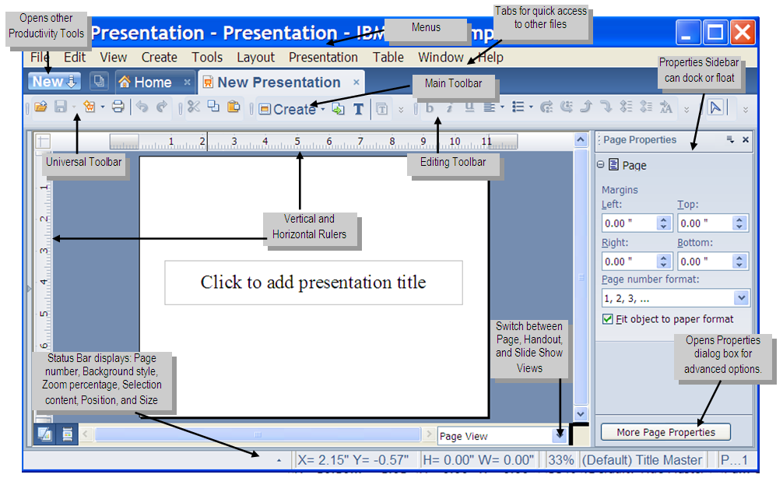
Figure 1-1: The Lotus Symphony Presentations interface

Examining the Properties Sidebar
The Properties sidebar is a context-sensitive tool that enables you to format pages, text, and other elements by specifying properties. The most commonly used properties are displayed on the sidebar, but you can also click the More Page Properties or All Text Properties button to display a tabbed dialog box that can be useful when you need to specify several properties at one time. The following figure shows the Properties sidebar.

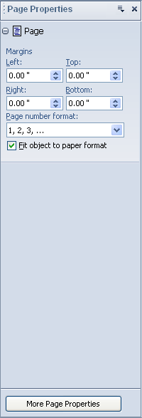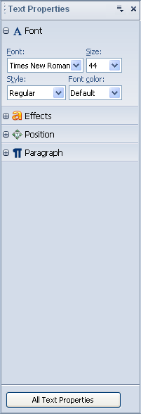
Figure 1-2: The Properties Sidebar

Examining Preferences
In addition to the properties available in the Properties sidebar, there are global properties that you can modify for Lotus Symphony Presentations. In the main menu bar, click File→Preferences to open the Preferences dialog box. Expand IBM Lotus Symphony if necessary, and then expand Lotus Symphony Presentations.

The following figure shows the Preferences dialog box.

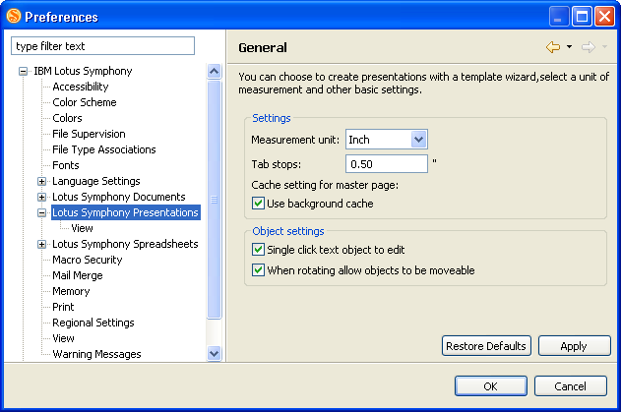
Figure 1-3: The Preferences dialog box

On the General page shown in the previous figure, you can set the length of the tab stops, and specify how object selection is handled. On the View page just below in the navigation pane, you can configure options for page display rulers and guideline grids, image and text placeholders, and contours.


Topic B: Creating, Opening, and Saving Presentations
There are several ways to start working with IBM® Lotus® Symphony™ Presentations. You can create new presentations or open presentations that have already been created. New presentations can be blank, or they can be based on a template. As you build your presentations, you will want to preserve the work you have done by saving the presentations. By examining the various ways of creating, opening, and saving presentations, you can decide which techniques you want to use to minimize your design time while developing effective presentations.

Creating a Blank Presentation
Creating a blank presentation enables you to add and format content and pages to build a presentation. To create a blank presentation, you can use any of the following techniques:
- From the main Lotus Symphony menu, click File→New→Presentation.
- From the Lotus Symphony Home page, click Create a new Presentation.
- From any page, click the New button, and click Lotus Symphony Presentation.
- From any page, on the toolbar, click the drop-down arrow for the New button, and click Presentation.

When you create a blank presentation, the presentation contains only a title page. The following figure shows a blank presentation.

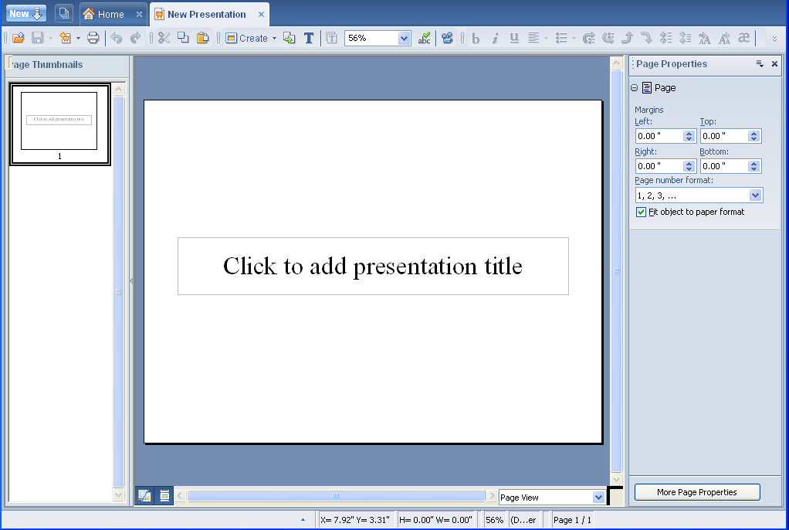
Figure 1-4: A blank presentation

Creating a Presentation from a Template
Creating a presentation from a template enables you to reuse page designs or page content, or both, that have already been created. Several templates are available with Lotus Symphony Presentations, and these are stored in the Default Template Library. To create a presentation from a template, follow these steps.

- Click File→New→From Template→Presentation.
- In the New from Template dialog box, click a template in the Template list. When you select a template, a preview of the selected template is displayed to the right of the list.
- Select either Create presentation based on page content and design or Create presentation based on page designs only.
- Click OK.

Opening an Existing Presentation
To open a presentation, you can use any of the following techniques:
- Click File→Open→File, navigate to the location of the file, select the file, and click Open.
- On any page, click the Open button on the toolbar, navigate to the location of the file, select the file, and click Open.
- If the file has been opened recently, click File→Recent Files, and click the file name.
- In Windows Explorer or My Computer, navigate to the location of the file, and then double-click the file name.

Opening presentations in other formats
A major benefit of Symphony Presentations is that its compatibility with other presentation programs, including Microsoft® PowerPoint. Presentations that have been created in PowerPoint can be viewed, edited, and saved in Symphony Presentations. The process of opening a PowerPoint presentation is no different than opening a presentation created in Lotus Symphony; you can click the Open icon in the toolbar, or use the File menu. In the Open dialog box, navigate to the location of the PowerPoint presentation, and then click Open.

Note: In the Open dialog box, verify that All Files is selected in the Files of type drop-down list. If this is not selected, PowerPoint files may not be visible in the navigation window.

Saving a Presentation
To save your work, you need to save your presentation. For new presentations or templates, click the Save button on the toolbar, or click File→Save As, and provide a location and name for the presentation file. By default, the presentation will be saved in the OpenDocument Presentation format and given a file-name extension of .odp; however, you can also save files in the following formats:
- OpenDocument Presentation Template (.otp file extension)
- OpenOffice.org 1.1 Presentation (.sxi file extension)
- OpenOffice.org 1.1 Presentation Template (.sti file extension)
- Microsoft PowerPoint 97/2000/XP (.ppt file extension)
- Microsoft PowerPoint 97/2000/XP Template (.pot file extension)

For existing presentations and templates, you can save the file with a new name, by using the File→Save As command as you would for a new presentation or template, or you can update the file by clicking the Save button on the toolbar or by clicking File→Save.

Exporting a Presentation
Lotus Symphony Presentations enables you to export the pages of the presentation into various formats. Click File→Export to open the Export dialog box. In the File format drop-down list, the available exporting formats are:
- Hypertext Markup Language (.html) – This option exports your presentation into a series of HTML documents, with each page being exported to a separate HTML file and image file. When viewing these files, links are provided at the top of the page to allow you to view the previous or next file within the series. In the HTML Export dialog box, you can specify the following settings:
    - Publication type (Standard HTML format, Standard HTML with frames, Automatic)
    - Optional pages (Title page, Notes)
    - Monitor resolution (Low, Medium, High)
    - Graphic format (GIF, JPG)
- Portable Document Format (.pdf) – This option exports your presentation into a single PDF file. When viewing the PDF file, each page will receive its own link in the Bookmarks region In the PDF Options dialog box, you can specify the following settings:
    - Page range (All, Range, Selection)
    - Compression (Screen optimized, Print optimized, Press optimized)
- JPEG (.jpg) – This option exports your presentation into a series of JPEG image files. Each page in the presentation is exported in a separate image file. In the JPEG Export Options dialog box, you can specify the following settings:
    - Page range (All, Range, Pages)
    - Image conversion (Greyscale, Quality)

The following graphic shows the supported file formats for exporting Lotus
Symphony Presentations files.

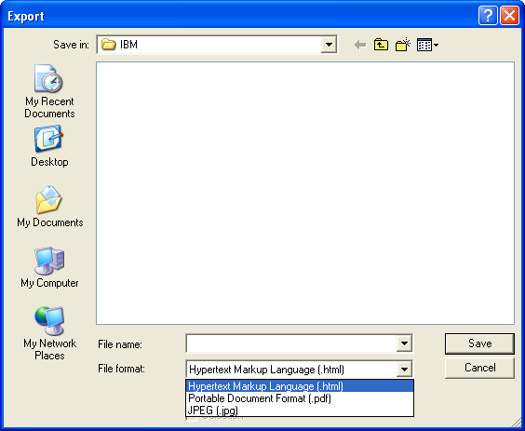
Figure 1-5: Export options

Activity 1-1: Get Started with Lotus Symphony Presentations

Data Files:
- wwcorp_3rdQT_presentation.odp

Scenario
Your manager has asked you to review the department’s standard screen show design and offer at least two suggestions on a new presentation design for the management team to consider. You decide that you need to examine a current presentation to determine what types of content are included, so that you can best determine how that content can be displayed in an engaging manner.

To complete this activity:
- Open wwcorp_3rdQT_presentation.odp in Lotus Symphony Presentations, and review the pages contained in the presentation.
- Create three test presentations based on the blue_light.otp, sketch.otp, and world_map_1.otp templates, and add sample text similar to that displayed in wwcorp_3rdQT_presentation.odp.
- Save the test presentations as my_test_bluelight.odp, my_test_sketch.odp, and my_test_worldmap.odp, respectively, and then close all open tabs.

Follow these steps to get started with Lotus Symphony Presentations.

Step | Action
Open wwcorp_3rdQT_presentation.odp, and review the presentation.
1 | On the desktop, double-click the IBM Lotus Symphony icon to start Lotus Symphony. On the toolbar, click the Open button, navigate to c:\lotus_ed\ Presentations, click wwcorp_3rdQT_presentation.odp., and click Open.
2 | Examine the left side of the screen. The Page Thumbnails list shows a small version of each page in the presentation. Use this list to view each page in the presentation, paying attention to the type of content that is included in the presentation. If you need to see a page more closely, click the thumbnail to show the page in the workspace.
Create three test presentations from templates, save the files, and close all open tabs.
3 | Next, you decide to create several test presentations from templates so that you can see how the department’s content would be displayed in them. Click File→New→From Template→Presentation. In the New from Template dialog box, click the blue_light.otp template from the Template list, and click OK.
4 | On page 1, click in the text box, and type Executive Report  Save the file as my_test_bluelight.odp
5 | For the next sample design, create a presentation based on the sketch.otp template, and include the content on the title page. Save this file as my_test_sketch.odp
6 | For the final sample design, create a presentation based on the world_map_1.otp template, and include the content on the title page. Save this file as my_test_worldmap.odp
7 | Close all of the open tabs.


Lesson Summary
In this lesson, you were introduced to Lotus Symphony Presentations. You examined the Lotus Symphony Presentations interface, and you described ways to create, open, and save presentations. These basic skills will help you to build all of your presentations.


Modifying Pages in IBM® Lotus® Symphony™ Presentations

- Topic A: Modifying Text
- Topic B: Working with Views
- Topic C: Working with Pages

Introduction
By creating effective presentations, you can engage your audience and keep their attention focused. By using the application’s tools, you will be able to quickly create dynamic formats customized for any situation, as well as develop templates for later use.

After completing this lesson, you should be able to:
- Modify text.
- Work with views.
- Work with pages.

Topic A: Modifying Text
By understanding how to enter text, you will be able to enter information quickly by either cutting and pasting or typing directly into text placeholders or boxes. Once you review the basic procedures, you will not have to waste time worrying about shifts in formatting or type fonts when you enter your text.

Adding Bullet and Numbered Lists
Using bullet and numbered lists on pages provides related information in an easily readable format. To add a bullet or numbered list to an existing page, click the drop-down arrow on the Bullets button on the toolbar, and click either Bullets or Numbering. To change the appearance of the bullets or numbers, click Layout→Bullets and Numbering.

Inserting Symbols or Special Characters
If you need to include symbols or special characters within a page’s text, you can click the Special Characters button on the toolbar, or you can click Create→Special Characters, to open the Special Characters dialog box. Scroll through the list of available characters, click the character you want to add, and then click OK, and the character will be included on the page.

Inserting a Text Box
Before you can add text to a page, you need to insert a text box on that page. To add a text box to a page, click the Text Box button on the toolbar, or click Create→Text Box. The mouse pointer changes shape, and you need to click and drag on the page where you want to place the text box. When you release the mouse button, the text box will be displayed on the page and you will be able to add text to it.

Applying Presentation Styles
IBM® Lotus® Symphony™ Presentations provides two types of styles: presentation styles and graphics styles. To view the Style List, click Layout→Style List. You can apply or modify these styles by selecting the style and clicking the appropriate button in the Style List.

The following figure shows the Style List with presentation styles displayed in hierarchical format.

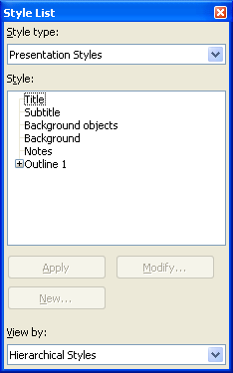
Figure 2-1: The Style List

Changing Text Properties
To change text properties, select the text that you want to affect, and specify the new properties in the Text Properties sidebar. Categories of text properties shown on the Properties sidebar include:
- Font
- Effects
- Position
- Paragraph

To view all of the text properties that you can adjust, click the All Text Properties button at the bottom of the Properties sidebar.

In addition, some toolbar buttons provide quick access to common formatting such as bold, italic, underline, increasing font size, and decreasing font size.

Dragging Text to a New Location
If you want to move the entire contents of a text box, select the text box by clicking anywhere within it, and then place the mouse pointer over the border until the pointer changes shape. Then, drag the text box to its new location on the page. To move text within a text box, select the text that you want to move, and then drag it to its new location within the text box.

Finding and Replacing Text
You can use the Edit→Find and Replace command to search for and replace text that needs to be changed throughout a presentation.

Topic B: Working with Views
IBM® Lotus® Symphony™ Presentations offers several view options to best enable you to review and present your content. Page view, Outline view, Page Sorter view, and Notes view all display your presentations in a slightly different manner without affecting the content within the presentation.

Page View
Page view is the default view in IBM® Lotus® Symphony™ Presentations. It displays one page in the workspace, and you have the option of showing all pages in the Page Thumbnails sidebar or displaying page tabs at the bottom of the workspace. The following graphic shows a presentation in Page view with page tabs displayed.

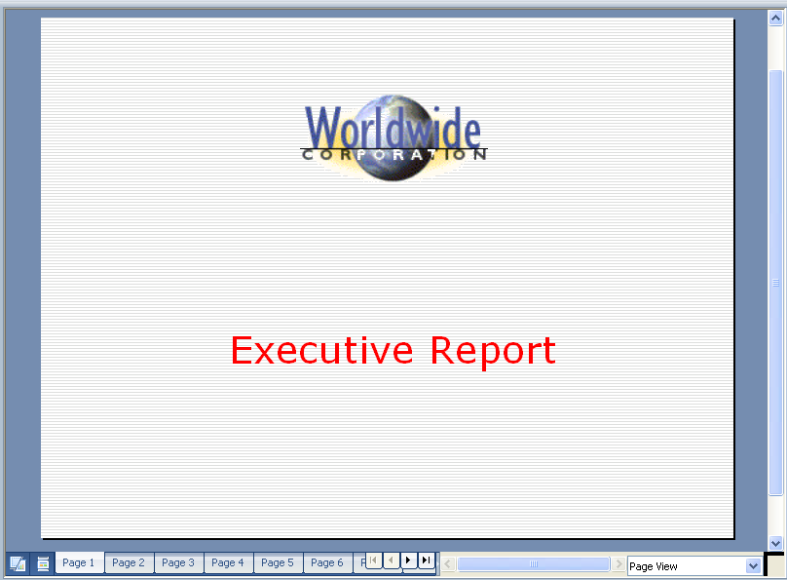
Figure 2-2: Page view with page tabs displayed

Outline View
Outline view displays pages in an outline format, showing the page titles and any text on the pages in the main workspace. This view can make it easier to rearrange the pages in your presentation or to change page titles. To display a presentation in Outline view, click View→Page→Outline View, or click Outline View in the view list at the bottom of the workspace. When you select a page in Outline view, the actual page layout is displayed in a Preview window.

The following figure shows a presentation in Outline view.

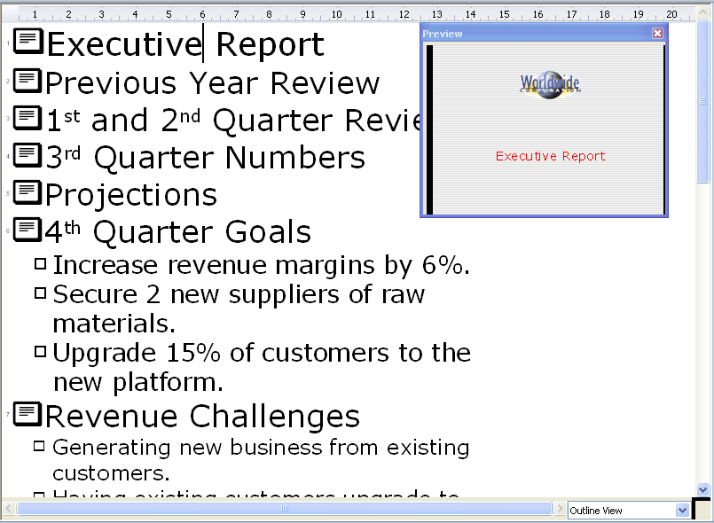
Figure 2-3: Outline view

Page Sorter View
Page Sorter view shows smaller versions of the pages in a presentation. Like in Outline view, you can easily rearrange pages in this view, and this view also features a Preview window. To display a presentation in Page Sorter view, click View→Page→Page Sorter View, or click Page Sorter View in the view list at the bottom of the workspace.

The following figure shows a presentation in Page Sorter view.

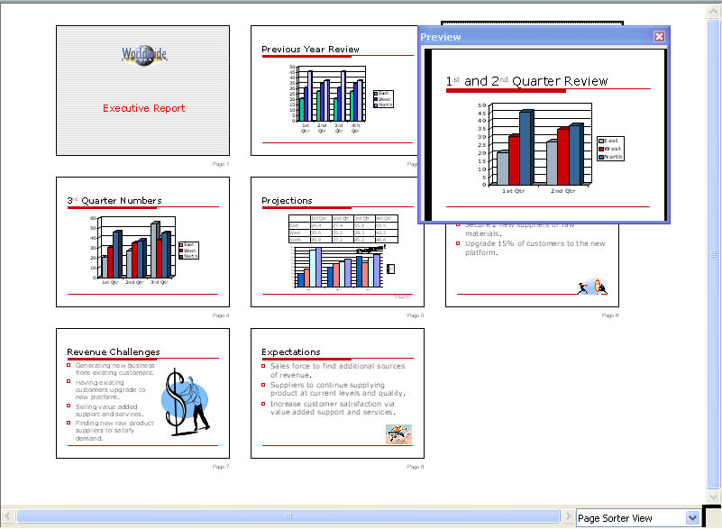
Figure 2-4: Page Sorter view

Notes View
If you want to include speaker notes in your presentation, you can switch to Notes view to add them. Speaker notes are not shown to the audience during a screen show. To display a presentation in Notes view, click View→Page→Notes View, or click Notes View in the view list at the bottom of the workspace.

The following figure displays a presentation in Notes view.

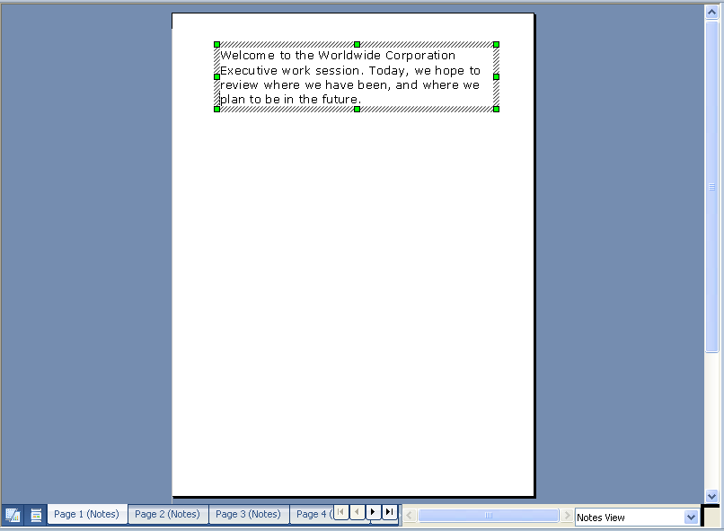
Figure 2-5: Notes view


Topic C: Working with Pages
Lotus® Symphony® Presentations™ offers several built-in page layouts to deliver visually effective presentations. Being able to add the appropriate page layout will enable you to create your presentations quickly because you can avoid trying to fit content into the wrong format.

Inserting a New Page
To create a new blank page, on the toolbar, click Create→Page, or, from the menu, click Create→New Page. If you are in Page view or Page Sorter view, you can also right-click and click Create Page in the context menu. The Create New Page dialog box enables you to specify the page name, select an instant layout, and select a master page design. The area below the master page list displays a preview of the selected instant layout. Click OK to add the new page to your presentation. To insert a page from another presentation, click Create→New Pages from File, browse for and open the file, select the pages to insert, specify the target position, and click either Insert or Insert All.

Duplicating an Existing Page
To create a duplicate page, click the Duplicate Page button on the toolbar, or click Create→Duplicate Page.

Reordering Pages
The procedure for rearranging page order depends on which view is active.
- In Page view and Notes view, if the Page Thumbnails sidebar is displayed, click the page you want to move, and drag it to its new location. If the page tabs are displayed, click the page tag of the page you want to move, and drag it to the intended destination.
- In Outline view, click the page title and click the Move Up one Level or Move Down one Level button on the toolbar until the page is in the intended destination.
- In Page Sorter view, select a page and drag it to its new location.

Deleting Pages
The procedure for removing pages from a presentation also depends on what view is active.
- In Page view, you can click Edit→Delete Page, or you can right-click a page, a page thumbnail, or a page tab, and click Delete Page from the context menu. Click Yes to confirm the deletion.
- In Page Sorter view, you can click Edit→Delete Page, or you can right-click a page and click Delete Page from the context menu. Click Yes to confirm the deletion.

Hiding Pages
To temporarily remove a page from a presentation, switch to Page Sorter view, right-click the page, and then click Show/Hide Page. The name of the hidden page changes to gray. To show the page, right-click the page, and then click Show/Hide Page again.

The following figure shows a presentation with a hidden page.

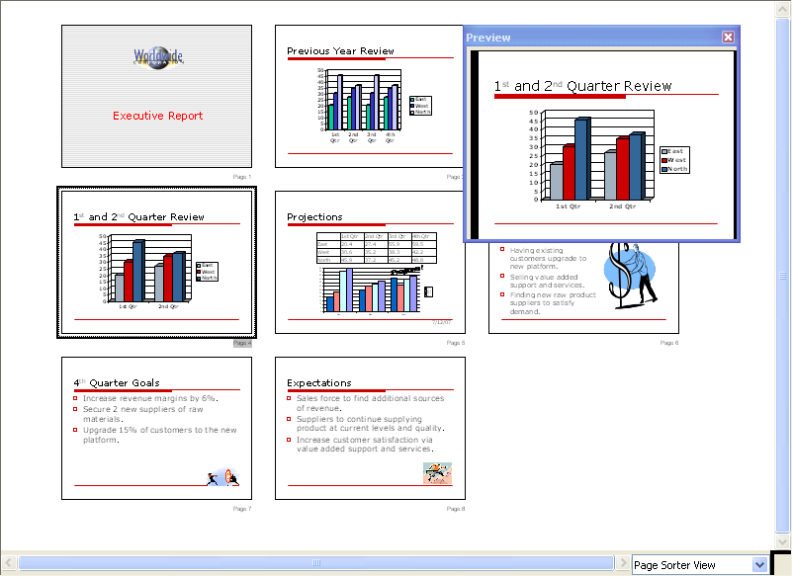
Figure 2-6: Hiding pages in a presentation

Activity 2-1: Modify Pages in LSP

Data Files:
- wwcorp_3QT_presentation.odp
- wwcorp_std.odp

Scenario
The management team at WWCorp has recently decided to use a new visual standard for its screen shows. Your manager has asked that you use the new wwcorp_std.otp file to revise the third quarter presentation for the Executive Board.

To complete this activity:
- Open wwcorp_std.otp and save it as my_exec_pres.odp
- Add pages that contain text boxes and bullet lists.
- Revise text properties and the location of text on a page.
- Change the order of the pages in the presentation, hide a page, and delete a page.

Follow these steps to modify pages in Lotus Symphony Presentations.

Step | Action
1 | Click File→Open→File,and navigate to c:\lotus_ed\Presentations. Click wwcorp_std.otp, and click Open. Save the file as my_exec_pres.odp so that your changes will not affect the standard file.
2 | At the bottom of the workspace, click the drop-down arrow next to Page View, and click Page Sorter View. Click the last page in the presentation, right-click, and click Create Page. In the Create New Page dialog box, under Select an instant layout, click the blank page, and click OK.
3 | Use the View drop-down list to switch to Outline View. Type Revenue Challenges to add a title to the page.
4 | Click the Duplicate Page button to create another page. Select the text Revenue Challenges, and type 4th Quarter Goals  Return to the Revenue Challenges page, and view the page in the Page View.
5 | On the toolbar, click the Text Box button to create a text box below the dividing line. Then, click the Bullets button to create a bullet list within the text box. Press the Tab key, and then type Generating new business from existing customers. and press Enter. Type Having existing customers upgrade to new platform. and press Enter.
6 | The wwcorp_3QT_presentation.odp file has some text that you want to include. Open that file, and click page 6. Click in the text box that contains the bullet list, and drag to select the last two bullet items. On the toolbar, click the Copy button, and switch back to my_exec_pres. Click the Paste button.
7 | The text you pasted in does not look the same as the text that you added. To make the text appearance consistent, select the pasted text, and on the Text Properties sidebar, change Font to Times New Roman, change Size to 24, and change Font color to white. Click the Save button to save your work.
8 | Switch to Page Sorter view. Pages 3 and 4 are out of order. Click page 3 and drag it between page 4 and page 5.
9 | Switch to Outline view, and select page 7. Type 4th Quarter Goals and then press Enter to create another page.
10 | You decide that although the Revenue Challenges information needs to be in the presentation, it does not need to be discussed at the first meeting at which you will show this presentation. Switch to Page Sorter view, and on the toolbar, click the Show/Hide Page button.
11 | The blank page at the end of the presentation is not needed at this time. Click it and then click Edit→Delete Page, and then click Yes to confirm the deletion. Save the file and close any open tabs.

Lesson Summary
In this lesson, you modified pages by editing text, working with views, and working with pages. The ability to modify your pages will help you create accurate presentations that you can use as a basis for other presentations that you want to create in the future.


Delivering an IBM® Lotus® Symphony™ Presentations Screen Show

- Topic A: Finalizing a Presentation
- Topic B: Delivering a Screen Show

Introduction
By preparing your pages for presentation, you will be able to establish your professionalism and credibility. By ensuring that your presentation unfolds correctly and presents information flawlessly, you can concentrate on making a stellar impression.

After completing this lesson, you should be able to:
- Finalize a presentation.
- Deliver a screen show

Topic A: Finalizing a Presentation
Spending time pulling together the delivery aspect of your presentation will allow you to seamlessly present it.

Page Transitions
Page transitions are visual effects that you can apply to the pages in your presentation to add visual interest to your presentations. Transition effects include the following:
- No effect
- Cross-fading
- Fly in
- Uncover
- Fade
- Open/close
- Wavy line
- Spiral
- Roll
- Build up
- Other

Some effects have additional options associated with them, such as the direction the effect appears to travel on the page. The Page Transition dialog box includes a Preview button that you can use to test the effectiveness of the transition that you have selected. The following graphic shows the Page Transition dialog box with the Preview window open.

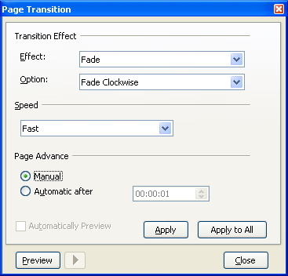
Figure 3-1: The Page Transition dialog box and Preview window

Animating Page Transitions
Follow these steps to specify page transitions.
- If necessary, switch to Page view, Page Sorter view, or Notes view.
- Select the page that you want to affect.
- Click Presentation→Page Transition.
- For Effect, click an effect in the drop-down list.
- If necessary, for Option, click an option in the drop-down list.
- To specify the speed of the transition effect, click an option in the Speed drop-down list.
- If you want to have the page advance automatically, select Automatic after, and then specify an automatic trigger delay time.
- If you always want to preview the transition effects that you apply, select the Automatically Preview check box.
- If the Automatically Preview check box is not selected and you want to preview a transition effect, click the Preview button, and then click the Play button. The Preview window displays the transition effect for the current page.
- If you want to apply the selected transition effect to the current page, click Apply. If you want to use the same transition effect throughout the entire presentation, click Apply to All.
- When you have completed your work with page transitions, click Close.

Creating Notes Pages
Notes pages provide a place for you to record information that you want to explain as you are presenting your screen show. To create notes pages, switch to Notes view, and type the text on the page.

Checking Spelling
To ensure that your presentations have a professional appearance, you should verify that all text in the presentation is spelled correctly. Lotus Symphony Presentations provides a Spellcheck button on the toolbar that you can use to check the spelling on the pages in your presentation. You can also access the Spellcheck tool by clicking Tools→Spell Check.

Topic B: Delivering a Screen Show
Having a hard copy of the presentation will help you to quickly refer to a previous page, rather than switching between the pages during the presentation. Providing hard copies of the presentation to the audience will allow them to refer to the content you are presenting, provides a place to record their notes, and allows them to concentrate more directly on your speech.

Running a Screen Show
Running a screen show enables you to display your pages to the intended audience. To run a screen show, you can click the Screen Show button on the toolbar, you can right-click the workspace and click Play Screen Show, or you can click Presentation→Play Screen Show. You can also run a partial screen show by right-clicking a page and clicking Play from Current Page or by clicking Presentation→Play from Current Page.

When the screen show is displayed, you can use the following techniques to
move through the screen show:
- To move forward through the pages, click the mouse button or press the Enter key.
- To move backward through the pages, right-click the mouse button.
- To stop a screen show before the end of the pages, you can press the Backspace or Esc key.

Printing a Presentation
Printing your presentations provides you with a copy to refer to as you are presenting to your audience. In some instances, it will be helpful to provide printed copies of the presentation to your audience, as well. There are several options for printing:
- To print just the presentation pages, click the Print button on the toolbar, or click File→Print and then click OK.
- To print just the Notes pages, click File→Print, under View, click Options, select Notes, and click OK.
- To print the presentation in Outline view, click File→Print, click Options, under View, select Outline, and click OK.
- To print handouts, which show the presentation pages in a smaller format, click File→Print, click Options, under View, select Handouts, select how many pages you want to include per page, and click OK.

The Print Options dialog box also enables you to specify the color mode to
use during printing. Options include Default, Grayscale, and Black &
white.

Exporting a Presentation
IBM® Lotus® Symphony™ Presentations enables you to export your presentations to formats other than the default OpenDocument Presentation (.odp) format. Supported formats include HyperText Markup Language (HTML), Portable Document Format (PDF), and JPEG format. To export a presentation, click File→Export, specify the location to save the file, provide a file name, and then in the File format drop-down list, click the format for the exported file, and click Save.

Activity 3-1: Deliver a Lotus Symphony Presentations Screen Show

Data Files:
- final_exec_pres.odp

Scenario
You have completed adding content to the final_exec_pres.odp file and need to prepare it for delivery to the Executive Board.

To complete this activity:
- Open final_exec_pres.odp, add page transitions, and preview the transitions.
- Create a notes page, check the spelling in the presentation, and save the file as my_final_pres.odp
- Run the screen show, and export the presentation to a PDF file with the same file name.

Follow these steps to deliver a Lotus Symphony Presentations screen show.

Step | Action
1 | Open final_exec_pres.odp. Select page 2, and click Presentation→Page Transition. For Effect, click Cross-fading, and for Option, click Fade from Top Left. Click the Preview button, and then click the Play button to view the transition effect. Click Apply.
2 | Drag the Page Transition dialog box and Preview window to uncover the Page Thumbnails sidebar. Select page 3, and apply an Effect and Option of your choice, preview the effect, and then apply it. Continue in this manner until pages 2 through 7 have transition effects applied to them. Close the Preview window and the Page Transition dialog box.
3 | Select page 1, and switch to Notes view. Click in the text box below the page, and type Welcome to the Worldwide Corporation Executive work session. Today, we hope to review where we have been, and where we plan to be in the future.
4 | Switch back to Page view, and click the Spellcheck button. For Qtr, click Always Ignore. For markings, verify that margins is selected in the Suggestions list, and click Replace. Click OK to confirm the completion of the spelling check operation. Save the file as my_final_pres.odp  Note: If the Spellcheck button is not visible on the toolbar, expand the Main toolbar, or click Tools→Spellcheck.
5 | Click the Screen Show button, and click to advance through your presentation. When the presentation is complete, click File→Export, change File format to Portable Document Format (.pdf), and click Save. Close all open tabs.

Lesson Summary
In this lesson, you delivered a Lotus Symphony Presentations screen show. By finalizing the presentation, including applying page transitions, creating speaker notes, and checking the spelling of all text, you can ensure that your audiences are viewing interesting and accurate presentations. You also practiced the main delivery options for presentations, including playing a screen show and printing and exporting presentation files. These skills will enable you to present your ideas to others.

Follow-up
In this course, you used the basic features of Lotus Symphony Presentations. From examining the LSP interface to creating, opening, and saving presentations, you should have the foundational knowledge necessary to create and deliver effective presentations.

What’s Next?
After completing the Using IBM® Lotus® Symphony™ Presentations: Basics course, you may want to continue with the Using IBM® Lotus® Symphony™ Presentations: Beyond Basics and Using IBM® Lotus® Symphony™ Presentations: Power User courses.

Also available are the following courses:
- Using IBM® Lotus® Symphony™ Spreadsheets: Basics
- Using IBM® Lotus® Symphony™ Spreadsheets: Beyond Basics
- Using IBM® Lotus® Symphony™ Spreadsheets: Power User
- Using IBM® Lotus® Symphony™ Documents: Basics
- Using IBM® Lotus® Symphony™ Documents: Beyond Basics
- Using IBM® Lotus® Symphony™ Documents: Power User

Appendix 

Additional Resources
The following additional resources are available for more information on Lotus Symphony Presentations:
- Tour: http://symphony.lotus.com/idcontents/pdf/N8T50/start_n8t50.htm
- Demo: http://symphony.lotus.com/software/lotus/symphony/help.nsf/DemoForPresentations
- Tutorial: http://symphony.lotus.com/idcontents/tutorial/en/presentations_tutorial/start_presentations.htm
- Toolbar Reference Card: http://symphony.lotus.com/idcontents/refcard/en/n8r50_refcarddita-pdf-minimal.pdf
- Keyboard Reference Card: http://symphony.lotus.com/idcontents/refcard/en/n8r50_shortcutdita-pdf-minimal.pdf

As they are developed, other resources may be added to this location: http://symphony.lotus.com/software/lotus/symphony/help.nsf/home

Available Plug-Ins
Extend the value of Lotus Symphony with plug-ins from IBM, partners, and developers. A complete list of all available plug-ins can be found here: http://symphony.lotus.com/software/lotus/symphony/plugin.nsf/home

