Using IBM® Lotus® Symphony™ Presentations: Beyond Basics
Student Guide

Using IBM® Lotus® Symphony™ Presentations: Beyond Basics
Part Number: Y1300
Course Edition: 1.0

Notices
DISCLAIMER: You may not copy, reproduce, translate, or reduce to any electronic medium or machine-readable form, in whole or in part, any documents, software, or files provided to you without prior written consent of IBM Corporation, except in the manner described in the documentation. While every reasonable precaution has been taken in the preparation of this manual, the author and publishers assume no responsibility for errors or omissions, nor for the uses made of the material contained herein and the decisions based on such use. Neither the author nor the publishers make any representations, warranties, or guarantees of any kind, either express or implied (including, without limitation, any warranties of merchantability, fitness for a particular purpose, or title). Neither the author nor the publishers shall be liable for any indirect, special, incidental, or consequential damages arising out of the use or inability to use the contents of this book, and each of their total liability for monetary damages shall not exceed the total amount paid to such party for this book.

TRADEMARK NOTICES The following terms are trademarks or service marks of International Business
Machines Corporation in the United States, other countries, or both: DB2®, Domino®, Domino® Designer,
Everyplace, ibm.com®, LearningSpace®, Lotus®, Lotus Enterprise Integrator®, Lotus Notes®, Lotus Workflow, Quickr™, Rational®, Sametime®, Symphony™, Tivoli®, VisualAge®, and WebSphere®.

Java and all Java-based trademarks and logos are trademarks of Sun Microsystems, Inc., in the United
States, other countries, or both.

Microsoft, Windows, Windows NT, and the Windows logo are trademarks of Microsoft Corporation in the
United States, other countries, or both.

Intel, Intel Inside (logos), MMX and Pentium are trademarks of Intel Corporation in the United States, other countries, or both.

UNIX is a registered trademark of The Open Group United States and other countries.

Linux is a trademark of Linus Torvalds in the United States, other countries, or both.

Copyright © 2008 IBM Corporation.
Lotus software, IBM Software Group, One Rogers Street, Cambridge, MA 02142

Under the copyright laws, neither the documentation nor the software may be copied, photocopied, reproduced, translated, or reduced to any electronic medium or machine-readable form, in whole or in part, without the prior written consent of IBM, except in the manner described in the documentation or the applicable licensing agreement governing the use of the software.

All rights reserved.

Licensed Materials - Property of IBM

U.S. Government Users Restricted Rights - Use, duplication, or disclosure restricted by GSAADP Schedule Contract with IBM Corporation.

You must purchase one copy of the appropriate kit for each student and each instructor. For all other education products you must acquire one copy for each user or you must acquire a license for each copy provided to a user.

Using IBM® Lotus® Symphony™ Presentations: Beyond Basics
Lesson 1: Formatting a Presentations 11
Introduction 12
Topic A: Formatting Pages 13
Specifying Page Properties 13
Applying Page Layouts 15
Changing Color Schemes 16
Adding Headers and Footers 17
Topic B: Using Templates 19
Importing a Template 19
Applying a Template 20
Saving a Presentation as a Template 21
Activity 1-1: Format a Presentation 22
Lesson Summary 23
Lesson 2: Adding Tables and Charts 25
Introduction 26
Topic A: Adding Tables 27
Creating a Table 27
Inserting and Deleting Rows and Columns 27
Changing Row Height and Column Width 28
Formatting Tables 30
Inserting a Chart 31
Editing Charts 32
Formatting Charts 33
Topic C: Working with Pages 34
Adding a Graphic from the Gallery 34
Adding a Graphic from a File 35
The Graphic Properties Sidebar 35
The Drawing Toolbar 36
Adding Shapes and Lines 36
Animating Text with Graphical Effects 37
Activity 2-1: Add Tables and Charts 39
Lesson Summary 41
Follow-up 42
What’s Next? 42
Additional Resources 43
Available Plug-Ins 43

About This Course
By using Lotus Symphony Presentations to create and deliver presentations, you will capture your audience’s attention and communicate your ideas more effectively. You will also clearly establish your authority and professionalism with a dynamic presentation style that makes full use of Lotus Symphony Presentation’s features.

Course Description
Target Student
This course is designed for IBM® Lotus® Symphony™ end users who will use these materials to learn the basic tasks associated with the Lotus Symphony Presentations editor.

Course Prerequisites
This course assumes that students have some experience with using presentation software.

How to Use This Book

As a Learning Guide
Each lesson covers one broad topic or set of related topics. Lessons are arranged in order of increasing proficiency with IBM Lotus Symphony Presentations; skills you practice in one lesson are used and developed in subsequent lessons. For this reason, you should work through the lessons in sequence.

Each lesson is organized into results-oriented topics. Topics include all the relevant and supporting information you need to master Lotus Symphony Presentations, and activities allow you to apply this information to practical hands-on examples.

As a Review Tool
Some of the information covered in class may not be relevant to your environment immediately, but it may become important later on. For this reason, we encourage you to spend some time reviewing the topics and activities after the course.

As a Reference
The organization and layout of the book make it easy to use as a learning tool and as an after-class reference. You can use this book as a first source for definitions of terms, background information on given topics, and summaries of procedures.

Course Objectives
After completing this course, you should be able to:
- Format a presentation.
- Add tables and charts to presentations.

Course Requirements

Hardware
This course assumes users will be using their personal computer to take this course. The following are the system requirements to support an installation of IBM® Lotus® Symphony™ 1.1:
- At least 750 MB of free disk space on Linux and at least 540 MB of free disk space on Microsoft® Windows®.
- At least 512 MB of memory.

Software
The following list identifies the software requirements for installing Lotus Symphony 1.1. Please note that proper licensing for all software is required and is the responsibility of the training organization.
- Microsoft® Windows® XP + SP2 or Microsoft® Windows Vista®
- IBM Lotus Symphony 1.1

Class Setup

Course Files
The following table describes the course files.
Title | File name | Description
Quarterly Report Beyond Basics | Quarterly Report_Beyond Basics.odp | Presentation file to be used in the activities in this course.

Course Setup Tasks
Complete the tasks in the following table to set up the course prior to the
start of class. Detailed procedures for each task appear on the following
pages.

Task | Procedure
1 | Uninstall any previously installed version of IBM Lotus Symphony.
2 | Install Lotus Symphony 1.1.
3 | Install the course data files.

Task 1: Uninstall Previous Versions of IBM Lotus Symphony
If you currently have an earlier version of Lotus Symphony installed, you will need to uninstall it prior to installing Lotus Symphony 1.1. Follow these steps to uninstall any previously installed versions of Lotus Symphony.

Step | Action
1 | Verify that Lotus Symphony is closed
2 | Click Start→Control Panel→Add or Remove Programs.
3 | In the Add or Remove Programs dialog box, click IBM Lotus Symphony  and then click Remove.  Note: It may take a few minutes for the program to uninstall.

Task 2: Install Lotus Symphony 1.1
If you have not yet installed Lotus Symphony 1.1, you will need to do so before taking this course. Follow these steps to install Lotus Symphony 1.1.

Step | Action
1 | In a Web browser, go to http://symphony.lotus.com/software/lotus/symphony/home.nsf/home and click Download to download the Lotus Symphony 1.1 installation files. A new window opens and lists the IBM Lotus Symphony installation types. Click the version for the Windows operating system. In the next window, the product information is displayed. Select a language and click Continue. Select I agree after viewing the licensing information, and then click I confirm.
2 | In the Download using Download Director dialog box, select Lotus Symphony Setup for Windows, and click Download now.
3 | After the files have finished downloading, click Launch in the Download Director.
4 | The Installation Wizard for IBM Lotus Symphony is displayed. On the Welcome to IBM Lotus Symphony 1.1 page, click Next.
5 | On the Software License Agreement page, select I accept the terms in the license agreement, and click Next.
6 | On the next page, leave the default install location or browse to and select a custom location, and then click Next.
7 | On the File Type Associations page, verify that the Open Document Format file types and OpenOffice.org 1.1 file types are selected by default. Click Next.
8 | On the next page, click Install.
9 | On the IBM Lotus Symphony Install Complete page, verify that Open Lotus Symphony is selected, and then click Finish.

Task 3: Install the Course Data Files
Data files for students to use during the course activities are provided and installed as part of course setup. Follow these steps to install the course data files.

Step | Action
1 | Open the Y1300labfiles.zip file and run the Y1300labfiles.exe self-extracting file. This executable will create the \lotus_ed\ folder and install sub-folders named \Documents, \Spreadsheets, and \Presentations.  Note: These course files apply to all Lotus Symphony training modules, so you will only need to install these files once.

Course Icons
The following table explains the icons used in this course.

Step | Action
 | An activity is a student-centered learning process that allows students to learn by performing a task. Activities can be instructor-led or completed independently.
 | Scenario information is used to introduce an activity problem or goal. Scenarios use fictitious people and organizations to present details, problem statements, and parameters that are used to complete the activity or lab exercise.
 | Caution statements are included in the courseware to make students aware of potential negative consequences of an action, setting, or decision, that are not easily known.
 | Tips and notes provide additional information, guidance, or a hint about a topic or task.
 | An Instructor Note is a special comment to the instructor regarding delivery, classroom strategy, classroom tools, exceptions, and other special considerations. The Instructor Note is included in the Instructor Guide only.
 | A Display Slide provides a prompt to the instructor to display a specific slide. The Display Slide icon is included in the Instructor Guide only.


Formatting a Presentations

- Topic A: Formatting Pages
- Topic B: Using Templates

Introduction
You must consider your audience when planning the delivery of your presentation. You can have live audiences who are present as you deliver the presentation, remote audiences who view a presentation that you send them, or self-service audiences who view the presentation from a kiosk at an exhibit. With the tools provided in Lotus® Symphony® Presentations™, you can build and deliver a presentation that suits your intended audience.

After completing this lesson, you should be able to:
- Describe how to add headers and footers.
- Describe how to save a presentation as a template.


Topic A: Formatting Pages
Consider a magazine page that does not have a defined layout for positioning
content and images. This could result in a page that lacks readability
due to poor presentation of content. For a presentation to be effective, it is
essential that it has a well-planned layout. Using only built-in layouts may
not always suit individual presentation styles or requirements. IBM® Lotus®
Symphony™ Presentations provides you with the ability to create and save
reusable page layouts to meet your specific needs.

Specifying Page Properties
A page in a presentation can be edited and customized by accessing the Page Properties dialog box. To access the Page Properties dialog box right, right-click an unoccupied area of the page and click Page Properties. You can also access it on the Page Properties sidebar by clicking View→Properties Sidebar→Open, and then the More Page Properties button at the bottom of the sidebar. Once you are in the Page Properties dialog box, click the Page tab to set your page’s orientation, format, size, margins, and numbering options. The following figure shows the Page Properties dialog box.

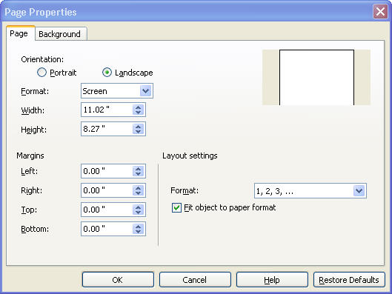
Figure 1-1: The Page Properties dialog box
You can set a specific color, gradient, design, or texture for the page’s background. To edit the background, click the Background tab in the Page Properties dialog box. The following figure shows the Background tab.

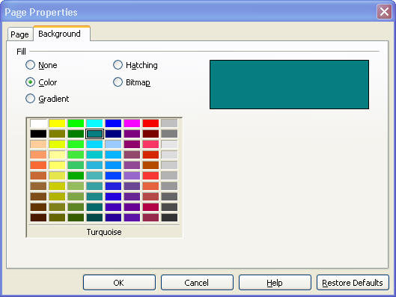
Figure 1-2: The Background tab of the Page Properties dialog box

Applying Page Layouts
You can format your pages with a specific layout to make it easier to work on your presentation. You can choose a blank layout, or you can select an instant layout that can be a combination of title, text, graphics, and charts. To access thePage Layout dialog box, right-click the page and click Page Layout, or click Layout→Page Layout. The following figure shows the Page Layout dialog box.

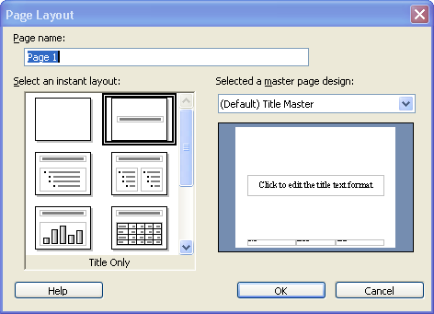
Figure 1-3: The Page Layout dialog box

Changing Color Schemes
You can customize your pages with a specific color or scheme of colors, textures, hatch patterns, bitmap patterns, or even images. To change the properties of your page’s background, click Layout→Background Fill. The following figure shows the Background Fill dialog box.

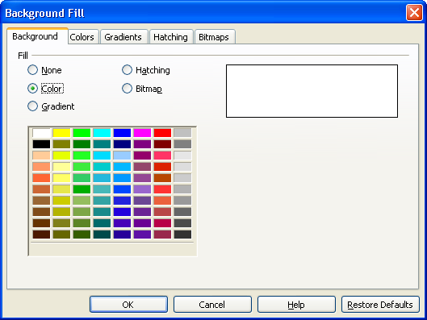
Figure 1-4: The Background Fill dialog box

Adding Headers and Footers
Headers and footers help you keep your presentation organized by adding graphics, text, page numbers, or dates to all of your pages. A header will add the information on the top of the page, while a footer will show the information on the bottom of the page. To add headers and footers to your presentations, click Create→Headers and Footers. You can set the preferences for the headers and footers on the Page tab of the Header and Footer dialog box. The following figure shows the Page tab of the Header and Footer dialog box.

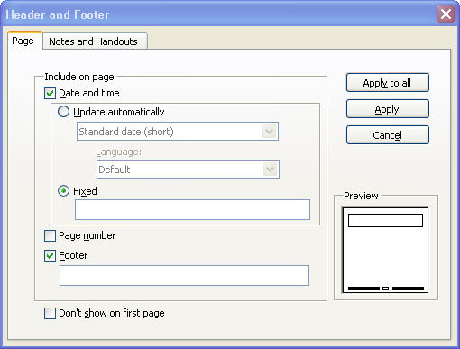
Figure 1-5: The Page tab of the Header and Footer dialog box

You can also create headers or footers for your notes and handouts by clicking the Notes and Handouts tab in the dialog box. The following figure shows the Notes and Handouts tab.

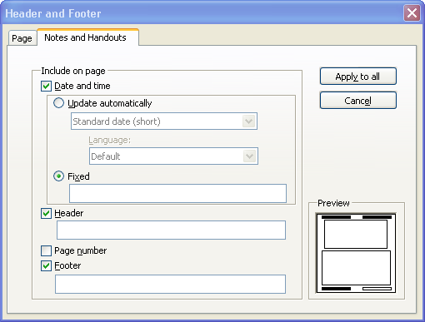
Figure 1-6: The Notes and Handouts tab of the Header and Footer dialog box


Topic B: Using Templates
IBM® Lotus® Symphony™ Presentations offers many default template options and also allows you to import or create templates, enabling you to add unique style to your presentation.

Importing a Template
A template is a document with a defined layout and properties that can facilitate the creation of a presentation. Lotus Symphony Presentations has many default templates available for your use; you can also import a page design and use it as a template on your pages. To import a template, click File→Template Organizer→Launch. Then, in the Template Organizer dialog box, click the Actions button, and click Import a Template. Browse for the desire template and click OK. The following figure shows the Template Organizer dialog box.

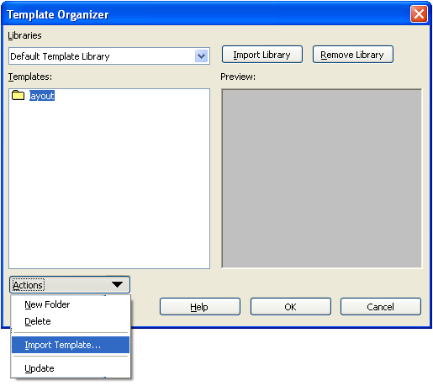
Figure 1-7: The Template Organizer dialog box

Applying a Template
After you have found the template you want to use for your presentation, you need to apply it to your pages. Follow these steps to apply a template.

To apply a template:
- Click File→Template Organizer→Launch.
- In the Template Organizer dialog box, click the library where your template is stored in the Libraries drop-down menu.
- Click the template in the Templates list.
- Click OK.

The following figure shows the Template Organizer dialog box.

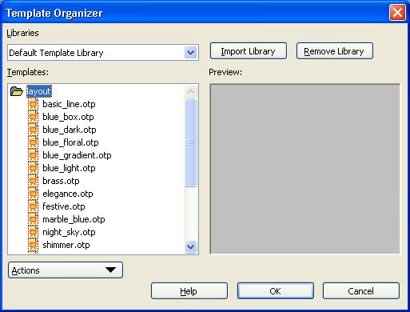
Figure 1-8: The Template Organizer dialog box, with the Default Template Library displayed

Saving a Presentation as a Template
You can save presentations that you have customized as templates so you can use them in the future. Follow these steps to save a presentation as a template.
- Click File→Template Organizer→Save File to.
- Select the library where you want your template saved.
- Give your new template a name.
- Click Save.

The following figure shows the Save file to dialog box.

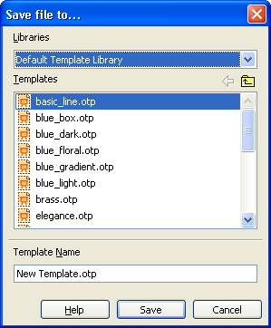
Figure 1-9: The Save file to dialog box

Activity 1-1: Format a Presentation

Data Files:
- Quarterly Report.odp

Scenario
You have been asked to finish a presentation that one of your coworkers at Worldwide Corporation has started. The presentation is a quarterly executive report, and it needs some formatting. To complete your assignment, you need to open the document in its current state and add formatting to the pages, add headers, change the color scheme, apply a template, and then save the presentation as a template.

To complete this activity:
- Open the Quarterly Report.odt file.
- Change the background color on the first page to Marble.
- Change the layout of a page.
- Add headers and footers.
- Save the current presentation as a template.

Follow these steps to format the presentation.

Step | Action
1 | Double-click the IBM Lotus Symphony icon on the desktop.
2 | On the Home – IBM Lotus Symphony page, click File→Open→File.
3 | In the Open dialog box, navigate to the directory where the Quarterly Report.odt file is stored. Click the file and then click Open.
4 | On the Page Properties sidebar, click the More Page Properties button. Click the Background tab, and then click Bitmap. Click the Marble style and click OK. In the Page Settings dialog box, click No to apply the background to the first page only.
5 | Navigate to page 7. Click Layout→Page Layout. Replace the current layout with the Title, Text layout. Click OK. Delete the image on the page by clicking it and pressing the Delete key on your keyboard.
6 | Navigate to page 1. Click Create→Header and Footer. Add the footer Executive Report and the page numbers to all pages except the first one. Click Apply to all.
7 | Click Create→Header and Footer. Click the Notes and Handouts tab, add the header: Executive Report, and click Apply to All.
8 | Click File→Template Organizer→Save File To. Name the template Executive Report Template.otp and click Save.


Lesson Summary
In this lesson, you imported and created templates, and explored the formatting options available in page properties. Understanding the formatting options allows you to create unique and attractive presentations.


Adding Tables and Charts

- Topic A: Adding Tables
- Topic B: Adding Charts
- Topic C: Adding Graphics and Shapes

Introduction
Some information lends itself to being presented in a structured way, and not presenting it in such a fashion may have a negative impact on the clarity of that information. Presenting data in the form of a bulleted list or in a paragraph often affects the clarity of the information, and the audience might not understand what you are trying to convey. Using a table or chart to present this type of data can effectively bring out the relationships among the data.

After completing this lesson, you should be able to:
- Describe how to format tables.
- Describe how to format charts.
- Describe how to animate text with graphical effects.

Topic A: Adding Tables
Your audience will struggle to comprehend your presentation if you try to present complex data through text alone. By using tables, you can clearly display information and allow your audience to immediately grasp its meaning, particularly when you need to compare results.

Creating a Table
Tables will help you organize and present numeric information in a clear and concise way. Follow these steps to create a table.

To create a table:
1. Click Table→Create Table.
2. In the new window, enter the number of columns and row you wish to have.
3. Click OK.

The following figure shows the Create Table dialog box.

Note: The maximum number of columns and rows that you can have in a table is
25.

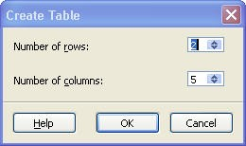
Figure 2-1: The Create Table dialog box

Inserting and Deleting Rows and Columns
Inserting and deleting rows and columns is a simple process. To insert a row, open the Table menu, and click Insert Rows Before or Insert Rows After. IBM® Lotus® Symphony™ Presentations will insert the row before or after the cursor position. When you are inserting columns, click Insert Columns Before or Insert Columns After in the Table menu.

If you want to delete a row or a column, open the Table menu and click Delete Selected Rows or Delete Selected Columns.
The following figure shows the Table menu.
Note: You can insert or delete more than one row or column by selecting two or more rows or columns before you select an insert or delete option from the Table menu.

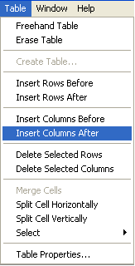
Figure 2-2: The Table menu

Changing Row Height and Column Width
To change the height and width of the rows and columns in a table, click Table→Table Properties, and enter the desired width and height on the Table tab. You can also name your table and choose a specific alignment for it. The following figure shows the Table Properties dialog box.
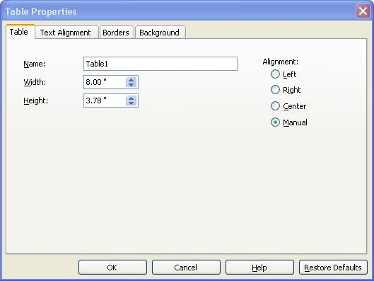
Figure 2-3: The Table Properties dialog box
Merging or Splitting Cells
You can select two or more adjacent cells and merge them into one cell. To
merge cells, select two or more cells, and click Table→Merge Cells. The
following figure shows the Table menu.

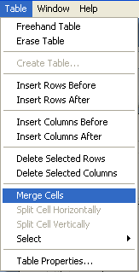
Figure 2-4: The Table menu

You can also split one large cell into multiple individual cells. To split cells, place the cursor in the cell you want to split, and click Table→Split Cell Horizontally or Split Cell Vertically. The following figure shows the Split Cell Vertically option.

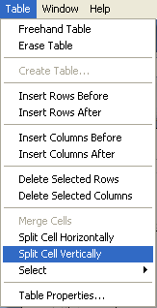
Figure 2-5: The Split Cell Vertically option

Formatting Tables
The Table Properties dialog box enables you to apply different types of formatting to a table such as borders, text alignment, and background color.

To format the table properties, follow these steps:
- Click the table. Click Table→Table Properties.
- In the Table Properties dialog box, click the Table tab.
- Customize your table’s name, width, height, and alignment.
- Click OK.

To format the text alignment, follow these steps:
- Click the table. Click Table→Table Properties.
- Click the Text Alignment tab.
- Modify alignment properties for the table, rows, or cells.
- Click OK.

To format borders, follow these steps:
- Click the table. Click Table→Table Properties.
- Click the Border tab.
- Modify the border’s properties such as the style, color, and spacing.
- Click OK.

To format the background, follow these steps:
- Click the table. Click Table→Table Properties.
- Click the Background tab.
- Select the desired background color for your table, cell, or row.
- Click OK.
Topic B: Adding Charts
Relationships between numerical data can be difficult to interpret. Adding charts to your presentation creates a visual relationship with that information. Charts can enhance your page text or make a point on their own.

Inserting a Chart
If you are presenting content that involves numbers and statistics, consider using a chart. Charts make your presentations easier to understand and follow, and they improve the appearance of your presentation. To insert a chart, click Create→Chart. When you release the mouse button, you will see a default chart on the page. The following figure shows a chart.

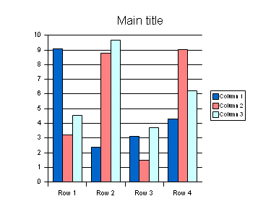
Figure 2-6: Default chart added to a page

Editing Charts
To edit a chart, select the chart you want to edit, and click Edit→Chart Data to open the Chart Data dialog box. The following table shows a list of all the options available in the Chart Data dialog box.

Option | Description
Apply to chart | Allows you to apply new settings to a chart.
Insert Row | Inserts new rows below the current row.
Insert Column | Inserts new columns after the current column.
Delete Row | Deletes current row.
Delete Column | Deletes current column.
Switch Column | Switches the current column with the column to the right.
Switch Row | Switches the current row with the row below.
Sort Columns | Sort cells in ascending order.
Sort Rows | Sorts rows in ascending order.
Sort by Columns | Sorts the table by columns.
Sort by Rows. | Sorts the table by rows.

The following figure shows the chart data.

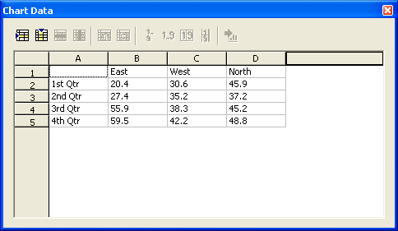
Figure 2-7: Chart data

Formatting Charts
You can customize charts by formatting them according to your needs. To format your chart, double-click it to select it, and then click Layout→Chart Area. The Chart Area dialog box enables you to format the width and color of the chart’s lines, the color of the area, and the transparency. You can also modify individual chart elements, such as axes, data labels, and legends, by right-clicking the chart, or with toolbar icons and menu commands. The following figure shows the Chart Area dialog box.

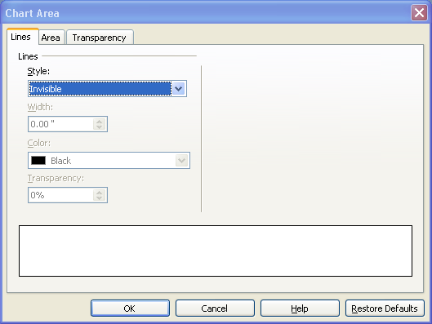
Figure 2-8: The Chart Area dialog box

Note: You can format the bars of your charts by changing their color or add texture. First, double-click the chart, and then double-click the bar you want to edit. In the Data Series dialog box, click Area, then select a color or texture for your bars.


Topic C: Working with Pages
By adding graphical objects, you can create a more engaging presentation. Graphical objects will illustrate difficult concepts and help your audience understand the text of your presentation. By emphasizing key points through graphical objects, you can help your audience to focus on the essential points of the presentation.

Adding a Graphic from the Gallery
You can add graphics to your presentations from the Gallery provided by IBM® Lotus® Symphony™. To open the Gallery, click Tools→Gallery. You can browse images by theme. Once you find the image you want to insert, click the image, and drag it onto your page. The following figure shows the Gallery.

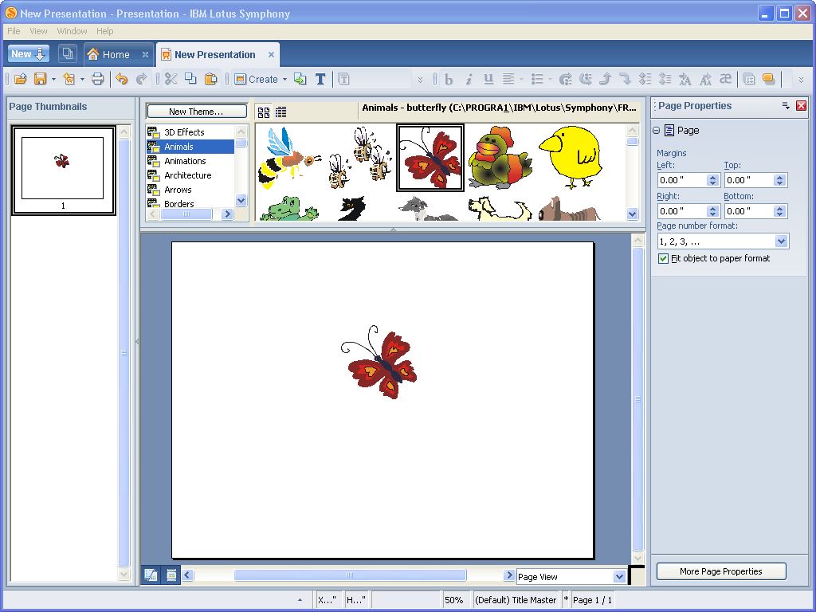
Figure 2-9: Adding graphics from the Gallery

Note: To hide the gallery window, click Tools→Gallery.

Adding a Graphic from a File
If you want to insert a graphic that is not part of the Gallery, you can do so by saving the image to your computer and clicking Create→Graphic from File. Browse to the file you want to insert, click the graphic, and click Open.

The Graphic Properties Sidebar
The Graphic Properties sidebar will help you to easily edit and format your graphics. You can open the Graphic Properties sidebar by clicking View→Properties Sidebar→Open. The Properties sidebar will open on the right side of your screen, allowing you to modify the size and position of your graphic; its color, rotation, or luminance; graphic mode; filters; and many other features. The following figure shows the Graphic Properties sidebar.

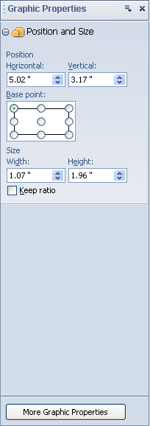
Figure 2-10: the Graphic Properties sidebar

The Drawing Toolbar
The Drawing toolbar allows you to insert shapes, lines, callouts, flow charts, connectors, arrows, fontwork, and text. To activate the Drawing toolbar, click View→Toolbar→Drawing. You will see the new toolbar appear in the upper section of your screen. The following figure shows the Drawing toolbar.

Figure 2-11: The Drawing toolbar

Note: To hide the Drawing toolbar, click View→Toolbar→Drawing.

Adding Shapes and Lines
You can add lines and shapes to your presentations. To add a line, just click the Line icon; the cursor changes into a cross-hair symbol with a line beside it. Click where you want the line to begin. Hold down the mouse button and drag it to the point where you want the line to end. You can draw horizontal, vertical, and diagonal lines by holding down the Shift key as you drag. Release the mouse button when you have finished drawing the line. In addition to straight lines, you can also create free form lines, polygons, 45-degree lines, curves, and dimension lines. The following graphic illustrates the line options.


Figure 2-12: Line options

To add a shape, click the Basic Shape icon, and click the shape you want to insert. The cursor changes to a cross-hair symbol. Start drawing the shape where you want it to be located and release the mouse button when the shape has reached the desired size and form. You can insert rectangles, rounded rectangles, triangles, trapezoids, ovals, diamonds, and many other basic shapes. The following figure illustrates the basic shape options.

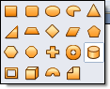
Figure 2-13: Basic shapes
To edit and format lines and shapes, right-click the object and click Shape Properties. The following graphics shows the Shape Properties dialog box.

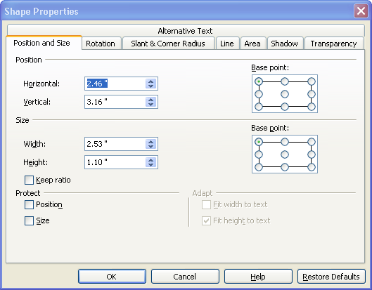
Figure 2-14: The Shape Properties dialog box

Animating Text with Graphical Effects
Adding the right amount and types of animated text and graphics will make your presentations attractive and professional looking. Follow these steps to apply preset animation effects, to objects or graphics.
- Select the object you want to animate and click Presentation→Animation Effects. The Order of Animation Effect window will open.
- Click New.
- In the Animation Effects dialog box, select the type of effect you want to apply, as well as the speed.
- Click OK.
Click the Options tab to set additional features such as starting point, delay, repeat, and trigger form, among others. The following graphic shows the Animation Effects dialog box.

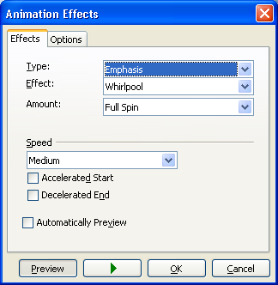
Figure 2-15: The Animation Effects dialog box

Activity 2-1: Add Tables and Charts

Data Files:
- Quarterly Report_Beyond Basics.odp

Scenario
To complete the Quarterly Report, you will need to add a page with future projections. The page will include a table and a chart. You will also need to add a graphic and animations to your presentation.

To complete this activity:
- Add future projections using a table and a chart.
- Add a graphic.
- Animate your presentation.

Follow these steps to add a table and chart to your presentation.

Step | Action
1 | In the Quarterly Report_Beyond Basics presentation, navigate to page 4. Click Create→New Page. Select the Title, Table layout and click OK.
2 | Click the Title text box, and type Projections
3 | Double-click the table icon in the middle of the page. Create a table with four rows and five columns. In the Properties sidebar, click the All Table Properties button. In the Table Properties dialog box, on the Table tab, change the Width to 6.30” and the Height to 1” and click OK. Click your table and drag just below the title in the middle of the page.
4 | In the first row of the table, in the second cell, type 1st Qtr  In the third cell type 2nd Qtr  In the fourth cell, type 3rd Qtr  In the fifth cell, type 4th Qtr
5 | In the second row of the table, in the first cell type East  in the second cell, type 20.4  In the third cell type 27.4  In the fourth cell, type 55.9  In the fifth cell, type 59.5
6 | In the third row of the table, in the first cell type West  in the second cell, type 30.6  In the third cell type 35.2  In the fourth cell, type 38.3  In the fifth cell, type 42.2
7 | In the fourth row of the table, in the first cell type North  in the second cell, type 45.9  In the third cell type 37.2  In the fourth cell, type 45.2  In the fifth cell, type 48.8  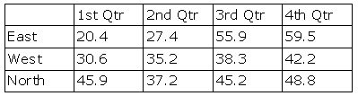
8 | Click the title text box and type Projections
9 | Click Create→New Page, select the Title, Chart layout, and click OK.
10 | Double-click the Chart icon on the page. Right-click the chart and click Chart Data.  In the first row, in column B, type East  In the first row, in column C, type West  In the first row, in column D, type North
11 | In the second row, in column A, type 1st Qtr  In the second row, in column B, type 20.4  In the second row, in column C, type 30.6  In the second row, in column D, type 45.9
12 | In the third row, in column A, type 2nd Qtr  In the third row, in column B, type 27.4  In the third row, in column C, type 35.2  In the third row, in column D, type 37.2
13 | In the fourth row, in column A, type 3rd Qtr  In the fourth row, in column B, type 55.9  In the fourth row, in column C, type 38.3  In the fourth row, in column D, type 45.2
14 | In the fifth row, in column A, type 4th Qtr  In the fifth row, in column B, type 59.5  In the fifth row, in column C, type 42.2  In the fifth row, in column D, type 48.8
15 | Close the Chart Data dialog box, and then in the IBM Lotus Symphony message box, click Yes. Double-click the Main Title text box and type Projections for Next Year
16 | Click the chart to select it, right-click it, and click OLE Object Properties. Click the Position and Size tab and adjust the Horizontal position to 1.95” and the Vertical position to 3.94”. Also, specify the Width as 6.15” and the Height as 2.66”. Click OK.
17 | On the Drawing toolbar, click the Fontwork icon. Type Progress! And click OK. In the Fontwork dialog box, click the Gallery tab, and then click fontwork 4. Click the Options tab, and change the color to red.  Note: If the Drawing Toolbar is not visible, click View→Toolbar→Drawing.
18 | Click the fontwork to select it, right-click it, and then click Shape Properties. On the Position and size tab, change the Horizontal position to 7.12” and the Vertical position to 3.72”. Also change the Width to 1.83” and the Height to .94”. Click OK.
19 | Click the fontwork, and then click Presentation→Animation Effects. Click New. Under Type, click Entrance. The Effect should be Peek In and the Direction should be From Left. Specify medium speed for the animation.
20 | In the Animation Effects dialog box, click the Options tab. Click On Mouse Click and click OK.

Lesson Summary
In this lesson, you added and formatted tables and charts in a presentation.
You enhanced a presentation by adding in a graphic. Using these tools will
help you create dynamic presentations that will relay information to the audience
in an attractive and effective way.

Follow-up
In this course, you customized Lotus Symphony Presentations by using templates, formatting pages, and changing page properties. You applied colors, created tables and charts, and added graphics to a presentation. Utilizing these tools, you can create dynamic presentations that will capture the attention of your audience and effectively deliver your information.

What’s Next?
After completing the Using IBM® Lotus® Symphony™ Presentations: Beyond Basics course, you may want to continue with the Using IBM® Lotus® Symphony ™ Presentations: Power User courses.

Also available are the following courses:
- Using IBM® Lotus® Symphony™ Presentations: Basics
- Using IBM® Lotus® Symphony™ Spreadsheets: Basics
- Using IBM® Lotus® Symphony™ Spreadsheets: Beyond Basics
- Using IBM® Lotus® Symphony™ Spreadsheets: Power User
- Using IBM® Lotus® Symphony™ Documents: Basics
- Using IBM® Lotus® Symphony™ Documents: Beyond Basics
- Using IBM® Lotus® Symphony™ Documents: Power User

Finally, information about the Lotus Symphony product is available at the Lotus Symphony Web site, which is at http://symphony.lotus.com/software/lotus/symphony/home.nsf/home
Appendix 

Additional Resources
The following additional resources are available for more information on Lotus Symphony Presentations:
- Tour: http://symphony.lotus.com/idcontents/pdf/N8T50/start_n8t50.htm
- Demo: http://symphony.lotus.com/software/lotus/symphony/help.nsf/DemoForPresentations
- Tutorial: http://symphony.lotus.com/idcontents/tutorial/en/presentations_tutorial/start_presentations.htm
- Toolbar Reference Card: http://symphony.lotus.com/idcontents/refcard/en/n8r50_refcarddita-pdf-minimal.pdf
- Keyboard Reference Card: http://symphony.lotus.com/idcontents/refcard/en/n8r50_shortcutdita-pdf-minimal.pdf

As they are developed, other resources may be added to this location: http://symphony.lotus.com/software/lotus/symphony/help.nsf/home

Available Plug-Ins
Extend the value of Lotus Symphony with plug-ins from IBM, partners, and developers. A complete list of all available plug-ins can be found here: http://symphony.lotus.com/software/lotus/symphony/plugin.nsf/home

