Using IBM® Lotus® Symphony™ Spreadsheets: Beyond Basics
Student Guide

Using IBM® Lotus® Symphony™ Spreadsheets: Beyond Basics
Part Number: Y1300
Course Edition: 1.0

Notices
DISCLAIMER: You may not copy, reproduce, translate, or reduce to any electronic medium or machine-readable form, in whole or in part, any documents, software, or files provided to you without prior written consent of IBM Corporation, except in the manner described in the documentation. While every reasonable precaution has been taken in the preparation of this manual, the author and publishers assume no responsibility for errors or omissions, nor for the uses made of the material contained herein and the decisions based on such use. Neither the author nor the publishers make any representations, warranties, or guarantees of any kind, either express or implied (including, without limitation, any warranties of merchantability, fitness for a particular purpose, or title). Neither the author nor the publishers shall be liable for any indirect, special, incidental, or consequential damages arising out of the use or inability to use the contents of this book, and each of their total liability for monetary damages shall not exceed the total amount paid to such party for this book.

TRADEMARK NOTICES The following terms are trademarks or service marks of International Business
Machines Corporation in the United States, other countries, or both: DB2®, Domino®, Domino® Designer,
Everyplace, ibm.com®, LearningSpace®, Lotus®, Lotus Enterprise Integrator®, Lotus Notes®, Lotus Workflow, Quickr™, Rational®, Sametime®, Symphony™, Tivoli®, VisualAge®, and WebSphere®.

Java and all Java-based trademarks and logos are trademarks of Sun Microsystems, Inc., in the United
States, other countries, or both.

Microsoft, Windows, Windows NT, and the Windows logo are trademarks of Microsoft Corporation in the
United States, other countries, or both.

Intel, Intel Inside (logos), MMX and Pentium are trademarks of Intel Corporation in the United States, other countries, or both.

UNIX is a registered trademark of The Open Group United States and other countries.

Linux is a trademark of Linus Torvalds in the United States, other countries, or both.

Copyright © 2008 IBM Corporation.
Lotus software, IBM Software Group, One Rogers Street, Cambridge, MA 02142

Under the copyright laws, neither the documentation nor the software may be copied, photocopied, reproduced, translated, or reduced to any electronic medium or machine-readable form, in whole or in part, without the prior written consent of IBM, except in the manner described in the documentation or the applicable licensing agreement governing the use of the software.

All rights reserved.

Licensed Materials - Property of IBM

U.S. Government Users Restricted Rights - Use, duplication, or disclosure restricted by GSAADP Schedule Contract with IBM Corporation.

You must purchase one copy of the appropriate kit for each student and each instructor. For all other education products you must acquire one copy for each user or you must acquire a license for each copy provided to a user.

Using IBM® Lotus® Symphony™ Spreadsheets: Beyond Basics
Lesson 1: Formatting and Protecting IBM® Lotus® Symphony Spreadsheets 10
Introduction 11
Topic A: Formatting Pages 12
Page Style 12
Page Borders 14
Headers and Footers 16
Freezing Rows or Columns as Headers 17
Topic B: Formatting Sheets 18
Creating Sheets 18
Renaming Sheets 19
Copying or Moving Sheets 19
Deleting Sheets 20
Navigating Through Sheet Tabs 21
Rotating Sheet Columns and Rows 22
Topic C: Adding Content to A Spreadsheet 24
The Instant Corrections Property 24
Protecting Sheets and Cells 25
Activity 1-1: Format and Protect Lotus Symphony Spreadsheets 26
Lesson Summary 29
Lesson 2: Adding Content and Visual Elements 30
Introduction 31
Topic A: Adding Tables 32
Calculating with Dates and Times 32
Calculating Time Differences 34
Entering Fractions 34
Entering a Number with Leading Zeros 34
Applying Sort Lists 35
Applying Filters 36
Entering Matrix Formulas 36
Creating a Chart 38
Formatting Charts 41
Modifying a Chart’s Display 42
Using a Lotus Symphony Spreadsheet Chart in a Lotus Symphony Document 42
Topic C: Adding Graphics and Shapes 43
Adding a Graphic from the Gallery 43
Adding a Graphic from a File 43
The Graphic Properties Sidebar 44
The Drawing Toolbar 44
Activity 2-1: Add Content And Visual Elements 46
Lesson Summary 49
Follow-up 50
What’s Next? 50
Additional Resources 52
Available Plug-Ins 52

About This Course
A spreadsheet should be easy to interpret and visually appealing. Formatting a spreadsheet will improve its aesthetic appeal and help avoid data cluttering. By applying format options, you can visually differentiate one set of data from another, making it easier to locate and analyze information.

Course Description
Target Student
This course is designed for IBM® Lotus® Symphony™ end users who will use these materials to learn the basic tasks associated with the Lotus Symphony Spreadsheet editor.

Course Prerequisites
This course assumes that students have some experience with using spreadsheet software.

How to Use This Book

As a Learning Guide
Each lesson covers one broad topic or set of related topics. Lessons are arranged in order of increasing proficiency with IBM Lotus Symphony Spreadsheets; skills you practice in one lesson are used and developed in subsequent lessons. For this reason, you should work through the lessons in sequence.

Each lesson is organized into results-oriented topics. Topics include all the relevant and supporting information you need to master Lotus Symphony Spreadsheets, and activities allow you to apply this information to practical hands-on examples.

As a Review Tool
Some of the information covered in class may not be relevant to your environment immediately, but it may become important later on. For this reason, we encourage you to spend some time reviewing the topics and activities after the course.

As a Reference
The organization and layout of the book make it easy to use as a learning tool and as an after-class reference. You can use this book as a first source for definitions of terms, background information on given topics, and summaries of procedures.

Course Objectives
After completing this course, you should be able to:
- Format and protect Lotus Symphony Spreadsheets files.
- Add content and visual elements to spreadsheets.

Course Requirements

Hardware
This course assumes users will be using their personal computer to take this course. The following are the system requirements to support an installation of IBM® Lotus® Symphony™ 1.1:
- At least 750 MB of free disk space on Linux and at least 540 MB of free disk space on Microsoft® Windows®.
- At least 512 MB of memory.

Software
The following list identifies the software requirements for installing Lotus Symphony 1.1. Please note that proper licensing for all software is required and is the responsibility of the training organization.
- Microsoft® Windows® XP + SP2 or Microsoft® Windows Vista®
- IBM Lotus Symphony 1.1

Class Setup

Course Files
The following table describes the course files.
Title | File name | Description
Top Sales Report | TopSalesReport.ods | Spreadsheet file to be used in lesson 1 activity.
Top Sales Report | TopSalesReport – BeyondL2.ods | Spreadsheet file to be used in lesson 2 activity.
WWCorp logo | wwcorplogo.png | Spreadsheet file to be used in lesson 2 activity.

Course Setup Tasks
Complete the tasks in the following table to set up the course prior to the
start of class. Detailed procedures for each task appear on the following
pages.

Task | Procedure
1 | Uninstall any previously installed version of IBM Lotus Symphony.
2 | Install Lotus Symphony 1.1.
3 | Install the course data files.

Task 1: Uninstall Previous Versions of IBM Lotus Symphony
If you currently have an earlier version of Lotus Symphony installed, you will need to uninstall it prior to installing Lotus Symphony 1.1. Follow these steps to uninstall any previously installed versions of Lotus Symphony.

Step | Action
1 | Verify that Lotus Symphony is closed
2 | Click Start→Control Panel→Add or Remove Programs.
3 | In the Add or Remove Programs dialog box, click IBM Lotus Symphony  and then click Remove.  Note: It may take a few minutes for the program to uninstall.

Task 2: Install Lotus Symphony 1.1
If you have not yet installed Lotus Symphony 1.1, you will need to do so before taking this course. Follow these steps to install Lotus Symphony 1.1.

Step | Action
1 | In a Web browser, go to http://symphony.lotus.com/software/lotus/symphony/home.nsf/home and click Download to download the Lotus Symphony 1.1 installation files. A new window opens and lists the IBM Lotus Symphony installation types. Click the version for the Windows operating system. In the next window, the product information is displayed. Select a language and click Continue. Select I agree after viewing the licensing information, and then click I confirm.
2 | In the Download using Download Director dialog box, select Lotus Symphony Setup for Windows, and click Download now.
3 | After the files have finished downloading, click Launch in the Download Director.
4 | The Installation Wizard for IBM Lotus Symphony is displayed. On the Welcome to IBM Lotus Symphony 1.1 page, click Next.
5 | On the Software License Agreement page, select I accept the terms in the license agreement, and click Next.
6 | On the next page, leave the default install location or browse to and select a custom location, and then click Next.
7 | On the File Type Associations page, verify that the Open Document Format file types and OpenOffice.org 1.1 file types are selected by default. Click Next.
8 | On the next page, click Install.
9 | On the IBM Lotus Symphony Install Complete page, verify that Open Lotus Symphony is selected, and then click Finish.

Task 3: Install the Course Data Files
Data files for students to use during the course activities are provided and installed as part of course setup. Follow these steps to install the course data files.

Step | Action
1 | Open the Y1300labfiles.zip file and run the Y1300labfiles.exe self-extracting file. This executable will create the \lotus_ed\ folder and install sub-folders named \Documents, \Spreadsheets, and \Presentations.  Note: These course files apply to all Lotus Symphony training modules, so you will only need to install these files once.

Course Icons
The following table explains the icons used in this course.

Step | Action
 | An activity is a student-centered learning process that allows students to learn by performing a task. Activities can be instructor-led or completed independently.
 | Scenario information is used to introduce an activity problem or goal. Scenarios use fictitious people and organizations to present details, problem statements, and parameters that are used to complete the activity or lab exercise.
 | Caution statements are included in the courseware to make students aware of potential negative consequences of an action, setting, or decision, that are not easily known.
 | Tips and notes provide additional information, guidance, or a hint about a topic or task.
 | An Instructor Note is a special comment to the instructor regarding delivery, classroom strategy, classroom tools, exceptions, and other special considerations. The Instructor Note is included in the Instructor Guide only.
 | A Display Slide provides a prompt to the instructor to display a specific slide. The Display Slide icon is included in the Instructor Guide only.


Formatting and Protecting IBM® Lotus® Symphony™ Spreadsheets

- Topic A: Specifying Page Formatting
- Topic B: Formatting Sheets
- Topic C: Protecting Cells and Sheets

Introduction
IBM® Lotus® Symphony™ Spreadsheets has many tools available that allow you to uniquely format your spreadsheet and enhance its visual appeal.

After completing this lesson, you should be able to:
- Specify page formatting.
- Format sheets.
- Protect sheets and cells.


Topic A: Formatting Pages
In order to attract the attention of readers, magazines use attractive colors and styles to present articles and their title pages. Similarly, applying page formatting will enhance your spreadsheets by heightening their visual appeal, making them very attractive and interesting.

Page Style
A style is a named collection of appearance settings that can be applied to cells or pages in a spreadsheet. Using a style can be quicker than applying individual formatting options, and it can ensure consistency of formatting throughout a document. A style may include text formatting options such as different typefaces, colors, and effects, as well as cell formatting options such as line spacing, borders, and shading. You can use built-in styles, modify existing styles, or create your own custom styles. To access this function, click Layout→Style list. In the Style List dialog box, click a Style type in the drop-down list, and then select from the available styles in the Style list. There are several default styles available, or you can create a
new style with custom preferences.

The following figure shows the Style List dialog box.

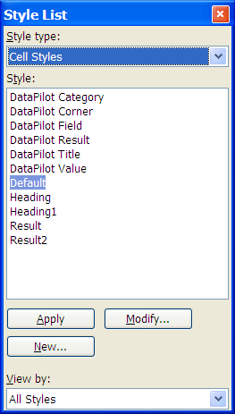
Figure 1-1: The Style List dialog box
To create a new style, click New. The Style dialog box displays. You should first name the new style, so you can easily locate it for use later. The following figure shows the Style dialog box.

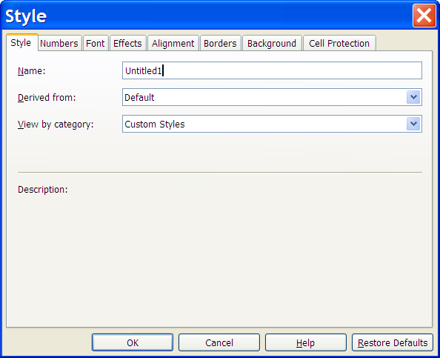
Figure 1-2: The Style dialog box

The Style dialog box contains multiple tabs, each containing different options you can configure to create your custom style:
- Numbers: Allows you to define the number format for the selected area or the current cell.
- Font: Allows you to define the font format for the select area or the current cell, including font type, size, style, and color.
- Effects: Allows you to define effects for text in a selected area or the current cell, including underlining style, strikethrough options, emphasis marks, and other style options.
- Alignment: Allows you to define alignment for a selected area or the current cell.
- Borders: Allows you to define border options for the selected area or the current cell.
- Background: Allows you to define a background color or graphic object.
- Cell Protection: Allows you to define cell protection for a selected area or the current cell.

Page Borders
To define border styles for the pages in a spreadsheet, click File→Page Setup and then click the Borders tab. Select one of the default border styles in the Default section. Select a line style and color for the selected border style in the Line section. These settings apply to all border lines that are included in the selected border style. Select the distance between the border lines and the page contents, the shadow position, and the shadow color in the Shadow style section. Click OK to apply your changes.

The following figure shows the Border options.

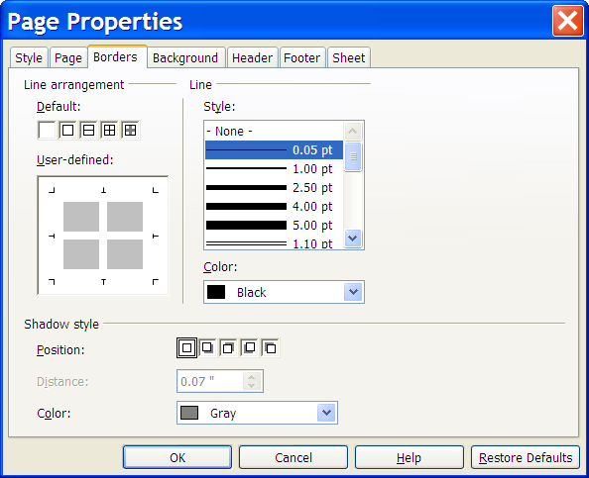
Figure 1-3: The Border options
Page Background
You can select a color or a graphic image to use in the background of each page of your spreadsheet. To access the background options, click File→Page Setup and then click the Background tab. To select a single color as the background, click Color in the Background type drop-down list. Then select a color as the background color or click No fill. Below the color areas, the name of the current background color is shown. Click OK to apply the currently highlighted color.

The following figure shows the Background color options.

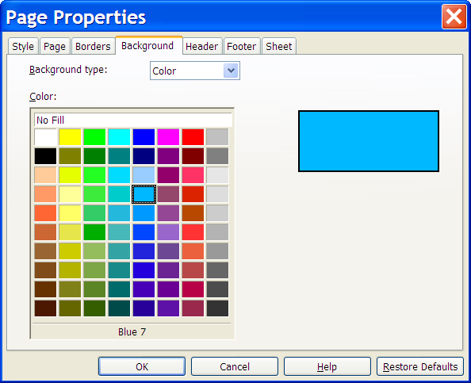
Figure 1-4: The Background color options

To select a graphic image as the background, click Graphic in the Background type drop-down list. Click Browse to open the Search Pattern dialog box, which allows you to navigate to and select a graphic image for use as a background. Click Link to specify that you want to link the selected image with your spreadsheet. If you select this option, the directory of the image will be displayed under the Link check box. Select Preview to see the image in the preview area before inserting it in the spreadsheet. Click Position to specify where to position the image on the page by clicking one of the circles in the position field to specify where to position the image on the page. Click Area to specify that the image is repeated and displays multiple copies of the image as a tile pattern background.
The following figure shows the Background graphic options.

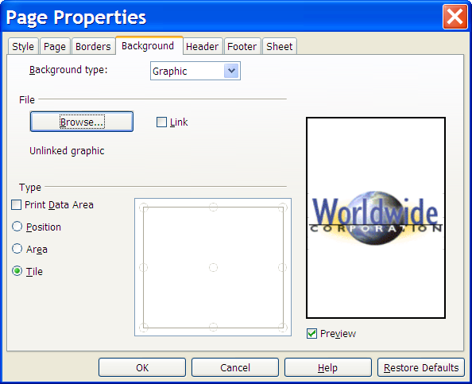
Figure 1-5: The Background graphic options

Headers and Footers
IBM® Lotus® Symphony™ provides you with options to create custom headers and footers. To access the header and footer options, click Create→Header and Footer to display the Header and Footer dialog box. There are separate tabs for Header and Footer, but each contain the same options. You can use the settings to insert page numbers, page count, sheet number, and text. You can also choose which area of the page to add header or footer content: left, center, or right. Headers and footers are added to the current page style. Any page that uses the same style automatically receives the header or footer that you add to the document.

Formatting headers and footers
You can define different headers and footers for left or right pages by using the Page Setup Properties. You can also apply direct formatting to the text in a header or footer, such as adding a separator line or a shadow as a border. You can adjust the spacing of the text relative to the header or footer frame. To add a border to the header or the footer, click the Borders tab within Page Properties. To add a separator line between the header or the footer and the content of the page, in the User-defined section, click where you wish the line to display. Click a line style in the Style area and select a color for the line. To add a shadow to the header or the footer, select the desired Shadow style options and click OK.

Freezing Rows or Columns as Headers
When you have a large spreadsheet that requires scrolling to view all the content, you can designate specific rows or columns to freeze, so that when you scroll down or to the right, those rows remain to help orient the viewer. To designate rows to freeze, select the row below the row you want to be in the frozen region, or to designate columns to freeze, select the column to the right of the row you want to be in the frozen region. To freeze both vertically and horizontally, select the cell that is below the row and to the right of the column that you want to freeze. After you have selected the correct location, click View→Freeze Window.


Topic B: Formatting Sheets
There may be times that you will need to incorporate multiple spreadsheets related to the same topic into a workbook. You might have more sheets that contain data. You might have individual sheets you need to rearrange. With the proper tools, you can create workbooks of varying sizes that allow you to collect information efficiently.

Creating Sheets
To insert new worksheets, you can click Create→Sheet, or you can right-click a sheet tab and click Insert Sheet. Either option will display the Create Sheet dialog box. In the Create Sheet dialog box, you can choose to insert the new sheet before or after the current sheet. In the Sheet section, you can select the number of sheets to insert and type a name for the sheet.

The following figure shows the Create Sheet dialog box.
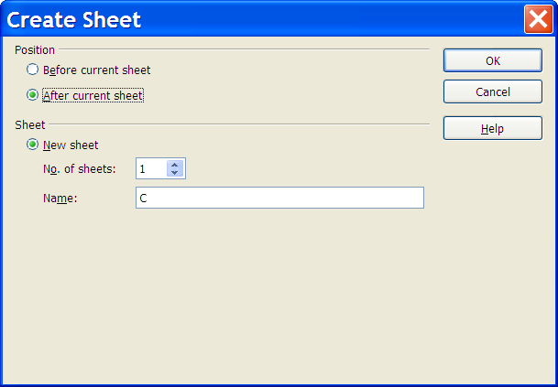
Figure 1-6: The Create Sheet dialog box

Renaming Sheets
IBM® Lotus® Symphony™ Spreadsheets allows you to rename sheets to more easily identify and organize your data in a workbook. The name of a sheet may consist of letters, numbers, and spaces. The name of a sheet is independent of the name of the spreadsheet. To rename a sheet, right-click the name tab of the sheet you wish to rename and click Re-label Sheet. The Re-label Sheet dialog box displays, where you can enter a new name. Enter a new name for the sheet and click OK. You can also press and hold the Alt key and click any sheet name to activate edit mode and type the new name.

The following figure shows examples of named sheets.

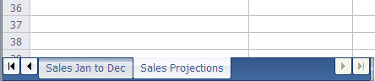
Figure 1-7: Examples of named sheets

Copying or Moving Sheets
Lotus Symphony Spreadsheets gives you several tools you can use to move or copy sheets within the same workbook or between workbooks. You can reposition sheets by using the Move/Copy Sheet dialog box or by manually dragging a sheet to its new location. To access the Move/Copy Sheet dialog box, click Edit→Sheet→Move/Copy, or right-click the sheet tab and click Move/Copy Sheet. In the Move/Copy Sheet dialog box, you select the document to which you want to copy the sheet. By default, the current document is listed. If you wish to copy to a new spreadsheet file, that file should be open in Lotus Symphony Spreadsheets in order to be listed in the To document drop-down list. The Insert before list box lists all sheets in the current document. Select the sheet name before which you want to copy the sheet, or select move to end position to move the sheet to last in the workbook.

The following figure shows the Move/Copy Sheet dialog box.

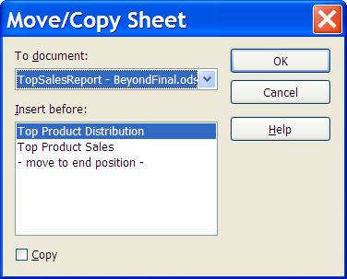
Figure 1-8: The Move/Copy Sheet dialog box

Deleting Sheets
To delete sheets with unwanted or obsolete data, you can use the Delete option that can be accessed by clicking Edit→Sheet→Delete. For the Delete option to be available, you must first select the sheet by clicking the appropriate sheet name tab. A warning message will display asking you to confirm your intention to delete the selected sheet. Click OK to continue deleting the sheet.

Note: You cannot delete a sheet if changes to the document are being recorded or if the Record Revisions option is active. To verify that changes are not being recorded, click Edit→Revisions→Record. An arrow next to Record indicates the option is enabled; select it to disable the Record option.

Navigating Through Sheet Tabs
The Spreadsheet Navigator is a handy stand-alone navigation tool that can be access by clicking Edit→Navigator or pressing Ctrl+Shift+F5. The Navigator contains the following options to help you easily locate content:
- Column: Type the column letter in the Column spin box . Press Enter to reposition the cell cursor to the specified column in the same row.
- Row: Type a row number in the Row spin box. Press Enter to reposition the cell cursor to the specified row in the same column.
- Data Range: Specifies the current data range denoted by the position of the cell cursor.
- Start: Moves to the cell at the beginning of the current data range, which you can highlight using the Data Range button.
- End: Moves to the cell at the end of the current data range, which you can highlight using the Data Range button.
- Form Navigator: Displays all forms and subforms in the current spreadsheet.
- Contents: Shows or hides the contents in the Navigator dialog box.
- Toggle: Toggles the content view. Only the selected Navigator element and its sub-elements are displayed. Click the icon again to restore all elements for viewing.
- What If: Displays all available scenarios. Double-click a name to apply that scenario. The result is shown in the sheet.
- Drag mode: Opens a submenu for selecting the drag mode. You can also select the drag mode through the context menu in the Navigator window. You decide which action is performed when dragging and dropping an object from the Navigator into a document. Depending on the mode you select, the icon indicates whether a hyperlink, a link, or a copy is created.

The following figure shows the Lotus Symphony Spreadsheets Navigator.

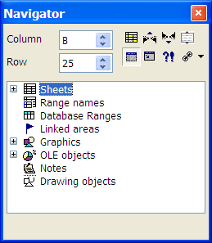
Figure 1-9: The Lotus Symphony Spreadsheets Navigator

Rotating Sheet Columns and Rows
Lotus Symphony Spreadsheets provides an option that transposes or rotates spreadsheet data so that the rows become columns and the columns become rows. To do this, select the cell range that you want to transpose, and click Edit→Cut. Then, click the cell that will be the top-left cell in the results of transposing the content. Click Edit→Paste Special. In the Paste Special dialog box, select Paste all and Transpose. Click OK to view the transposed columns and rows.

The following figure shows the Paste Special dialog box.

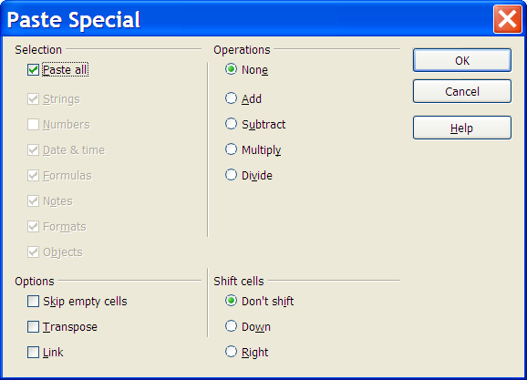
Figure 1-10: The Paste Special dialog box


Topic C: Adding Content to A Spreadsheet
You have a spreadsheet that other users in your organization need to read. However, you do not want anyone to alter the data or layout of the spreadsheet in any way. Before sharing the spreadsheet, you decide to protect it so the other users will have read-only access. Protecting files gives you the flexibility to share them while knowing that the data is secure.

The Instant Corrections Property
IBM® Lotus® Symphony™ provides an Instant Corrections property that automatically corrects many common typing errors and applies formatting while you type, such as replacing straight quotes with custom smart quotes or always beginning cell content with an uppercase letter (when it begins with a letter). You can immediately undo any instant corrections by pressing Ctrl+Z. To deactivate and reactivate the Instant Corrections properties, click Tools→Instant Corrections. The Instant Corrections dialog box provides four categories of options that must be individually selected or cleared:
- Replace: Lists text that should be replaced with different text, used to fix common typographical errors or add common symbols.
- Exceptions: Lists acceptable abbreviations that you do not want Lotus Symphony to indicate as misspelled words and lists words that contain two capital letters that should not be indicated as incorrect.
- Options: Lists various formatting options.
- Custom Quotes: Allows you to indicate the type of quotes you want used in your document.

Inserting non-breaking spaces
To prevent two words from being separated at the end of a line, press the Ctrl key when you type a space between the words.

Inserting non-breaking dashes
An example of a non-breaking dash is a company name such as A-Z. Obviously you would not want A- to appear at the end of a line and Z at the beginning of the next line. To solve this problem, press Shift+Ctrl+minus sign. In other words, hold down the Shift and Ctrl keys and press the minus key.

Inserting hyphens and dashes
In order to enter longer dashes, you can find under Tools→Instant Corrections→Options the Replace dashes option. This option replaces one or two minus signs under certain conditions with a long dash. For additional replacements, see the replacements table under Tools→Instant Corrections→Replace. Here you can, among other things, replace a shortcut automatically by a dash, even in another font.

Inserting definite separators
To support automatic hyphenation by entering a separator inside a word yourself, use the keys Ctrl+minus sign. The word is separated at this position when it is at the end of the line, even if automatic hyphenation for this paragraph is switched off.

Protecting Sheets and Cells
In IBM® Lotus® Symphony™ Spreadsheets, cell protection is activated for all cells as the default. However, it is only effective if you protect the sheet or the document. To protect the sheet or document, click Tools→Protect Document→Sheet. The Protect Sheet dialog box is displayed. Type and confirm a password, and then click OK to protect the sheet. It is extremely important to note that if you enter a password and then later forget it, you will have no way to deactivate the applied protection. If you merely want to protect the cells from inadvertent changes, it is better not to enter a password and just click OK to protect the sheet. To unprotect a sheet that has
been password protected, click Tools→Protect→Sheet and enter the password when prompted. If no password was designated and the field was left blank when protecting the sheet, then when you are prompted for a password, do not enter one and click OK.

If you have specific cells in the document that you do not want to protect, for example, cells in which the user is to make entries, then prior to protecting the sheet, you should select these cells and click Layout→Cell Protection. In the Cell Protection dialog box, clear the Protected check box.

The Cell Protection dialog box also contains the Hide formula option, which makes the formulas invisible and protects them from changes, and the Hide when printing option, which displays the protected cells on-screen, but not when printed.

Activity 1-1: Format and Protect Lotus Symphony Spreadsheets

Data Files:
- TopSalesReport.ods

Scenario
You have been asked to provide a report detailing the amount delivered for the company’s top four products in each of the manufacturing locations during the month of July. You have the relevant data already in your spreadsheet, and now you want to format the spreadsheet for projection and distribution at an upcoming meeting. After some thought, you realize that some people at the meeting may want more detailed sales figures to go with the distribution numbers for these products, so you decided to add a second sheet with this information.

To complete this activity:
- Format the sheet.
- Add a new sheet.
- Copy data to the new sheet.
- Enter and format data in the new sheet.
- Password protect the sheet data.

Follow these steps to format and protect your Lotus Symphony Spreadsheet

Step | Action
1 | Click File→Open→File. In the Open dialog box, browse to C:\lotus_ed\Spreadsheets and double-click the TopSalesReport.ods file to open it.
2 | Click File→Page Setup.
3 | On the Page tab, in the Orientation section, click Landscape. In the Margins section, for the Left, Right, Top and Bottom fields, type 1.0" and click OK.
4 | Click Create→Header and Footer. Verify that the Header tab is active.
5 | In the Left Area section, type Top Products - June Delivery
6 | Highlight the text you just typed, and click 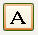.
7 | In the Text Attributes dialog box, on the Font tab, in the Size drop-down list, click 14. In the Style drop-down list, click Bold. In the Font color drop-down list, click Blue 6 and then click OK.
8 | Verify that the Center area and Right area sections contain no text.
9 | Click the Footer tab.
10 | Verify that the Center area section contains Page 1 and click OK.
11 | Select cells A1:E1 and in the Text and Cell Properties sidebar, in the Cell color drop-down list, click Blue 5. In the Font color drop-down list, click White.
12 | Click Create→Sheet.
13 | In the Create Sheet dialog box, select After current sheet.
14 | In the Sheet section, in the Name field, type Top Product Sales and click OK.
15 | Right-click the A sheet tab and click Re-label Sheet.  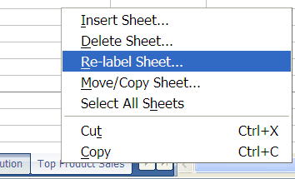
16 | In the Re-label Sheet dialog box, type Top Product Distribution and click OK.  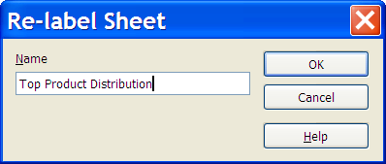
17 | Verify that the Top Product Distribution sheet is active.
18 | Highlight columns A, B, and C and click Edit→Copy.
19 | Click the Top Product Sales sheet tab.
20 | Highlight columns A, B, and C and click Edit→Paste.
21 | Click the Top Product Distribution sheet tab.
22 | Highlight column E and click Edit→Copy.
23 | Click the Top Product Sales sheet tab.
24 | Highlight column D and click Edit→Paste.
25 | In cell E1, type Unit Price
26 | In cell F1, type Total Sales
27 | Enter the following in the Unit Price column:  - E2: 90  - E3: 90  - E4: 90  - E5: 45  - E6: 45  - E7: 45  - E8: 50  - E9: 50  - E10: 50  - E11: 140  - E12: 140  - E13: 140
28 | Select cells E2:E13 and click Layout→Properties→Text and Cell Properties.
29 | Click the Numbers tab and in the Category list, click Currency.
30 | In the Format list, select the red text ($1,234.00) and click OK.
31 | Select cells F2:F13, and click Layout→Properties→Text and Cell Properties.
32 | On the Numbers tab, in the Category list, click Currency.
33 | In the Format list, select the red text ($1,234.00) and click OK.  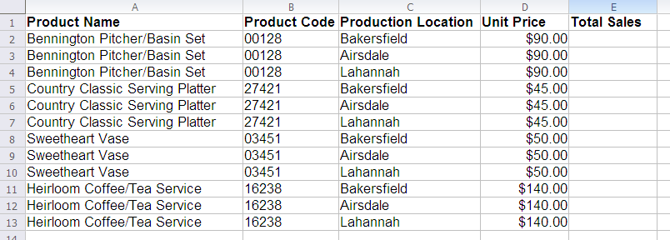
34 | Select cells A1:F1 and in the Text and Cell Properties sidebar, in the Cell color drop-down list, click Blue 5. In the Font color drop-down list, click White.
35 | Click the Top Product Distribution sheet tab.
36 | Click Tools→Protect Document→Sheet.
37 | In the Protect Sheet dialog box, in the Password field, type passw0rd where 0 is the numeral zero. Type the password again in the Confirm field. Click OK.
38 | Use the same password to protect the Top Product Sales sheet.
39 | Save the file, but do not close it. You will use it in the next lesson.


Lesson Summary
In this lesson, you specified page formatting, formatted sheets to enhance workbooks, and protected cell and sheet data. Using these tools allow you to uniquely format your spreadsheets and enhance their visual appeal.


Adding Content and Visual Elements

- Topic A: Entering Values and Formulas
- Topic B: Using Charts
- Topic C: Adding Graphics and Shapes

Introduction
Once you have organized data and structured it appropriately, you may still find it difficult to perform a detailed analysis, especially if the data is large and complex. IBM® Lotus® Symphony™ Spreadsheets resolves this by providing several features that allow you to present data in graphical and other logical forms. This assists you in efficiently making informed decisions.

After completing this lesson, you should be able to:
- Enter values and formulas.
- Use charts.
- Add graphics and shapes.

Topic A: Adding Tables
Manual calculation of values in spreadsheets can be cumbersome, time-consuming, and prone to errors. It is ideal to have an easier and quicker way of calculating values. In IBM® Lotus® Symphony™ Spreadsheets, you can create basic formulas to perform calculations on values in spreadsheets. Creating basic formulas will help you reduce the amount of time it takes to cull valuable information from the data you have entered into a worksheet.

Calculating with Dates and Times
A Date and Time function assigns a serial number to date and time data in order to use the data in a calculation. Although the data is converted to a serial number, it is displayed in the worksheet as text. Date and Time functions range from a function that enters the current date into a worksheet each time it is opened to a function that will calculate how much time has elapsed between a start time and an end time. Function syntax is the general form of the function that provides the structure for entering function arguments properly to return the desired results. The syntax shows the names of the arguments, the proper order of the arguments, and whether arguments are required or optional. The syntax varies from function to function. To complete a function, you enter specific arguments and values in place of the general syntax.

Date values
The following functions convert date values to calculable numbers and back.

Value | Syntax | Description
DateSerial Function [Runtime] | DateSerial (year, month, day) | Returns a date value for a specified year, month, or day.
DateValue Function [Runtime] | DateValue [(date)] | Returns a number from a date string. The date string is a complete date in a single numeric value. You can also use this serial number to determine the difference between two dates.
Day Function [Runtime] | Day (Number) | Returns a value that represents the day of the month based on a serial date number generated by DateSerial or DateValue.
Month Function [Runtime] | Month (Number) | Returns the month of a year from a serial date that is generated by the DateSerial or the DateValue function.
WeekDay Function [Runtime] | WeekDay (Number) | Returns the number corresponding to the weekday represented by a serial date number that is generated by the DateSerial or the DateValue function.
Year Function [Runtime] | Year (Number) | Returns the year from a serial date number that is generated by the DateSerial or the DateValue function.
CDateToIso Function [Runtime] | CDateToIso(Number) | Returns the date in ISO format from a serial date number that is generated by the DateSerial or the DateValue function.
CDateFromIso Function [Runtime] | CDateFromIso(String) | Returns the internal date number from a string that contains a date in ISO format.

Time values
The following functions convert time values to calculable numbers.

Value | Syntax | Description
Hour Function [Runtime] | Hour (Number) | Returns the hour from a time value that is generated by the TimeSerial or the TimeValue function.
Minute Function [Runtime] | Minute (Number) | Returns the minute of the hour that corresponds to the serial time value that is generated by the TimeSerial or the TimeValue function.
Second Function [Runtime] | Second (Number) | Returns an integer that represents the seconds of the serial time number that is generated by the TimeSerial or the TimeValue function.
TimeSerial Function [Runtime] | TimeSerial (hour,minute, second) | Calculates a serial time value for the specified hour, minute, and second parameters that are passed as numeric value. You can then use this value to calculate the difference between times.
TimeValue Function [Runtime] | TimeValue (Text As String) | Calculates a serial time value from the specified hour, minute, and second, parameters passed as strings that represents the time in a single numeric value. This value can be used to calculate the difference between times.

Calculating Time Differences
If you want to calculate time differences, use the following formula: =(B2<A2)+B2-A2. The later time is B2 and the earlier time is A2. In the formula, an entire 24-hour day has a value of 1 and one hour has a value of 1/24. The logical value in parentheses is 0 or 1, corresponding to 0 or 24 hours. The result returned by the formula is automatically issued in time format due to the sequence of the operands. For example, if you want to know the time difference between 22:45 and 3:20 in the same day, the applied formula would be =(3:20<22:45)+3:20-22:45 and result would be 4:35 or 4 hours and 35 minutes.

Entering Fractions
Fractional numbers can be entered in a cell and used for calculations. For example, if you enter 1/5 in a cell and press Enter, the Formula bar will display the value 0.2, but the cell will display 1/5. The 0.2 value is used for calculations.

For common fractions, such as 1/2, 1/4, and 3/4, the Instant Correct function will replace them with corresponding fraction symbols like 1⁄2. In order to disable this option, click Tools→Instant Corrections→Options tab, and clear the Replace 1/2 with 1⁄2 check box.

By default, multi-digit fractions will be converted to the most appropriate two-digit fraction. For example, 4/16 will be converted to 1/4. If you want to view multi-digit fractions, you must change the cell format to the multi-digit fraction view. Click Layout→Properties→Text and Cell Properties→Numbers tab. In the Category list, verify that Fraction is selected, and in the Format list, click -1234 10/81 and then click OK.

Entering a Number with Leading Zeros
By default, numbers that begin with zero will have the zero suppressed after you enter them in a cell. If you want to have the zeros display in your data, when you enter the number put an apostrophe before it. This will indicate that you want the number to be formatted as text. However, because you have entered the number as text, you cannot use the number in calculations. If you want to apply a numerical format to a column of numbers in text format, select the column currently configured to text number format. Click Layout→Properties→Text and Cell Properties→Numbers tab. In the Category list, verify that Fraction is selected and click OK. Click Edit→Find and Replace. In the Search for dialog box, type ^[0-9] and in the Replace with dialog box, type &. Select Regular expressions and Current selection only and then click Replace All.

Applying Sort Lists
Lotus Symphony Spreadsheets has a Sort List feature that allows you to type one piece of information in a cell, then drag it to fill in a consecutive list of items. For example, enter the text Sunday or Sun in an empty cell. Select the cell and click the mouse on the lower-right corner of the cell border. Then drag the selected cell a few cells to the right or downward. When you release the mouse button, the highlighted cells will be filled with the names of the weekdays. You can view the predefined series available for Sort Lists by clicking File→Preferences→IBM Lotus Symphony→Lotus Symphony Spreadsheets→Sort Lists. You can also create your own custom lists to include in this feature, such as list of your company’s office locations.

The following table shows a single-level sort in ascending order.

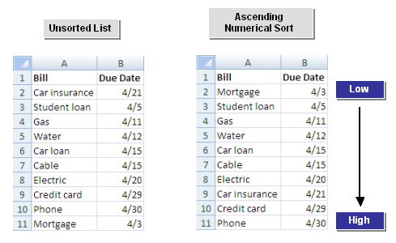
Figure 2-1: Single-level sort in ascending order

Applying Filters
Filters allow you to display only certain data that complies with your criteria. Lotus Symphony Spreadsheets includes three kinds of filters: instant filter, standard filter, and special filter. The instant filter filters the records based on the content of the currently selected data field. You can use the standard filter to connect up to three conditions with either a logical AND or a logical OR operator. The special filter exceeds the three condition limitation and allows up to a total of eight filter conditions. With special filters, you enter the conditions directly into the sheet. Each of the filters can be accessed by clicking Manipulate→Filter and selecting one of the filter options.

The following figure shows the Standard Filter dialog box.

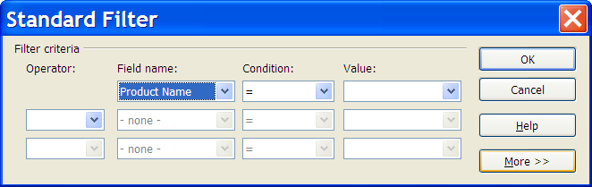
Figure 2-2: The Standard Filter dialog box

Entering Matrix Formulas
A Matrix formula uses matrix operations and returns a result that can be a matrix, a vector, or a scalar, depending on the computations involved. Whatever the result may be, an area on the spreadsheet of precisely the correct size must be selected before the formula is typed in (otherwise you will either lose some of the answer or get additional and possibly confusing information). The following example explains how to enter a Matrix formula in Lotus Symphony Spreadsheets. Assume you have entered 10 numbers in Columns A, B, and C (A1:A10, B1:B10, and C1:C10), and you would like to calculate the sum of each row in Column D. Using the mouse, select the range D1:D10. Then, in the Formula bar, type = and then select cells A1:A10, which contain the first values for the sum formula. In the Formula bar, at the end of the formula text, type + and then select cells B1:B10. In the Formula bar, at the end of the formula text, type + and then select cells C1:C10. Next, press Shift+Ctrl+Enter. The matrix area is automatically protected against modifications, such as deleting rows or columns; however, it is possible to edit any formatting, such as the cell background.
The following figure shows an example of a Matrix formula.

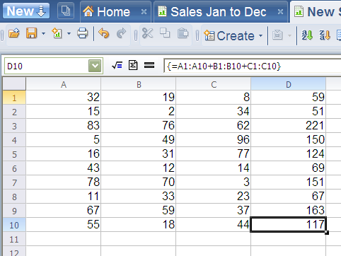
Figure 2-3: Example of a Matrix formula

Topic B: Using Charts
Sometimes, when you look at a large amount of data, the rows of numbers can seem endless. This complicated display of data makes it difficult to draw any meaningful conclusions. When you use a chart, however, you can consolidate data into a visual format that is easily understandable. By looking at the information graphically, you can quickly compare the data and assimilate information you would not have noticed otherwise.

Creating a Chart
A chart is a visual representation of data from source data in a spreadsheet or a table that displays the relationship between the different sections of the data. Each set of values that is represented in the chart is called a chart data series. Charts can include a chart title, a legend that explains what the different colors represent, a scale or values on the vertical axis, and a category on the horizontal axis. There are different chart types, such as pie, bar, and column charts. You can choose the chart type that best represents the data you want to display. A chart can be embedded as a graphic object on a worksheet page, or it can appear on a dedicated chart sheet that contains only the chart and associated chart tools and commands. When the chart is embedded in the same document as the data, it stays linked to the data, so that the chart automatically updates when you change the source data. To create a chart, click Create→Chart or click the icon on the main toolbar. Define the area of values that you want to include in your chart:
- Range: Enter the area of the table containing the data that you want to include in your chart. You can also drag to select the cell range.
- First row as caption: Uses the entries in the top row of the selection as labels for the data range.
- First column as caption: Uses the entries in the left column of the selection as labels for the data range.

The following figure shows the Chart Setup dialog box.

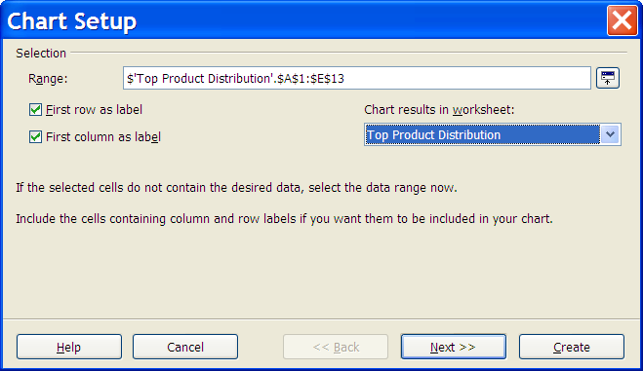
Figure 2-4: The Chart Setup dialog box

Then, click Next. The Chart Style dialog box is displayed. Here you select the chart type and the data series the chart should use: columns or rows. The following figure shows the first page of the Chart Style dialog box.

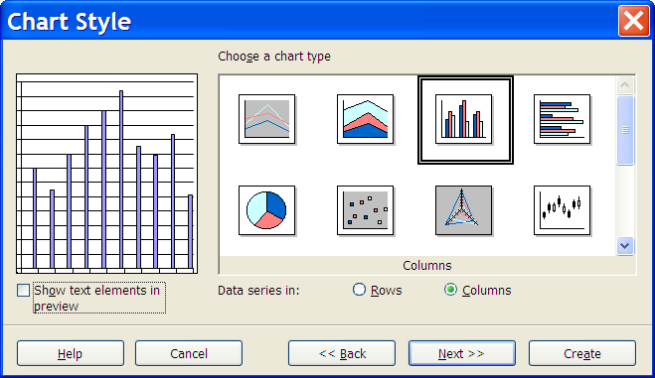
Figure 2-5: The Chart Style dialog box, page 1
Then, click Next. Next, choose a display variant for the type of chart you previously selected, and select Grid lines and Data series in options. The following figure shows the second page of the Chart Style dialog box.

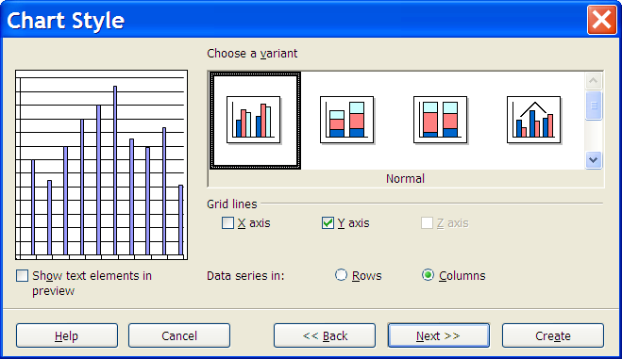
Figure 2-6: The Chart Style dialog box, page 2

Click Next. On this final screen, type a title for the chart and the axis. If you want a chart legend to display, select Legend. Click Create to create the chart. The following figure shows the third page of the Chart Style dialog box.

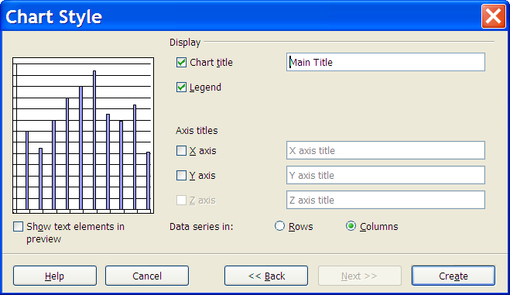
Figure 2-7: The Chart Style dialog box, page 3

Formatting Charts
After your chart is created, you can change the appearance of individual chart elements by using the Chart Area and Chart Wall dialog boxes. For example, you can change the color of chart columns or the chart background. The chart wall is the background behind the chart data, for example, the gridline area of a bar chart. The chart area is the background of the entire chart. To access the Chart Wall dialog box, double-click the chart data section of the chart, or click Layout→Chart Wall. To access the Chart Area dialog box, double-click the outer chart area, or click Layout→Chart Area. Both the Chart Area and Chart Wall dialog boxes provide the same options:
- Lines: Set the line formatting options for the selected area.
- Area: Set the fill options for the selected drawing object.
- Transparency: Set the transparency options for the fill that you apply to the selected object.

The following figure shows a formatted chart.

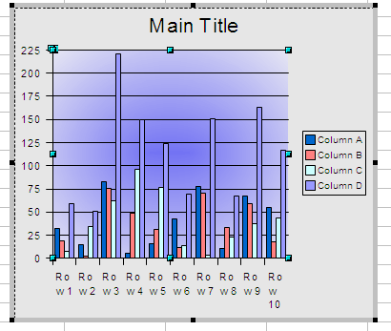
Figure 2-8: A formatted chart

Modifying a Chart’s Display
The Chart Object toolbar provides access to common chart commands.
The following table describes the commands.

Toolbar icon | Description
 | Title On/Off is used to show or hide the title and subtitle.
 | Legend On/Off is used to show or hide a legend.
 | AxesTitle On/Off is used to show or hide the axis labels.
 | Show/Hide Axis Descriptions switches the labeling of all axes on or off.
 | Horizontal Grid On/Off toggles the visibility of the grid display for the x-axis.
 | Vertical Grid On/Off toggles the visibility of the grid display for the y-axis.
 | Edit Chart Type displays the Chart Type dialog box and allows you to change the type of chart the data is displayed in.
 | Chart Style displays the Chart Style dialog box and allows you to change the style of the chart.
 | Chart Data displays the Chart Data dialog box, where you can edit the chart data.

Using a Lotus Symphony Spreadsheet Chart in a Lotus Symphony Document
You can insert a copy of an IBM® Lotus® Symphony™ Spreadsheet chart in an IBM® Lotus® Symphony™ Document by opening the document you want the chart to be copied to and opening the spreadsheet that contains the chart. Then in the spreadsheet, click the chart. Eight handles should display. Drag the chart from the spreadsheet to the document. You can resize and move the chart in Lotus Symphony Documents like you would any other object. To edit the chart data, double-click the chart.

Note: A Lotus Symphony Spreadsheets chart copied into a Lotus Symphony Document is no longer connected to the source data. The chart in the document will not be updated when you modify the original chart data in the spreadsheet.

Topic C: Adding Graphics and Shapes
When you use graphic elements in a spreadsheet, you can draw attention to specific areas of the spreadsheet and enhance the look of your spreadsheet with corporate logos and other graphic elements.

Adding a Graphic from the Gallery
The Gallery provides you with a collection of default images that you can insert into your document. To insert a graphic from the Gallery into your spreadsheet, click Tools→Gallery to display the Gallery Click a theme to view the related objects, and then right-click an object and click Insert→Copy.

Adding a graphic to the Gallery
You can also add a new graphic to the Gallery by dragging it. Click Tools→Gallery, click the theme to which you want to add the graphic, and then click and drag the graphic to the Gallery.

Adding a Graphic from a File
When you want to insert a graphic from a file, click Create→Graphic from File. In the Create Graphics dialog box, navigate to and select the graphic file you want to insert. The Files of type field allows you to restrict the selection to certain file types.

Select the Link check box if you want a link to the original file. When Link is selected, if the document is updated and loaded, then the graphic image is reloaded. The editing steps that you have carried out in the local copy of the image in the document are re-applied and the image is displayed. When Link is cleared, you are always working with the copy that was created when the graphic was first inserted.

To embed graphics that were first inserted as links, click Edit→Manage Links. In the Manage Links dialog box, select the file you want to embed, and then click Break Link. A warning will display asking you to confirm your choice. Click Yes, and then click Close.

The Graphic Properties Sidebar
The Graphic Properties sidebar allows you to modify the size, position, and base point of the selected graphic. The following figure shows the Graphic Properties sidebar.

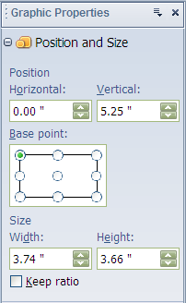
Figure 2-9: The Graphic Properties sidebar

Click the More Graphic Properties button to display the Graphic Properties dialog box, which contains options for:
- Position and Size: Contains options for size, position, and protection.
- Rotation: Contains options for rotation angle and pivot point.
- Slant & Corner Radius: Contains options for slant angle and corner radius.
- Graphics: Contains options for color correction, luminance, graphics mode, and image filter.
- Crop: Contains options for scaling and cropping.
- Alternative text: Allows you to enter alternative image and description text for the selected graphic.

The Drawing Toolbar
IBM® Lotus® Symphony™ Spreadsheets allows you to add objects, shapes, and lines to your spreadsheet. The Drawing toolbar allows you quick access to these drawing functions. Click View→Toolbars→Drawing to display the Drawing toolbar at the top of your document.
The Drawing toolbar contains the options described in the following table.

Icon | Description
 | Select: Lets you select objects in the current document. To select an object, click the object with the arrow. To select more than one object, drag a selection frame around the objects. To add an object to a selection, press Shift, and then click the object.
 | Rectangle Quickshape: Draws a rectangle where you drag in the current document. Click where you want to place a corner of the rectangle, and drag to the size you want. You can resize a rectangle by dragging one of the handles of the rectangle. To draw a square, hold down Shift while you drag.
 | Ellipse Quickshape: Draws an oval where you drag in the current document. Click where you want to draw the oval, and drag to the size you want. To draw a circle, hold down Shift while you drag.
 | 3-D Quickshapes: Provides several different shapes in 3-D format: cube, sphere, cylinder, cone, pyramid, torus, shell, and half-sphere. Select the 3-D shape type from the drop-down list. Then click where you want to draw the object and drag to the size you want.
 | Lines: Draws a straight line where you drag in the current document. To constrain the line to 45 degrees, hold down Shift while you drag.
 | Arrows: Draws an arrow where you drag in the current document. You can select the arrow head and direction. To constrain the line to 45 degrees, hold down Shift while you drag the arrow in the direction it should point.
 | Connectors: Draws a connector with one or more 90-degree angle bends. Click a connection point on an object, drag to a connection point on another object, and then release.
 | Basic Shapes: Provides many shape options. Click the shape type in the drop-down list. Then click where you want to draw the object and drag to the size you want.
 | Block Arrows: Provides many block arrow options. Click the arrow type in the drop-down list. Then click where you want to draw the object and drag to the size you want.
 | Flow Charts: Provides many shape options for flow charts. Click the shape type in the drop-down list. Then click where you want to draw the object and drag to the size you want. To add text to the shape, double-click it.
 | Stars and Symbols: Provides many symbol options. Select the symbol type from the drop-down list. Then click where you want to draw the object and drag to the size you want.
 | Callouts: Draws a line that ends in a rectangular callout with horizontal text direction from where you drag in the current document. Drag a handle of the callout to resize the callout. To add text, click the edge of the callout, and then type or paste your text. To change a rectangular callout to a rounded callout, drag the largest corner handle when the pointer changes to a hand.
 | Fontwork: Activates the Fontwork dialog box that allows you to insert font work into your spreadsheet.
 | Extrusion: Renders drawing objects with extrusion effects that look like 3-D effects.
 | Text Box: Draws a text box with horizontal text direction where you drag in the current document. Drag a text box to the size you want anywhere in the document, and then type or paste your text.

Activity 2-1: Add Content And Visual Elements

Before you begin:
If necessary, open the TopSalesReport.ods file.

Scenario
You are finalizing your sales report and decide to use a matrix formula to calculate totals for some of your data. You also want to add some visual enhancements to make the report more interesting.

To complete this activity:
- Add and copy a formula.
- Insert a chart.

Follow these steps to add content and visual elements to your spreadsheet.

Step | Action
1 | Click the Top Product Sales sheet tab.
2 | Click cell F2 and type =sum(D2*E2)
3 | Select cell F2 and click Edit→Copy.
4 | Select cells F3:F13 and click Edit→Paste.
5 | Click the Top Product Distribution sheet tab.
6 | Since this sheet was previously protect, you must unprotect it before you can make any changes. Click Tools→Protect Document→Sheet. In the Unprotect Sheet dialog box, type passw0rd and click OK.
7 | Select cells A1:A13, press and hold Ctrl while selecting cells E1:E13.
8 | Click Create→Chart.
9 | The cell ranges you already selected will be displayed in the Range field. Verify that the First row as label and First column as label check boxes are selected. Click Next.
10 | In the Choose a chart type section, select the Bars chart type, and click Next.  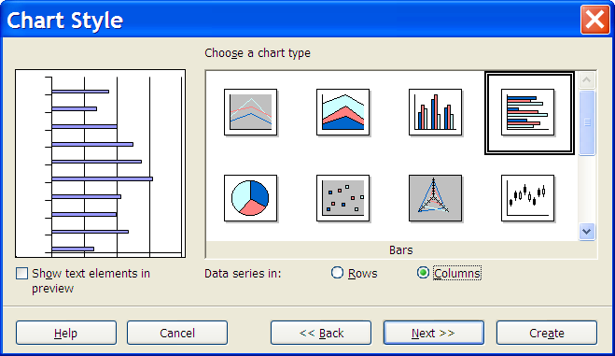
11 | In the Choose a variant section, leave the default selected and click Next.
12 | In the Axis titles section, select X axis and Y axis. In the X axis field, type Top Products and in the Y axis field, type Number Delivered
13 | In the Display section, in the Chart title field, type Top Product Distribution
14 | In the Axis titles section, select X axis and Y axis. In the X axis field, type Top Products and in the Y axis field, type Number Delivered
15 | Click and drag one of the left margin boxes on the chart until the x-axis data labels are fully visible.  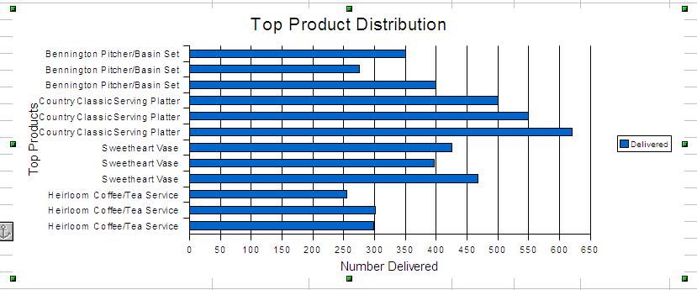
16 | Double-click in the outer chart background to open the Chart Area dialog box.
17 | On the Area tab, in the Fill section, select Color, and then click Blue 8. Click OK.
18 | Double-click in the chart data area to open the Chart Wall dialog box.
19 | On the Area tab, in the Fill section, select Gradient, and then click Square yellow/white. Click OK.  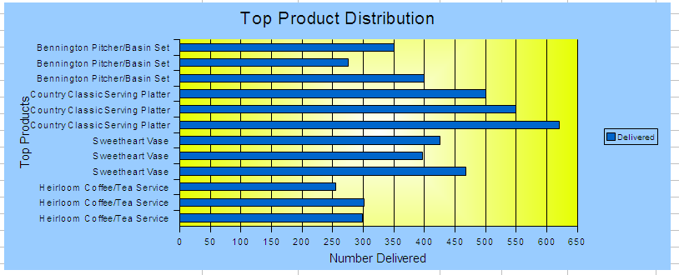
20 | Select cell G2 and click Create→Graphic from File.
21 | In the Create Graphics dialog box, browse to C:\lotus_ed\Spreadsheets and click the wwcorplogo.png file, and then click Open. The WWCorp logo is now displayed in the spreadsheet. 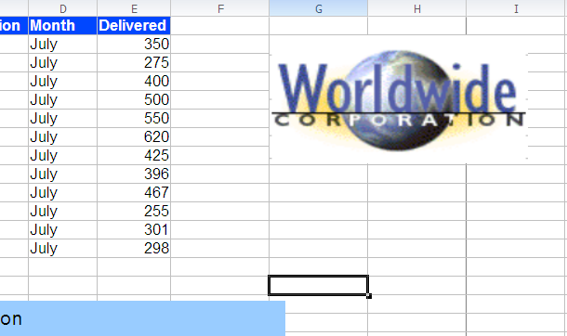
22 | Save and close the file.

Lesson Summary
In this lesson, you entered formulas and explored various formula options. You used spreadsheet data to create charts and enhanced the look of your spreadsheet by adding graphics and shapes.

Follow-up
In this course, you formatted sheets and used formula tools. You also enhanced your spreadsheets with graphics and created charts so the data can be analyzed. When you use one of these components, your workbook will appear more professional and it will be more useful for other individuals. When you combine these components, your workbook becomes a tool for analysis and collaboration with other individuals.

What’s Next?
After completing the Using IBM® Lotus® Symphony™ Spreadsheets: Beyond Basics course, you may want to continue with the Using IBM® Lotus® Symphony ™ Spreadsheets: Power User course.

Also available are:
- Using IBM® Lotus® Symphony™ Spreadsheets: Basics
- Using IBM® Lotus® Symphony™ Documents: Basics
- Using IBM® Lotus® Symphony™ Documents: Beyond Basics
- Using IBM® Lotus® Symphony™ Documents: Power User
- Using IBM® Lotus® Symphony™ Presentations: Basics
- Using IBM® Lotus® Symphony™ Presentations: Beyond Basics
- Using IBM® Lotus® Symphony™ Presentations: Power User

Finally, information about the Lotus Symphony product is available at the Lotus Symphony Web site, which is at http://symphony.lotus.com/software/lotus/symphony/home.nsf/home

Appendix 

Additional Resources
The following additional resources are available for more information on Lotus Symphony Spreadsheets:
- Tour: http://symphony.lotus.com/idcontents/pdf/N8T40/start_n8t40.htm
- Demo: http://symphony.lotus.com/software/lotus/symphony/help.nsf/DemoForSpreadSheets
- Tutorial: http://symphony.lotus.com/idcontents/tutorial/en/spreadsheets_tutorial/start_spreadsheets.htm
- Toolbar Reference Card: http://symphony.lotus.com/idcontents/refcard/en/n8r40_refcarddita-pdf-minimal.pdf
- Keyboard Reference Card: http://symphony.lotus.com/idcontents/refcard/en/n8r40_shortcutdita-pdf-minimal.pdf

As they are developed, other resources may be added to this location: http://symphony.lotus.com/software/lotus/symphony/help.nsf/home

Available Plug-Ins
Extend the value of Lotus Symphony with plug-ins from IBM, partners, and developers. A complete list of all available plug-ins can be found here: http://symphony.lotus.com/software/lotus/symphony/plugin.nsf/home

