Using IBM® Lotus® Symphony™ Spreadsheets: Power User
Student Guide

Using IBM® Lotus® Symphony™ Spreadsheets: Power User
Part Number: Y1300
Course Edition: 1.0

Notices
DISCLAIMER: You may not copy, reproduce, translate, or reduce to any electronic medium or machine-readable form, in whole or in part, any documents, software, or files provided to you without prior written consent of IBM Corporation, except in the manner described in the documentation. While every reasonable precaution has been taken in the preparation of this manual, the author and publishers assume no responsibility for errors or omissions, nor for the uses made of the material contained herein and the decisions based on such use. Neither the author nor the publishers make any representations, warranties, or guarantees of any kind, either express or implied (including, without limitation, any warranties of merchantability, fitness for a particular purpose, or title). Neither the author nor the publishers shall be liable for any indirect, special, incidental, or consequential damages arising out of the use or inability to use the contents of this book, and each of their total liability for monetary damages shall not exceed the total amount paid to such party for this book.

TRADEMARK NOTICES The following terms are trademarks or service marks of International Business
Machines Corporation in the United States, other countries, or both: DB2®, Domino®, Domino® Designer,
Everyplace, ibm.com®, LearningSpace®, Lotus®, Lotus Enterprise Integrator®, Lotus Notes®, Lotus Workflow, Quickr™, Rational®, Sametime®, Symphony™, Tivoli®, VisualAge®, and WebSphere®.

Java and all Java-based trademarks and logos are trademarks of Sun Microsystems, Inc., in the United
States, other countries, or both.

Microsoft, Windows, Windows NT, and the Windows logo are trademarks of Microsoft Corporation in the
United States, other countries, or both.

Intel, Intel Inside (logos), MMX and Pentium are trademarks of Intel Corporation in the United States, other countries, or both.

UNIX is a registered trademark of The Open Group United States and other countries.

Linux is a trademark of Linus Torvalds in the United States, other countries, or both.

Copyright © 2008 IBM Corporation.
Lotus software, IBM Software Group, One Rogers Street, Cambridge, MA 02142

Under the copyright laws, neither the documentation nor the software may be copied, photocopied, reproduced, translated, or reduced to any electronic medium or machine-readable form, in whole or in part, without the prior written consent of IBM, except in the manner described in the documentation or the applicable licensing agreement governing the use of the software.

All rights reserved.

Licensed Materials - Property of IBM

U.S. Government Users Restricted Rights - Use, duplication, or disclosure restricted by GSAADP Schedule Contract with IBM Corporation.

You must purchase one copy of the appropriate kit for each student and each instructor. For all other education products you must acquire one copy for each user or you must acquire a license for each copy provided to a user.

Using IBM® Lotus® Symphony™ Spreadsheets: Power User
Lesson 1: Working with Advanced Calculation Tools 10
Introduction 11
Topic A: Working with Advanced Calculation Tools 12
DataPilot Tables 12
Consolidating Data 14
Solving Equations 15
Applying Multiple Operations 15
Defining Validity for Cell Contents 16
Lotus Symphony What If 18
Topic B: Using References 19
Naming Cells 19
Relative Addressing 19
Absolute Addressing 19
Referencing a Cell in a Different Sheet 20
Topic C: Collaborating on Spreadsheets 21
Recording Changes 21
Adding Comments 22
Accepting or Rejecting Changes 22
Spreadsheet Navigator 23
Activity 1-1: Work with Advanced Calculation Tools 25
Lesson Summary 29
Follow-up 30
What’s Next? 30
Additional Resources 31
Available Plug-Ins 31

About This Course
Advanced analysis techniques help you extract more value from your static data by summarizing and forecasting values that are not readily apparent. Using collaboration techniques helps you add value to your data and analysis of the data by allowing you to incorporate the feedback of others into your data.

Course Description
Target Student
This course is designed for IBM® Lotus® Symphony™ end users who will use these materials to learn the basic tasks associated with the Lotus Symphony Spreadsheet editor.

Course Prerequisites
This course assumes that students have some experience with using spreadsheet software.

How to Use This Book

As a Learning Guide
Each lesson covers one broad topic or set of related topics. Lessons are arranged in order of increasing proficiency with IBM Lotus Symphony Spreadsheets; skills you practice in one lesson are used and developed in subsequent lessons. For this reason, you should work through the lessons in sequence.

Each lesson is organized into results-oriented topics. Topics include all the relevant and supporting information you need to master Lotus Symphony Spreadsheets, and activities allow you to apply this information to practical hands-on examples.

As a Review Tool
Some of the information covered in class may not be relevant to your environment immediately, but it may become important later on. For this reason, we encourage you to spend some time reviewing the topics and activities after the course.

As a Reference
The organization and layout of the book make it easy to use as a learning tool and as an after-class reference. You can use this book as a first source for definitions of terms, background information on given topics, and summaries of procedures.

Course Objectives
After completing this course, you should be able to:
- Work with advanced calculation tools.

Course Requirements

Hardware
This course assumes users will be using their personal computer to take this course. The following are the system requirements to support an installation of IBM® Lotus® Symphony™ 1.1:
- At least 750 MB of free disk space on Linux and at least 540 MB of free disk space on Microsoft® Windows®.
- At least 512 MB of memory.

Software
The following list identifies the software requirements for installing Lotus Symphony 1.1. Please note that proper licensing for all software is required and is the responsibility of the training organization.
- Microsoft® Windows® XP + SP2 or Microsoft® Windows Vista®
- IBM Lotus Symphony 1.1

Class Setup

Course Files
The following table describes the course files.
Title | File name | Description
Top Sales Report | TopSalesReport – PowerL1.ods | Spreadsheet file to be used in lesson activity.

Course Setup Tasks
Complete the tasks in the following table to set up the course prior to the
start of class. Detailed procedures for each task appear on the following
pages.

Task | Procedure
1 | Uninstall any previously installed version of IBM Lotus Symphony.
2 | Install Lotus Symphony 1.1.
3 | Install the course data files.

Task 1: Uninstall Previous Versions of IBM Lotus Symphony
If you currently have an earlier version of Lotus Symphony installed, you will need to uninstall it prior to installing Lotus Symphony 1.1. Follow these steps to uninstall any previously installed versions of Lotus Symphony.

Step | Action
1 | Verify that Lotus Symphony is closed
2 | Click Start→Control Panel→Add or Remove Programs.
3 | In the Add or Remove Programs dialog box, click IBM Lotus Symphony  and then click Remove.  Note: It may take a few minutes for the program to uninstall.

Task 2: Install Lotus Symphony 1.1
If you have not yet installed Lotus Symphony 1.1, you will need to do so before taking this course. Follow these steps to install Lotus Symphony 1.1.

Step | Action
1 | In a Web browser, go to http://symphony.lotus.com/software/lotus/symphony/home.nsf/home and click Download to download the Lotus Symphony 1.1 installation files. A new window opens and lists the IBM Lotus Symphony installation types. Click the version for the Windows operating system. In the next window, the product information is displayed. Select a language and click Continue. Select I agree after viewing the licensing information, and then click I confirm.
2 | In the Download using Download Director dialog box, select Lotus Symphony Setup for Windows, and click Download now.
3 | After the files have finished downloading, click Launch in the Download Director.
4 | The Installation Wizard for IBM Lotus Symphony is displayed. On the Welcome to IBM Lotus Symphony 1.1 page, click Next.
5 | On the Software License Agreement page, select I accept the terms in the license agreement, and click Next.
6 | On the next page, leave the default install location or browse to and select a custom location, and then click Next.
7 | On the File Type Associations page, verify that the Open Document Format file types and OpenOffice.org 1.1 file types are selected by default. Click Next.
8 | On the next page, click Install.
9 | On the IBM Lotus Symphony Install Complete page, verify that Open Lotus Symphony is selected, and then click Finish.

Task 3: Install the Course Data Files
Data files for students to use during the course activities are provided and installed as part of course setup. Follow these steps to install the course data files.

Step | Action
1 | Open the Y1300labfiles.zip file and run the Y1300labfiles.exe self-extracting file. This executable will create the \lotus_ed\ folder and install sub-folders named \Documents, \Spreadsheets, and \Presentations.  Note: These course files apply to all Lotus Symphony training modules, so you will only need to install these files once.

Course Icons
The following table explains the icons used in this course.

Step | Action
 | An activity is a student-centered learning process that allows students to learn by performing a task. Activities can be instructor-led or completed independently.
 | Scenario information is used to introduce an activity problem or goal. Scenarios use fictitious people and organizations to present details, problem statements, and parameters that are used to complete the activity or lab exercise.
 | Caution statements are included in the courseware to make students aware of potential negative consequences of an action, setting, or decision, that are not easily known.
 | Tips and notes provide additional information, guidance, or a hint about a topic or task.
 | An Instructor Note is a special comment to the instructor regarding delivery, classroom strategy, classroom tools, exceptions, and other special considerations. The Instructor Note is included in the Instructor Guide only.
 | A Display Slide provides a prompt to the instructor to display a specific slide. The Display Slide icon is included in the Instructor Guide only.


Working with Advanced Calculation Tools

- Topic A: Working with Advanced Calculation Tools
- Topic B: Using References
- Topic C: Collaborating on Spreadsheets

Introduction
One of the most time-consuming things you need to do when you create a workbook is calculate the data. It is not too bad when you are simply adding a column, but what happens when you need to figure out something more advanced, such as loan payments? Advanced math problems such as these can take hours to solve using simple math. Instead, you can use the advanced calculation functions built into IBM® Lotus® Symphony™ Spreadsheets. The functions perform the calculations and the answers are displayed almost instantaneously.

After completing this lesson, you should be able to:
- Work with advanced calculation tools.
- Use references.
- Collaborate on spreadsheets.


Topic A: Working with Advanced Calculation Tools
At times, you will need to use specialized functions to perform advanced calculations. Using specialized categories of functions will allow you to go beyond basic mathematics and perform operations on different types of data such as text, dates, and times.

DataPilot Tables
A DataPilot table is an interactive table you can use to combine, compare, and analyze large amounts of data. You can view different summaries of the source data, display the details for areas of interest, and create reports. You can arrange, rearrange, or summarize the data according to different points of view. To create a DataPilot table in IBM® Lotus® Symphony™ Spreadsheets, position the cursor within a range of cells containing values and row and column headings. Click Manipulate→Data Pilot→Start. In the Data Pilot: Select Source dialog box, select Current selection, unless you have data from a specific data source, and click OK. The Data Pilot dialog box is displayed, allowing you to choose the layout of the Data Pilot table. The table headings are shown as buttons. Right-click these buttons and then click Move to Row, Move to Column, or Move to Data as required to add them into the layout areas Column, Row and Data. If the button is dropped in the Data area, it will be given a caption that will also show the formula used to calculate the data.

The following figure shows the Data Pilot dialog box.

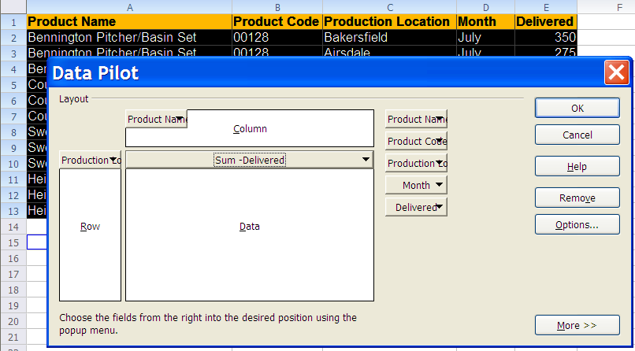
Figure 1-1: The Data Pilot dialog box
If you right-click one of the fields in the Data area and click Options, the Data Field dialog box is displayed. In the Data Field dialog box, you can select the type of calculations to be used for the data. To make multiple selections, press the Ctrl key while clicking the calculation options. Click OK to exit the Data Field dialog box.

The following figure shows the Data Field dialog box.

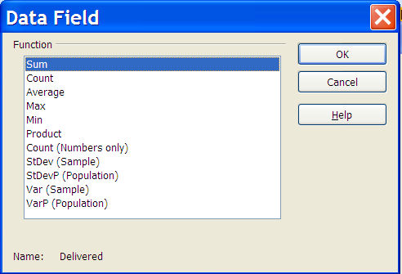
Figure 1-2: The Data Field dialog box

Click OK again to exit the Data Pilot dialog box. A Filter button will now be inserted into the table below the source data. Two rows further down the DataPilot table is inserted. The following figure shows a DataPilot table.

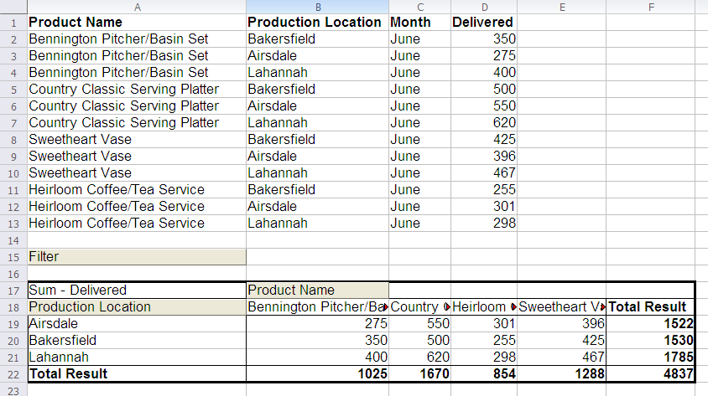
Figure 1-3: A Data Pilot table

Consolidating Data
You may want to consolidate cell ranges that contain similar data within a spreadsheet, or consolidate data from several different spreadsheets. Lotus Symphony Spreadsheets provides a Consolidation function that allows you to do this. Click in the spreadsheet where you want to add the consolidated data, and then click Manipulate→Consolidation. In the Consolidation dialog box, click the Source data range icon to select a cell range you want to consolidate. Click Add. This will add the selected range to the Consolidation ranges list box. Repeat these steps for each cell range you want to consolidate. The Copy results to field displays the first cell in the range where the consolidated data will display; you can adjust this location using the icon. Click OK to consolidate the data.

The following figure shows the Consolidation dialog box.

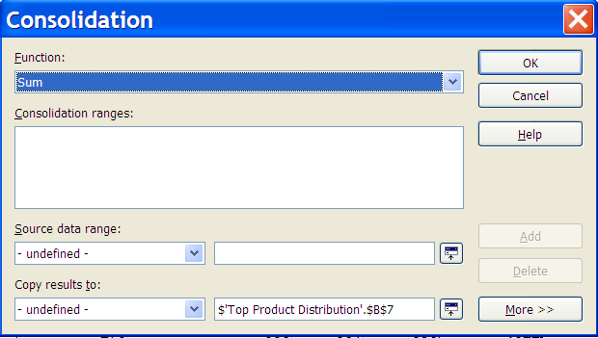
Figure 1-4: The Consolidation dialog box

If you prefer to retain links to the source ranges instead of copies, or if you want to consolidate ranges in which the order of rows or columns varies, click the More button in the Consolidation dialog box. Select Link to source data to insert the formulas that generate the results in the target range, rather than the actual results. If you link the data, any values modified in the source range are automatically updated in the target range. The corresponding cell references in the target range are inserted in consecutive rows, which are automatically ordered and then hidden from view. Only the final result, based on the selected function, is displayed. In the Consolidate by section, select either Row labels or Column labels if the cells of the source data range are not to be consolidated corresponding to the identical position of the cell in the range, but instead according to a matching row label or column label. To consolidate by row labels or column labels, the label must be contained in the selected source ranges. The text in the labels must be identical, so that rows or columns can be accurately matched. If the row or column label does not match any that exist in the target range, it will be appended as a new row or column. The data from the consolidation ranges and target range will be saved when you save the document. If you later open a document in which consolidation has been defined, this data will again be available.

Solving Equations
The Solve Equations function enables you to calculate a value as part of a formula that leads to the result you specify for the formula. You define the formula with several fixed values and one variable value and the result of the formula. To access the Solve Equations function, click the cell your formula result should appear in, and then click Tools→Solve Equations. The cell you selected will already be displayed in the Formula cell field; use the icon to change the formula cell location in the spreadsheet. In the Variable cell field, use the icon to select the cell that contains the value to be changed. In the Target value field, type the expected result of the formula. Then click OK. A dialog box will display indicating the result is available; click Yes to enter the result in the selected cell.

The following figure shows the Solve Equation dialog box.

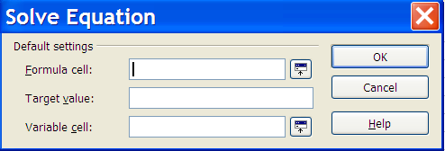
Figure 1-5: The Solve Equation dialog box

Applying Multiple Operations
To save time, you can use the Multiple Operations function to apply the same formula to different cells using different parameter values. To access the Multiple Operations function, click Manipulate→Multiple Operations. In the Multiple Operations dialog box, in the Formulas field, enter the cell references for the cells containing the formulas you want to use in the multiple operation. In the Row input cell field, enter the cell that you want to use as a variable for the rows in the data table. In the Column input cell field, enter the cell you want to use as a variable for the columns in the data table.

The following figure shows the Multiple Operations dialog box.

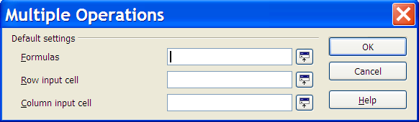
Figure 1-6: The Multiple Operations dialog box

Defining Validity for Cell Contents
For each cell, you can define in advance what type of content is valid for that cell. This allows you to restrict cells to receive specific values and ranges, which allows you to guide users who enter data in the spreadsheet. To define validity for cells, select the cells you want to define. Click Manipulate→Validity. In the Validity dialog box, on the Criteria page, in the Allow drop-down list, click a condition for new values entered into cells. Values you have already entered will not be affected. After you have selected a condition in the Allow drop-down list, then set additional conditions in the Data drop-down list. Depending on what selection you make, additional options may display to further define the condition.

The following figure shows the Validity dialog box.

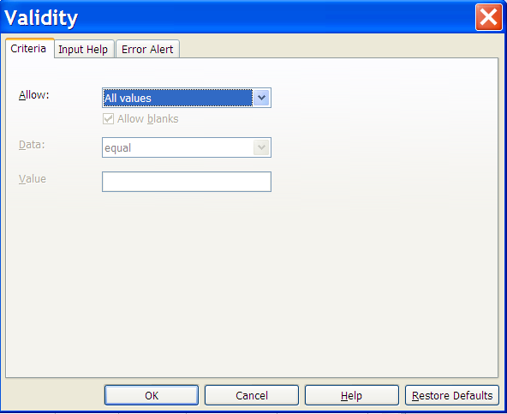
Figure 1-7: Validity dialog box

After you have configured the criteria options, use the Input Help and Error Alert tabs to create assistance for users inputting data. On the Input Help tab, enter a tip title and text that will be displayed if the cell is selected by a user. On the Error Alert tab, select an action to be carried out when the user inputs an error:
- Stop: Invalid entries are not accepted and the previous cell contents are retained.
- Warning: Will display a dialog box where the entry can either be cancelled or accepted, even if it violates the validity requirements.
- Information: Will display a dialog box where the entry can either be cancelled or accepted, even if it violates the validity requirements.

Lotus Symphony What If
The Lotus Symphony What If functions are important aids for making numbers that are dependent upon each other, and their resulting calculations, visible. What If allows you to create a list of values to select from for a given cell or group of cells. The contents of these cells change when you select different items from the list. If you modify specific basic requirements in the table, you will see the new result. You can give a name to the What If created in this manner and compare it with other What If results.

To create a What If, select all the cells that provide the data for the What If. Click Tools→What If. The Create What If dialog box displays and includes the following options:
- Name of What-if Situation: Defines the name for the what if. Use a clear and unique name so you can easily identify the scenario. You can also modify a scenario name in the Navigator through the Properties context menu command.
- Comment: Specifies additional information about the scenario. This information will be displayed in the Navigator when you click the k icon and select the desired scenario. You can also modify this information in the Navigator through the Properties context menu command.
- Settings: This section is used to define some of the settings used in the scenario display.
- Display border in: Highlights the scenario in your table with a border. The color for the border is specified in the field to the right of this option. The border will have a title bar displaying the name of the last scenario. The button on the right of the scenario border offers you an overview of all the scenarios in this area, if several have been defined. You can choose any of the scenarios from this list without restrictions.
- Copy back: Copies the data back into the active scenario, if one has been selected from the list. Afterwards, you can edit the data for each scenario directly in the sheet. If this option has not been selected together with Display border in, you will not be able to see scenarios in the sheet. In this case, you can use the Navigator. Click the Scenarios button located in the Navigator to show and then select one of the defined scenarios for this sheet.
- Copy entire sheet: Copies the entire sheet into an additional scenario sheet.


Topic B: Using References
You may find that you have data located in several different sheets that you need to use in your calculations. You could cut and past the data into a single spreadsheet, but if the original data changed, your duplicated data would be incorrect. Instead, you can calculate across sheets in a formula. Your calculation will be accurate, regardless of where the data is stored.

Naming Cells
IBM® Lotus® Symphony™ Spreadsheets allows you to assign names to cell ranges. First, select a cell or range of cells, and then click Create→Names→Define. In the Define Names dialog box, type the name of the selected area in the Name field and click Add. The new name will display in the list. Click OK to close the dialog box. You can refer to cells and cell ranges in formulas by using the names you have assigned them.

Relative Addressing
A relative addressing reference is a cell reference in a formula that changes when a formula is copied from one position to another, to reflect the new position. Relative references are used to create formulas that use values that are relative and are not fixed. Relative references contain a cell’s column and row heading.

For example, the cell in column A, row 1 is addressed as A1. You can address a range of adjacent cells by first entering the coordinates of the upper left cell of the area, then a colon followed by the coordinates of the lower right cell. For example, the square formed by the first four cells in the upper left corner is addressed as A1:B2. By addressing an area in this way, you are making a relative reference to A1:B2. The reference to this area will be adjusted automatically when you copy the formulas.

Absolute Addressing
Absolute addressing references are the opposite of relative addressing references. An absolute reference is a cell reference in a formula that does not change when the formula is copied from one position to another to reflect the new position. Absolute references are used in formulas to refer to the values in cells that need to be constant while performing calculations. All absolute references contain a dollar sign ( $ ) before the column and row heading in the cell reference.

Lotus Symphony Spreadsheets can convert the current reference, in which the cursor is positioned in the input line, from relative to absolute and vice versa when you press Shift+F4. If you start with a relative address such as A1, the first time you press this key combination, both row and column are set to absolute references ($A$1). The second time, only the row (A$1) is set, and the third time, only the column ($A1). If you press the key combination once more, both column and row references are switched back to relative (A1). IBM Lotus Symphony Spreadsheets shows the references to a formula.

Referencing a Cell in a Different Sheet
You can use the Lotus Symphony Navigator to reference cells from one sheet to another. The cells can be inserted as a copy, link, or hyperlink. You must define the range to be inserted with a name in the original file so that it can be inserted in the target file. Open the spreadsheet that contains the source cells. To set the source range as the range, select the cells and click Create→Names→Define. Save the source document, but do not close it. Open the sheet in which you want to insert something. Open the Navigator by clicking Edit→Navigator. Click the plus sign (+) in front of Range names, and select the source object. Right-click and click Drag Mode. Then select the type of the reference that you want, whether it be a hyperlink, link, or copy. Drag the selected source object into the cell of the current sheet where you want to insert the reference.


Topic C: Collaborating on Spreadsheets
In a work environment, there are instances where you may have to coordinate with others to work on a common file. While collaborating with other users, you make your data available to others, and they make their data available to you.

Recording Changes
It is rare that a document does not get reviewed or revised by another party at some point over the course of its creation. IBM® Lotus® Symphony™ Spreadsheets allows you to enable the recording of changes as they are made in a document, so that another party can quickly determine what was changed from one version to the next. This eliminates the need to open two separate versions of the same document and compare them line by line in order to discover what was changed.

To enable change recording, click Edit→Revisions→Record. Certain changes in your document are not recorded, such as changing tab stops, page margins, or other document-related properties. Change recording will, however, make note of any data additions, deletions, alterations, and other various formatting. For example, when you change data in a spreadsheet with change recording enabled, the cell that contains the changed data will display a red border. If you hover the mouse pointer over the red border, a yellow box will display, explaining the changes that were made to the data in that cell.

The following graphic shows an example of a recorded change.

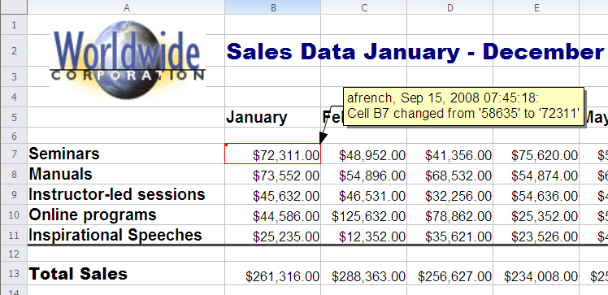
Figure 1-8: An example of a recorded change

Adding Comments
Comments provide a way for you and others to communicate with each other within the document, but without adding text to the content of the document itself. The benefit of this is that the comments travel along with the spreadsheet itself, and are not lost or misplaced in long e-mail chains. Comments are marked with the name of the user who has entered the comment, and they are also time-stamped to indicate when the comment was made.

A comment may only be added to text that has been changed in the spreadsheet, with change recording enabled. The purpose of the comment is to provide an explanation as to why the change was made. You can insert a comment by placing the cursor within the changed text, and clicking Edit→Revisions→Comment. In the Create Comment dialog box, you may provide a short message about the change. This comment will be visible when another reviewer opens the spreadsheet and accepts or rejects changes. It will also be displayed any time a user rolls the mouse over that particular change.

Comments vs. notes
It is important to be aware of the difference between a comment and a note. A comment may be applied only to a change that has been made to a spreadsheet with change recording enabled. A note, however, may be made anywhere in the spreadsheet and does not need to be associated with any particular changes.

To add a note to your spreadsheet, place the cursor where you would like to add a note, and click Create→Note. Provide the text to be displayed in your note, and click OK. A small yellow marker will indicate the presence of a note in the document. This note text is visible when a user rolls over the note. You can double-click the note marker at any time to edit it, or click the note and press Delete to remove it.

Caution: It is important that you do not highlight text before adding a note. The yellow note marker will overwrite any selected text. Instead, place the cursor to mark the location of the note without highlighting any text.

Accepting or Rejecting Changes
The benefit of recording the changes made to a spreadsheet is the ease in which another person may review these revisions. Instead of comparing spreadsheets on a line-by-line basis, Lotus Symphony Spreadsheets calls attention to all data and formatting changes to the spreadsheet. When you are ready to review the changes made by another reviewer, open the spreadsheet and click Edit→Revisions→Accept or Reject. In the Accept or Reject Changes dialog box, a list of all changes to the spreadsheet is provided.

The actions that you can take are provided at the bottom of the dialog box. The following table describes those actions.

Action | Result
Accept | Accepts the currently selected change in the above list, and removes the change highlight in the document.
Reject | Rejects the currently selected change in the above list, and places the original text in the document.
Accept All | Accepts all changes made to the document at once, and removes all change highlighting.
Reject All | Rejects all changes made to the document, and removes all change highlighting.

On the Filter tab of the dialog box, you can narrow your search of specific changes to the spreadsheet. This is especially helpful when the spreadsheet has been through multiple reviews since you have last seen it. You can filter the recorded changes by specifying a range of dates or sorting by author, by action, or by any comments that have been entered.

Spreadsheet Navigator
The Lotus Symphony Spreadsheets Navigator is a handy stand-alone navigation tool that can be access by clicking Edit→Navigator or pressing Ctrl+Shift+F5. The Navigator contains the following options to help you easily locate content:
- Column: Type the column letter in the Column spin box . Press Enter to reposition the cell cursor to the specified column in the same row.
- Row: Type a row number in the Row spin box. Press Enter to reposition the cell cursor to the specified row in the same column.
- Data Range: Specifies the current data range denoted by the position of the cell cursor.
- Start: Moves to the cell at the beginning of the current data range, which you can highlight using the Data Range button.
- End: Moves to the cell at the end of the current data range, which you can highlight using the Data Range button.
- Form Navigator: Displays all forms and subforms in the current spreadsheet.
- Contents: Shows or hides the contents in the Navigator dialog box.
- Toggle: Toggles the content view. Only the selected Navigator element and its sub-elements are displayed. Click the icon again to restore all elements for viewing.
- What If: Displays all available scenarios. Double-click a name to apply that scenario. The result is shown in the sheet.
- Drag mode: Opens a submenu for selecting the drag mode. You can also select the drag mode through the context menu in the Navigator window. You decide which action is performed when dragging and dropping an object from the Navigator into a document. Depending on the mode you select, the icon indicates whether a hyperlink, a link, or a copy is created.
The following image shows the Lotus Symphony Spreadsheets Navigator.

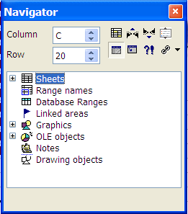
Figure 1-9: The Lotus Symphony Spreadsheets Navigator

Activity 1-1: Work with Advanced Calculation Tools

Data Files:
- TopSalesReport – PowerL1.ods

Scenario
A co-worker has sent you a spreadsheet file. He would like you to add a Data Pilot table to the Top Product Sales sheet and review all of the information on both sheets to verify its validity.

To complete this activity:
- Create a DataPilot table.
- Review the data and track any changes.
- Name cells in the Delivered column and reference that range on the Top Product Sales sheet.

Follow these steps to work with the advanced calculation tools.
Step | Action
1 | Click File→Open→File. In the Open dialog box, browse to c:\lotus_ed\Spreadsheets and doubleclick the TopSalesReport – PowerL1.ods file to open it.
Create a Data Pilot table.
2 | Click the Top Product Sales sheet tab.
3 | Select cells A1:F13.
4 | Click Manipulate→Data Pilot→Start.  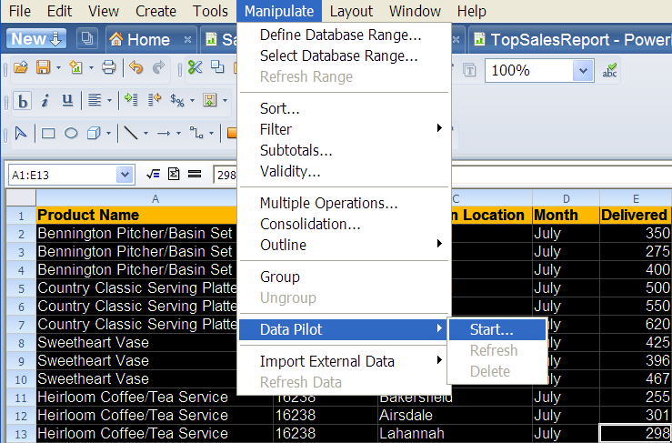
5 | In the Data Pilot: Select Source dialog box, verify that Current selection is selected in the Selection section, and then click OK.
6 | In the Data Pilot dialog box, right-click the Product Name button and click Move to Column.  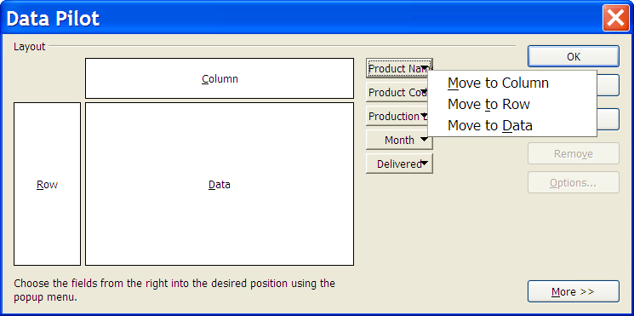
7 | Right-click the Production Location button and click Move to Row.
8 | Right-click the Delivered button and click Move to Data.
9 | Right-click the Total Sales button and click Move to Data.  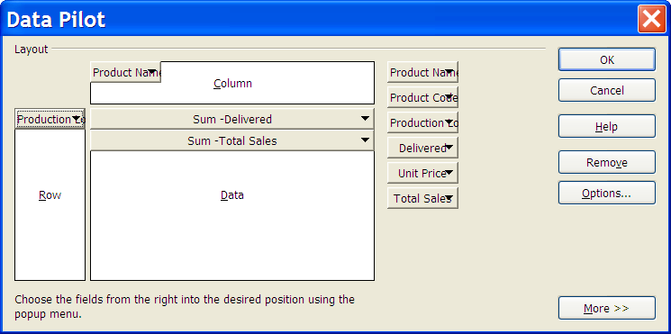
10 | Click OK.  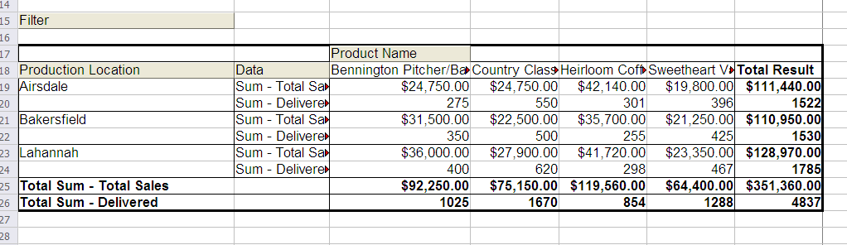
Review the data and track any changes.
11 | Click Edit→Revisions→Record to activate the record changes features.
12 | As you are reviewing the data on the Top Product Distribution sheet, you  notice that the data for the Lahannah location appears to be the June numbers,  not the July numbers as noted. Change the Lahannah figures to the  following:  ● Bennington Pitcher/Basin Set: 425  ● Country Classic Serving Platter: 650  ● Sweetheart Vase: 435  ● Heirloom Coffee/Tea Service: 350  Notice that as you change the data in column E, the chart data automatically  updates.
13 | You also want to leave a comment for your co-worker explaining why you  have changed the Lahannah data. Select cell E4 and click Edit→  Revisions→Comments.
14 | In the Comments dialog box, in the Text field, type Contained June  data, replaced with actual July data in all Lahannah  cells. and then click OK.
Name cells in the Delivered column and reference that range on the Top
Product Sales sheet.
15 | You decided to name the Delivered column data range so you can reference  the data where it is used in other locations, which will save time when  updating the numbers. You will not have to do it in multiple locations. Select  cells E1:E13. Click Create→Names→Define.
16 | In the Define Range Names dialog box, in the Name field, type  Delivered and click Add.  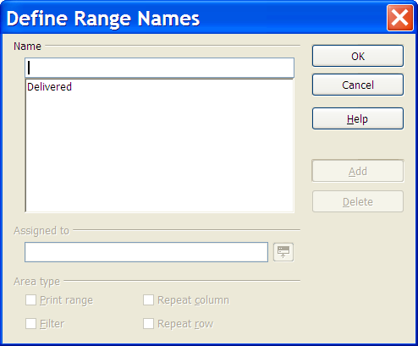
17 | Click OK.
18 | Save the file.
19 | Click the Top Product Sales sheet tab.
20 | Click Edit→Navigator to open the Lotus Symphony Navigator.
21 | In the Navigator, expand Range names, right-click Delivered, and click  Drag mode→Insert as copy.
22 | Drag the Delivered range name to cell D1. Notice that a copy of the named  ranged is applied to column D, including the tracked changes.
23 | Save and close the file.


Lesson Summary
In this lesson, you explored Lotus Symphony Spreadsheet’s advanced calculation tools, named cells and used the names to reference data, and you utilized collaboration tools to track changes, add comments and resolve changes.

Follow-up
In this course, you applied advanced calculation tools, utilized references, and collaborated on worksheets with others. Using collaboration techniques helps you add value to your data and analysis of the data by allowing you to incorporate feedback of others into your data.

What’s Next?
After completing the Using IBM® Lotus® Symphony™ Spreadsheets: Power User course, you may want to continue with any of the following courses:
- Using IBM® Lotus® Symphony™ Documents: Basics
- Using IBM® Lotus® Symphony™ Documents: Beyond Basics
- Using IBM® Lotus® Symphony™ Documents: Power User
- Using IBM® Lotus® Symphony™ Presentations: Basics
- Using IBM® Lotus® Symphony™ Presentations: Beyond Basics
- Using IBM® Lotus® Symphony™ Presentations: Power User

Also available are:
- Using IBM® Lotus® Symphony™ Spreadsheets: Basics
- Using IBM® Lotus® Symphony™ Spreadsheets: Beyond Basics

Finally, information about the Lotus Symphony product is available at the Lotus Symphony Web site, which is at http://symphony.lotus.com/software/lotus/symphony/home.nsf/home

Appendix 

Additional Resources
The following additional resources are available for more information on Lotus Symphony Spreadsheets:
- Tour: http://symphony.lotus.com/idcontents/pdf/N8T40/start_n8t40.htm
- Demo: http://symphony.lotus.com/software/lotus/symphony/help.nsf/DemoForSpreadSheets
- Tutorial: http://symphony.lotus.com/idcontents/tutorial/en/spreadsheets_tutorial/start_spreadsheets.htm
- Toolbar Reference Card: http://symphony.lotus.com/idcontents/refcard/en/n8r40_refcarddita-pdf-minimal.pdf
- Keyboard Reference Card: http://symphony.lotus.com/idcontents/refcard/en/n8r40_shortcutdita-pdf-minimal.pdf

As they are developed, other resources may be added to this location: http://symphony.lotus.com/software/lotus/symphony/help.nsf/home

Available Plug-Ins
Extend the value of Lotus Symphony with plug-ins from IBM, partners, and developers. A complete list of all available plug-ins can be found here: http://symphony.lotus.com/software/lotus/symphony/plugin.nsf/home

