

EMIX 1.0 and the OASIS Smart Grid Suite of Standards Version 1.0
Committee Note 01
06 June 2012
Specification URIs
This version:
http://docs.oasis-open.org/emix/emix-oasis/v1.0/cn01/emix-oasis-v1.0-cn01.pdf (Authoritative)
http://docs.oasis-open.org/emix/emix-oasis/v1.0/cn01/emix-oasis-v1.0-cn01.html
http://docs.oasis-open.org/emix/emix-oasis/v1.0/cn01/emix-oasis-v1.0-cn01.doc
Previous version:
N/A
Latest version:
http://docs.oasis-open.org/emix/emix-oasis/v1.0/emix-oasis-v1.0.pdf (Authoritative)
http://docs.oasis-open.org/emix/emix-oasis/v1.0/emix-oasis-v1.0.html
http://docs.oasis-open.org/emix/emix-oasis/v1.0/emix-oasis-v1.0.doc
Technical Committee:
OASIS Energy Market Information Exchange (eMIX) TC
Chairs:
William Cox (wtcox@coxsoftwarearchitects.com), Individual
Edward Cazalet (ed@cazalet.com), Individual
Editors:
David Holmberg (david.holmberg@nist.gov), NIST
William Cox (wtcox@coxsoftwarearchitects.com), Individual
Edward Cazalet (ed@cazalet.com), Individual
Related work:
This document is related to:
- Energy Market Information Exchange (EMIX) Version 1.0. Latest version.
http://docs.oasis-open.org/emix/emix/v1.0/emix-v1.0.html.
Abstract:
We describe how EMIX relates to other OASIS Standards, including WS-Calendar, Energy Interoperation, Emergency Management, SOA Reference Model, and Security standards.
Status:
This document was last revised or approved by the OASIS Energy Market Information Exchange (eMIX) TC on the above date. The level of approval is also listed above. Check the “Latest version” location noted above for possible later revisions of this document.
Technical Committee members should send comments on this document to the Technical Committee’s email list. Others should send comments to the Technical Committee by using the “Send A Comment” button on the Technical Committee’s web page at http://www.oasis-open.org/committees/emix/.
Citation format:
When referencing this document the following citation format should be used:
[emix-oasis-v1.0]
EMIX 1.0 and the OASIS Smart Grid Suite of Standards Version 1.0. 06 June 2012. OASIS Committee Note 01.
http://docs.oasis-open.org/emix/emix-oasis/v1.0/cn01/emix-oasis-v1.0-cn01.html.

Copyright © OASIS Open 2012. All Rights Reserved.
All capitalized terms in the following text have the meanings assigned to them in the OASIS Intellectual Property Rights Policy (the "OASIS IPR Policy"). The full Policy may be found at the OASIS website.
This document and translations of it may be copied and furnished to others, and derivative works that comment on or otherwise explain it or assist in its implementation may be prepared, copied, published, and distributed, in whole or in part, without restriction of any kind, provided that the above copyright notice and this section are included on all such copies and derivative works. However, this document itself may not be modified in any way, including by removing the copyright notice or references to OASIS, except as needed for the purpose of developing any document or deliverable produced by an OASIS Technical Committee (in which case the rules applicable to copyrights, as set forth in the OASIS IPR Policy, must be followed) or as required to translate it into languages other than English.
The limited permissions granted above are perpetual and will not be revoked by OASIS or its successors or assigns.
This document and the information contained herein is provided on an "AS IS" basis and OASIS DISCLAIMS ALL WARRANTIES, EXPRESS OR IMPLIED, INCLUDING BUT NOT LIMITED TO ANY WARRANTY THAT THE USE OF THE INFORMATION HEREIN WILL NOT INFRINGE ANY OWNERSHIP RIGHTS OR ANY IMPLIED WARRANTIES OF MERCHANTABILITY OR FITNESS FOR A PARTICULAR PURPOSE.

Table of Contents
1 Introduction 4
1.1 References 4
1.1.1 OASIS Committee Specifications and Drafts 4
1.1.2 Other References 5
2 EMIX and the OASIS Smart Grid Standards 6
2.1 Overview 6
2.2 EMIX and WS-Calendar 7
2.3 EMIX and Energy Interoperation 8
3 EMIX and Other Specifications 10
3.1 Composition for Consistency 10
3.2 Other OASIS Standards 10
4 Conclusion 11
Appendix A. Acknowledgments 12
Appendix B. Revision History 13

- Introduction
We describe how EMIX [EMIX] relates to the OASIS suite of Smart Grid Standards, WS-Calendar [WS-Calendar], Energy Interoperation [EnergyInteroperation], as well as other OASIS Standards including Emergency Management [REF NEEDED], SOA Reference Model [SOA-RM], and Security standards.
EMIX is an information model for energy and market information, which is in turn used by Energy Interoperation services for communicating price and product information. Understanding the relationship of the three standards helps in understanding the OASIS Smart Grid suite of standards.
To more effectively understand and use EMIX, one must start with a broad understanding of OASIS WS-Calendar [WS-Calendar] schedules to which price and product information is attached. We then describe how OASIS Energy Interoperation [EnergyInteroperation] and its OpenADR 2 profile uses both EMIX and WS-Calendar.
Composing relatively simple standards has significant advantages over building large unitary standards. The OASIS suite of Smart Grid Standards is designed for composition and re-use, and in fact composes with each other and with other specifications and technologies as we describe in Section 2.

References

OASIS Committee Specifications and Drafts
[EMIX]
OASIS Energy Market Information Exchange [EMIX] Version 1.0. Latest version.
http://docs.oasis-open.org/emix/emix/v1.0/emix-v1.0.pdf.
[EnergyInteroperation]
OASIS Energy Interoperation Version 1.0. Latest version.
http://docs.oasis-open.org/energyinterop/ei/v1.0/energyinterop-v1.0.pdf.
[SOA-RM]
OASIS Reference Model for Service Oriented Architecture Version 1.0, 12 October 2006. OASIS Standard. http://docs.oasis-open.org/soa-rm/v1.0/soa-rm.html
[WS-Calendar]
OASIS WS-Calendar Version 1.0, 30 July 2011. OASIS Committee Specification. http://docs.oasis-open.org/ws-calendar/ws-calendar-spec/v1.0/cs01/ws-calendar-spec-v1.0-cs01.pdf

Other References
[Collaborative]
Collaborative Energy Status Page, Various Dates, http://collaborate.nist.gov/twiki-sggrid/bin/view/SmartGrid/CollaborativeEnergyStatus
[Emergency]
OASIS Emergency Management Technical Committee, http://www.oasis-open.org/committees/emergency/
[EMIX Issues]
EMIX Issues Page, http://collaborate.nist.gov/twiki-sggrid/bin/view/SmartGrid/EMIXissuesPage
[PAP09}
Slides for Priority Action Plan 09, July 2011. http://collaborate.nist.gov/twiki-sggrid/pub/SmartGrid/PAP09DRDER/PAP09_OpenSG_20110719.pptx
- EMIX and the OASIS Smart Grid Standards

Overview
We focus on the suite of OASIS Smart Grid standards. The three standards respond to three of the National Institute of Science and Technology [NIST] Priority Action Plans [PAPs], and have been implemented so as to address interoperation requirements across and within domains of the Smart Grid.
The OASIS Smart Grid suite consists of three standards. The first two are pure information models, expressed as an XML vocabulary for describing information in their scope; the third is an information model, architecture, and set of Web services definitions for communicating among participants in the Smart Grid.
- OASIS Energy Market Information Exchange [EMIX] corresponding to NIST/SGIP Priority Action Plan 03
- OASIS WS-Calendar [WS-Calendar] corresponding to NIST/SGIP Priority Action Plan 04
- OASIS Energy Interoperation [EnergyInteroperation] corresponding to NIST/SGIP Priority Action Plan 09
The relationships of these three standards and a family of seed standards for energy usage information can be seen in Figure 1.
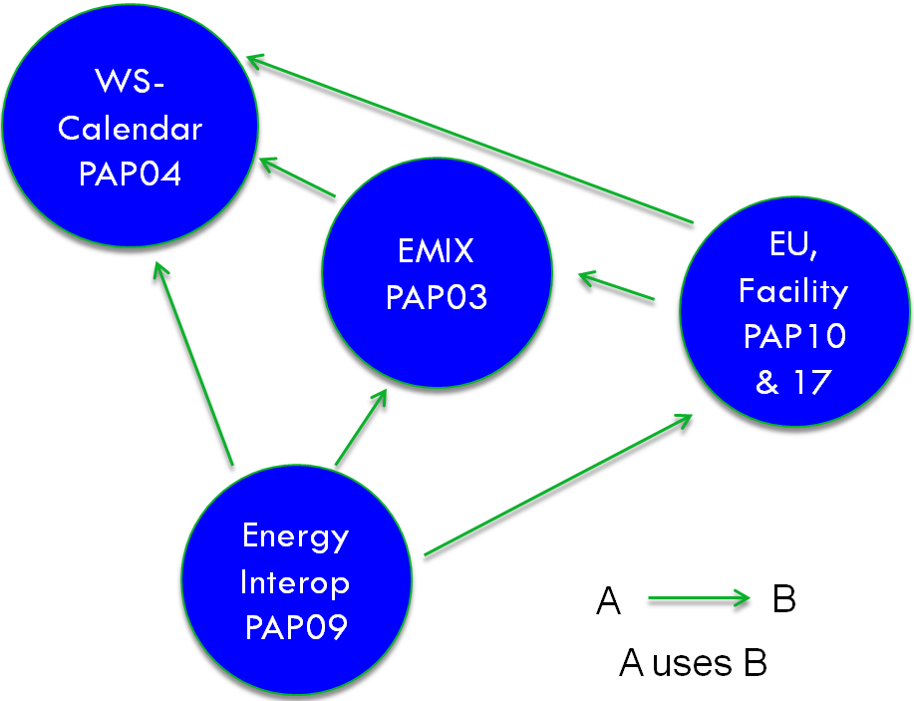
Figure 1 Dependency graph for EMIX, Energy Interoperation, and WS-Calendar
As shown, EMIX uses WS-Calendar and is in turn used by Energy Interoperation. Energy Interoperation and EMIX use the minimal subset of the NAESB Energy Usage information. The arrows indicate that Energy Interoperation uses both EMIX and WS-Calendar, while EMIX uses only WS-Calendar.
The following sections describe how the specifications are used and use other specifications.

EMIX and WS-Calendar
The WS-Calendar and Energy Market Information Exchange (EMIX) specifications are both information models, expressed as XML vocabularies. WS-Calendar uses and extends the IETF iCalendar standards, which are the common information model and vocabulary for calendaring and scheduling. The [WS-Calendar] specification was joint work between the North American Energy Standards Board [NAESB] and the Calendaring and Scheduling Consortium.
WS-Calendar uses Sequences of time Intervals to communicate schedules. Information elements that are unique to an Interval are communicated in the Interval, while information elements common to the entire Sequence are factored out and communicated once with the Sequence.
For example, the start time of the Sequence, and a common duration of each Interval might be communicated once with the Sequence (in a WS-Calendar artifact called a Gluon), while price information might vary across the Intervals and be contained within each Interval.
In WS-Calendar, a Gluon relates to a Sequence by relating to a specific Designated Interval within that Sequence. All other Intervals have defined temporal relationships, directly or indirectly, to the Designated Interval. If a Gluon contains a start date and time, that start date and time is inherited only by a single Designated Interval; the start dates and times for all other Intervals in the Sequence can be computed from that single date and time. This allows scheduling of an entire set of time-related intervals, a Sequence, with one operation rather than changing each interval’s start, end, and/or duration.
EMIX uses the common terminology of markets. EMIX expresses schedules for energy use, delivery, curtailment, and demand with the WS-Calendar vocabulary for schedules, and provides the EMIX vocabulary for expressing information on price and product definition. These definitions are used by implementers and by other standards.
EMIX extends WS-Calendar Intervals and Gluons, attaching price, quantity, product definitions, and more. In the EMIX information model, Interval Duration and the Product Description, Price, and Quantity for each Interval in a Sequence can each be inherited from a Gluon. This follows and extends the rules of inheritance defined in WS-Calendar.
Figure 2 below provides a model demonstrating a sequence of three Intervals, and the successive application of Gluons to bring them to market.
Figure 2 EMIX Schedule and Building a Product (from [EMIX] Section 6.4)

EMIX and Energy Interoperation
OASIS Energy Interoperation [EnergyInteroperation] uses the WS-Calendar and Energy Market Information Exchange (EMIX) information models to implement demand-response, distributed energy resource interactions, and transactive energy interactions.
For Events, information may consist of curtailment or generation or regulation levels, quantities, or prices. The price expression is simplified from EMIX.
Energy Interoperation defines interactions for conveying price quotes (such as clearing prices in a market) and tenders (such as offers to buy or sell) by conveying EMIX schedules with energy product information.
In addition several information items in Energy Interoperation build on EMIX definitions. These include
- The EMIX Market Context—a reference to the program, contract, tariff, or market related to the interaction
- The EMIX Resource Description—a description of capabilities for curtailment and generation and for ancillary services
- The EMIX Product Description—a description of details of time, place(s), and more
- Market (or program or tariff or…) Standard Terms—a description of notice, frequency, units, and other requirements

- EMIX and Other Specifications

Composition for Consistency
The OASIS Smart Grid Suite of Standards are defined to be composed as part of palette of standards used in an application environment, and also to have other standards composed with them.
For example, price and product information may be commercially sensitive. Following the compositional approach for electronic commerce and eBusiness standards, a deployment using EMIX will define and compose the necessary security standards to achieve the deployment business and security goals.
Likewise, the messages containing EMIX price and product information may travel on a variety of transports and with a variety of reliability, privacy, assured delivery, and non-repudiation standards and technologies that depend on the business and security goals of the deployment.
By defining information models that can be exchanged with any security and reliability, uses of EMIX in any environment can share code, information model, XML schema, and the understanding of energy products achieved through broad public discussion and review.

Other OASIS Standards
In this section we list several OASIS Standards used by or coordinated with by EMIX.
OASIS Emergency Management Standards—EMIX uses the same profile of the Open Geospatial Consortium’s GML. This allows, for example, an area affected by a power outage to be communicated in the same way to emergency management service.
OASIS Energy Interoperation—Useful capabilities are enabled by the GML geospatial definitions that are possible in EMIX. Prices may be described for an area of coverage of a particular feeder or substation, and with OASIS Energy Interoperation a curtailment event could be called on that area, or Distributed Energy Resources may be called on.
OASIS Security Standards—The industry-standard OASIS security standards can be composed with EMIX, WS-Calendar, and Energy Interoperation, tailoring security to the requirements for an interaction or a piece of information.
OASIS Message Reliability Standards—The industry-standard OASIS message reliability standards can be used to send and receive EMIX price and product information in Energy Interoperation messages or whatever messaging standards one selects.
- Conclusion
EMIX is part of a suite of Smart Grid Standards under development by OASIS. By standardizing the description of energy schedules and product attributes, EMIX provides a means for exchanging information among different domains of the Smart Grid and among participants with different business and information models.
- Acknowledgments
The following individuals have participated in the creation of this specification and are gratefully acknowledged:
Participants:
Edward Cazalet, Individual
Toby Considine, University of North Carolina
William Cox, Individual
David Holmberg, National Institute of Standards and Technology
- Revision History
Revision | Date | Editor | Changes Made
01 | [Rev Date] | David Holmberg | Based on contributed notes by TC members
02 | 13 October 2011 | William Cox | Rewrite based on review and comments

See the NIST Smart Grid Framework and Roadmap at http://nist.gov/smartgrid/upload/FinalSGDoc2010019-corr010411-2.pdf and the Smart Grid Interoperability Panel Priority Action Plans at http://collaborate.nist.gov/twiki-sggrid/bin/view/SmartGrid/PriorityActionPlans
http://collaborate.nist.gov/twiki-sggrid/bin/view/SmartGrid/PAP03PriceProduct
http://collaborate.nist.gov/twiki-sggrid/bin/view/SmartGrid/PAP04Schedules
http://collaborate.nist.gov/twiki-sggrid/bin/view/SmartGrid/PAP09DRDER
Addressed in NIST/SGIP Priority Action Plan 10 and Plan 17
http://naesb.org/
http://calconnect.org/
Only the Designated Interval inherits the Start Date and Time.
For example, Web Services Security, XACML, SAML, WS-SecureConversation, and more at http://www.oasis-open.org/standards
For example, WS-Reliability, Web Services Reliable Messaging, and more at http://www.oasis-open.org/standards

