

TeMIX: a Transactive Profile of EMIX 1.0 Version 1.0
Committee Note 01
06 June 2012
Specification URIs
This version:
http://docs.oasis-open.org/emix/emix-temixbrief/v1.0/cn01/emix-temixbrief-v1.0-cn01.pdf (Authoritative)
http://docs.oasis-open.org/emix/emix-temixbrief/v1.0/cn01/emix-temixbrief-v1.0-cn01.html
http://docs.oasis-open.org/emix/emix-temixbrief/v1.0/cn01/emix-temixbrief-v1.0-cn01.doc
Previous version:
N/A
Latest version:
http://docs.oasis-open.org/emix/emix-temixbrief/v1.0/emix-temixbrief-v1.0.pdf (Authoritative)
http://docs.oasis-open.org/emix/emix-temixbrief/v1.0/emix-temixbrief-v1.0.html
http://docs.oasis-open.org/emix/emix-temixbrief/v1.0/emix-temixbrief-v1.0.doc
Technical Committee:
OASIS Energy Market Information Exchange (eMIX) TC
Chairs:
William Cox (wtcox@coxsoftwarearchitects.com), Individual
Edward Cazalet (ed@cazalet.com), Individual
Editor:
Edward Cazalet (ed@cazalet.com), Individual
Related work:
This document is related to:
- Energy Market Information Exchange (EMIX) Version 1.0. Latest version.
http://docs.oasis-open.org/emix/emix/v1.0/emix-v1.0.html.
Abstract:
TeMIX is a transactive profile of EMIX Version 1.0.
Status:
This document was last revised or approved by the OASIS Energy Market Information Exchange (eMIX) TC on the above date. The level of approval is also listed above. Check the “Latest version” location noted above for possible later revisions of this document.
Technical Committee members should send comments on this document to the Technical Committee’s email list. Others should send comments to the Technical Committee by using the “Send A Comment” button on the Technical Committee’s web page at http://www.oasis-open.org/committees/emix/.
Citation format:
When referencing this document the following citation format should be used:
[emix-temixbrief-v1.0]
TeMIX: a Transactive Profile of EMIX 1.0 Version 1.0. 06 June 2012. OASIS Committee Note 01. http://docs.oasis-open.org/emix/emix-temixbrief/v1.0/cn01/emix-temixbrief-v1.0-cn01.html.

Copyright © OASIS Open 2012. All Rights Reserved.
All capitalized terms in the following text have the meanings assigned to them in the OASIS Intellectual Property Rights Policy (the "OASIS IPR Policy"). The full Policy may be found at the OASIS website.
This document and translations of it may be copied and furnished to others, and derivative works that comment on or otherwise explain it or assist in its implementation may be prepared, copied, published, and distributed, in whole or in part, without restriction of any kind, provided that the above copyright notice and this section are included on all such copies and derivative works. However, this document itself may not be modified in any way, including by removing the copyright notice or references to OASIS, except as needed for the purpose of developing any document or deliverable produced by an OASIS Technical Committee (in which case the rules applicable to copyrights, as set forth in the OASIS IPR Policy, must be followed) or as required to translate it into languages other than English.
The limited permissions granted above are perpetual and will not be revoked by OASIS or its successors or assigns.
This document and the information contained herein is provided on an "AS IS" basis and OASIS DISCLAIMS ALL WARRANTIES, EXPRESS OR IMPLIED, INCLUDING BUT NOT LIMITED TO ANY WARRANTY THAT THE USE OF THE INFORMATION HEREIN WILL NOT INFRINGE ANY OWNERSHIP RIGHTS OR ANY IMPLIED WARRANTIES OF MERCHANTABILITY OR FITNESS FOR A PARTICULAR PURPOSE.

Table of Contents
1 Introduction 4
1.1 References 4
2 Transactive Energy Dynamic Price Example 5
3 Summary 7
Appendix A. Acknowledgments 8
Appendix B. Revision History 9

- Introduction
TeMIX (Transactive Energy Market Information Exchange) is a subset or profile of the EMIX information model for Transactive Energy (see EMIX Note XX on Transactive Energy). The TeMIX profile is described by conformance rules defined in EMIX 12.3. These rules restrict each TeMIX transaction to a single interval. For each interval, the rate of delivery of energy (power) over the interval is constant. For example, if the interval duration is one hour then the rate of delivery (power) for each five minute sub interval in the hour is the same. This makes it easy to add up a number of transactions for different intervals for a month, day, hour and 5-minute interval to determine the position in each 5-minute interval. TeMIX conformance rules also restrict the intervals to standard nested intervals such as a year, month, day, hour, and 5-minutes.
TeMIX products are restricted to Energy and Transport in single intervals and Options on these two products.
TeMIX tenders and transactions are useful for price discovery, negotiation and response to grid conditions using many small, automated tenders and transactions. Complex positions with ramps, shaped delivery, and storage and withdrawal can be automatically constructed and modified from several small TeMIX transactions of various sizes, durations and start times.

References
[EMIX]
OASIS Energy Market Information Exchange [EMIX] Version 1.0. Latest version.
http://docs.oasis-open.org/emix/emix/v1.0/emix-v1.0.pdf.
- Transactive Energy Dynamic Price Example
This example is for a Load Serving Energy (LSE) serving retail customers (residential, commercial, industrial, distributed generation, or storage). The example applies to competitive and regulated LSEs. Determination of price is out of scope for this example. The LSE price is an all-in price for energy, transmission, distribution and fixed charges. The LSE tendered price is for the sale or purchase of a specific quantity of energy (a Tender) to a customer for a delivery interval and at a location. The buy and sell price and quantity may differ. Prices may vary by customer class. Customers will typically respond to LSE tenders but can also submit tenders to the LSE.
This example does not discuss the transactions between the LSE and the distribution operator, the system operator markets, other wholesale markets and other parties. Such transactions may or may not be based on TeMIX. The example assumes each retail customer purchases from a single LSE, but TeMIX allows for a retail customer to interact with multiple LSEs at the same time where regulations permit.
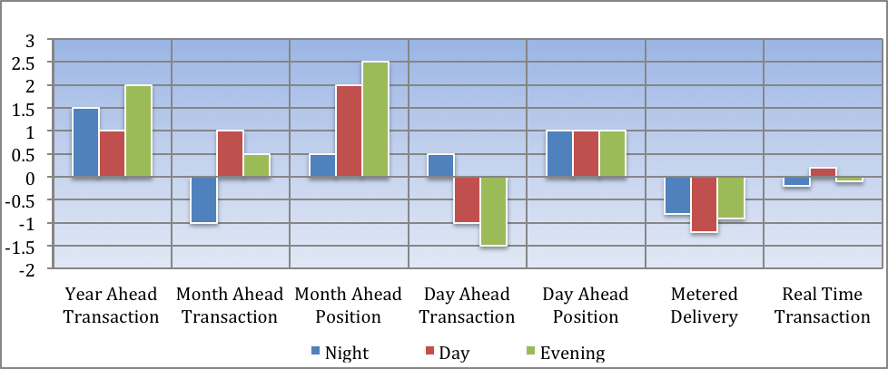
Figure 1: Illustrative Sequence of Forward and Real Time Transactions
The sequence of transactions in Figure 1 illustrates this example. TeMIX profile conformance rules are used. The sequence begins with LSE tenders for night, day, and evening blocks of power for a year at a buy and sell price. The tenders may be made one or more years ahead of delivery and a tender may be withdrawn before acceptance and a new tender made at any time. The customer may use behind the meter generation (such as PV or storage) to offset its usage or to sell the LSE. The tender price is cost- or market-based depending on the LSE’s regulatory status. The customer or an automated device decides the transacted quantity in each block and the customer is obligated to pay the transacted price and quantity.
Monthly and daily, the LSE also may tender similar blocks of power at current buy and sell prices. The customer or the customer’s device may transact to adjust his position as indicated in Figure 1. The customer incurs default 5-minute transactions for any difference between the 5-minute position in each interval and the measured delivery at a real-time price posted before or after the close of the interval.
The LSE may make tenders at any time. For example, ahead of each 5-minute interval the LSE may tender energy in each 5-minute interval for each of the 5-minute intervals in the next two hours. Customers may then forward buy and sell 5-minute energy at forward prices.
TeMIX transactions may be automatic using devices acting on the behalf of the customer and based on customer preferences and not the LSE’s preferences. Tenders made by the LSE will typically reflect the LSE’s marginal short and long-run costs for wholesale energy, ancillary services, transmission congestion, transmission access, T&D losses, distribution congestion and other fixed items. Theoretically, all such costs may vary by interval and be reflected in a varying price in each interval. When because of variable demand, plant outages, transmission outages, variable wind or solar or high levels of electric vehicle charging the tendered prices for each interval location and customer price response can help to bring supply and demand into balance at each location on the grid. For cost-based LSEs, the prices must, on average, recover regulated cost and profits.
TeMIX Tenders can be for small quantities offered to a retail customer at the tendered price. If the customer needs more, then the customer can access additional tenders, perhaps at different prices. The responsiveness of the customer to priced tenders provides information to the LSE on customer price sensitive demand that helps guide the LSE’s bids into system operator markets and transactions in other forward wholesale markets. By working with sequences of small tenders and transactions stability of the grid is also protected from sharp price changes avoiding the use of random or arbitrary restrictions on the customers to smooth responses to price changes or control signals from the LSE.
Real Time Pricing (RTP) can be viewed as an application of TeMIX where the only transaction is for the metered delivery of energy. The forward transactions in the above example are forward hedges to the RTP to manage risk for both the customer and the LSE and to provide forward information for forward wholesale transactions by the LSE. RTP may be optional or mandatory and forward transactions may be optional or mandatory depending on regulations. This approach provides the full incentive for customers and smart devices to save money based on responses to real-time prices while providing for hedging and forward commitment where customers and LSEs must make forward decisions.
- Summary
For LSE’s and retail customers, TeMIX is most useful for smart meter enabled customers that use smart appliances and other such devices. TeMIX provides transacted baselines in each interval so that the response of customers to price is discovered without verification and statistical estimation of baselines. Settlement and billing is simplified. The same system can apply to regulated or competitive LSEs and to all customer classes and distributed energy resources. A major advantage of TeMIX in this application is that customers and their automated devices respond with giving up any control of devices to the LSE and without providing forecasts or demand curves to the LSE’s.
TeMIX also has applications in other grid domains. The dynamic processes of TeMIX can help to enable the coordinated, decentralized operation of variable renewables, distributed generation, customer appliances, industrial processes, electric vehicles, storage, and peak load management with distribution, transmission and centralized generation which is an important goal of the smart grid.
- Acknowledgments
The following individuals have participated in the creation of this specification and are gratefully acknowledged:
Participants:
Edward Cazalet, Individual
- Revision History
Revision | Date | Editor | Changes Made
01 | 2011-09-29 | Ed Cazalet | Initial Document
02 | 2011-09-30 | Toby Considine | Converted to standard format

TeMIX was first described in a Draft White paper approved by the EMIX Technical Committee “Transactive Energy Market Information Exchange [TeMIX] an approved White Paper of the EMIX TC. Ed Cazalet et al. http://www.oasis-open.org/committees/download.php/37954/TeMIX-20100523.pdf.” This paper was written in the early stages of the work on EMIX and has not been updated to utilize the information models developed by the EMIX Technical Committee.

