

Using EMIX 1.0 to support Transactive Energy Markets Version 1.0
Committee Note 01
06 June 2012
Specification URIs
This version:
http://docs.oasis-open.org/emix/emix-trans/v1.0/cn01/emix-trans-v1.0-cn01.pdf (Authoritative)
http://docs.oasis-open.org/emix/emix-trans/v1.0/cn01/emix-trans-v1.0-cn01.html
http://docs.oasis-open.org/emix/emix-trans/v1.0/cn01/emix-trans-v1.0-cn01.doc
Previous version:
N/A
Latest version:
http://docs.oasis-open.org/emix/emix-trans/v1.0/emix-trans-v1.0.pdf (Authoritative)
http://docs.oasis-open.org/emix/emix-trans/v1.0/emix-trans-v1.0.html
http://docs.oasis-open.org/emix/emix-trans/v1.0/emix-trans-v1.0.doc
Technical Committee:
OASIS Energy Market Information Exchange (eMIX) TC
Chairs:
William Cox (wtcox@coxsoftwarearchitects.com), Individual
Edward Cazalet (ed@cazalet.com), Individual
Editor:
Edward Cazalet (ed@cazalet.com), Individual
Related work:
This document is related to:
- Energy Market Information Exchange (EMIX) Version 1.0. Latest version.
http://docs.oasis-open.org/emix/emix/v1.0/emix-v1.0.html
Abstract:
This document describes the use of EMIX 1.0 to support Transactive Energy Markets.
Status:
This document was last revised or approved by the OASIS Energy Market Information Exchange (eMIX) TC on the above date. The level of approval is also listed above. Check the “Latest version” location noted above for possible later revisions of this document.
Technical Committee members should send comments on this document to the Technical Committee’s email list. Others should send comments to the Technical Committee by using the “Send A Comment” button on the Technical Committee’s web page at http://www.oasis-open.org/committees/emix/.
Citation format:
When referencing this document the following citation format should be used:
[emix-trans-v1.0]
Using EMIX 1.0 to support Transactive Energy Markets Version 1.0. 06 June 2012. OASIS Committee Note 01.
http://docs.oasis-open.org/emix/emix-trans/v1.0/cn01/emix-trans-v1.0-cn01.html.

Copyright © OASIS Open 2012. All Rights Reserved.
All capitalized terms in the following text have the meanings assigned to them in the OASIS Intellectual Property Rights Policy (the "OASIS IPR Policy"). The full Policy may be found at the OASIS website.
This document and translations of it may be copied and furnished to others, and derivative works that comment on or otherwise explain it or assist in its implementation may be prepared, copied, published, and distributed, in whole or in part, without restriction of any kind, provided that the above copyright notice and this section are included on all such copies and derivative works. However, this document itself may not be modified in any way, including by removing the copyright notice or references to OASIS, except as needed for the purpose of developing any document or deliverable produced by an OASIS Technical Committee (in which case the rules applicable to copyrights, as set forth in the OASIS IPR Policy, must be followed) or as required to translate it into languages other than English.
The limited permissions granted above are perpetual and will not be revoked by OASIS or its successors or assigns.
This document and the information contained herein is provided on an "AS IS" basis and OASIS DISCLAIMS ALL WARRANTIES, EXPRESS OR IMPLIED, INCLUDING BUT NOT LIMITED TO ANY WARRANTY THAT THE USE OF THE INFORMATION HEREIN WILL NOT INFRINGE ANY OWNERSHIP RIGHTS OR ANY IMPLIED WARRANTIES OF MERCHANTABILITY OR FITNESS FOR A PARTICULAR PURPOSE.

Table of Contents
1 Introduction 4
1.1 References 4
2 What is Transactive Energy? 5
3 Transactive Energy Forward Transactions and Positions 6
4 Transactive Energy Standard Terms and Market Context 7
5 Transactive State 8
6 Transactive Transport 9
7 Transactive Options 10
Appendix A. Acknowledgments 11
Appendix B. Revision History 12

- Introduction
Transactive Energy transactions are for either physically delivered energy or financial hedges, as illustrated the above list. Forward and real time transactions for physical delivery of energy are critical to grid reliability.
  - References
[EMIX]
OASIS Energy Market Information Exchange [EMIX] Version 1.0. Latest version.
http://docs.oasis-open.org/emix/emix/v1.0/emix-v1.0.pdf.
[EPRI]
Concepts to Enable Advancement of Distributed Energy Resources: White Paper on DER. EPRI, Palo Alto, CA : 2010. 1020432.
[EnergyInteroperation]
OASIS Energy Interoperation Version 1.0. Latest version.
http://docs.oasis-open.org/energyinterop/ei/v1.0/energyinterop-v1.0.pdf
[Hammerstrom]
Hammerstrom, DJ, et al, “Standardization of a Hierarchical Transactive Control System”, in the Proceedings of Grid-Interop 2009, November 2009, Denver, CO, pp 35-41. http://www.gridwiseac.org/pdfs/forum_papers09/don-business.pdf
[WS-Calendar]
OASIS WS-Calendar Version 1.0, 30 July 2011. OASIS Committee Specification. http://docs.oasis-open.org/ws-calendar/ws-calendar-spec/v1.0/cs01/ws-calendar-spec-v1.0-cs01.pdf

- What is Transactive Energy?
A Transaction is defined here as an exchange among entities of a product for a price. Transactive Energy is a business process that may result in transactions of energy. Transactive Energy is most useful in decentralized markets, but it has applications in centralized markets. Generator and load response characteristics are not information elements of Transactive Energy; rather, the current responsiveness of supply and usage to price is discovered through frequent priced tenders and transactions.
OASIS EMIX provides an information model for price and product communication for energy transactions. OASIS Energy Interop provides a set of transactive services to communicate EMIX price and product information for energy transactions among entities.
A few examples of Transactive Energy transactions are:
- purchase of delivered electric energy by a retail customer at posted forward dynamic prices tendered by a regulated or competitive retailer (load serving entity)
- forward and real time physical delivery of electric energy by a generator to a retailer at negotiated prices and quantities
- energy futures contracts traded on a bid/ask exchange that are cash-settled against spot prices
- forward and real time sale of energy by a micro grid to another micro grid at negotiated prices and quantities
Transactive Energy transactions are for either physically delivered energy or financial hedges, as illustrated the above list. Forward and real time transactions for physical delivery of energy are critical to grid reliability.
Transactive Control is a term defined by others that applies to dispatch-like transactions based on explicit customer or generator response characteristics such as bid curves and ramp rates. Event-based demand response and system operator dispatch markets are examples of Transactive Control even though a transaction with a price and quantity may result. The REC / VEN flow of control approach is also an expression of Transactive Control. This note is focused on Transactive Energy; Transactive Control is not otherwise addressed in this note. Transactive Energy and Transactive Control can coexist in markets; EMIX and Energy Interop provide information models and services for both.
TeMIX (Transactive Energy Information Exchange) is a profile of Transactive Energy supporting automated transactions. EMIX Note XX focuses on TeMIX.
- Transactive Energy Forward Transactions and Positions
Transactive Energy uses forward energy transactions to accumulate forward positions. If the transactions and positions are financial then the final position must be financially balanced to zero. If the forward transactions are for delivery, differences between the forward positions and metered delivery are settled by real-time transactions. Figure 1 illustrates such a sequence of forward transactions and positions for delivery. In some markets, the forward transactions may be with several different counterparties.
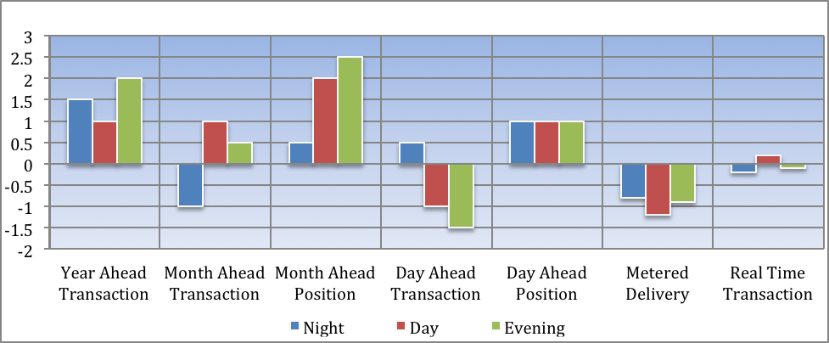
Figure 1: Illustrative Sequence of Forward and Real Time Transactions
- Transactive Energy Standard Terms and Market Context
The EMIX information model for Transactive Energy products and prices describes (1) quantities of energy in each of one or more designated intervals of time transacted at a defined location on the grid and (2) the price of the energy transaction.
Standard Terms in EMIX are typically used to describe the duration of the interval, currency, and other information. These Standard Terms are referred to as the Market Context for a Transaction. Information elements that vary by transaction such as quantity, price, start time and location are described in the payload for a transactive service.
- Transactive State
EMIX uses Transactive State to qualify the information model for Transactive Energy products and prices as illustrated in Figure 2 below.

Figure 2 : Transactive States
Five transactive states are used by Transactive Energy. The information model for a Transaction is an EMIX price and product description. A Tender is a bid or offer for a Transaction with an expiration time. An Indication of Interest is non-binding and may be (1) a request for a Tender, (2) a forecast of usage by a buyer, or (3) a forecast of price by a seller. Delivery is the metered quantity delivered. Publication artifacts include prices, quantities, costs, or revenues, but a Publication is not a Tender. Some Transactive states may not be used in given interactions and markets.
- Transactive Transport
EMIX Transactions for Transport (transmission and distribution) have the same basic information model and transactive services as EMIX transactions for energy. All EMIX energy transactions have a location specified by an EMIX interface. For Transport, the EMIX Interface specifies a pair of locations. EMIX makes no assumptions on how transport transactions prices are determined.
- Transactive Options
EMIX provides an information model for Options on Transactive Energy and Transport products. An Option provides its holder a right to either purchase or sell energy or transport at a strike price. Options can be used to limit the price of energy or transport for risk management, to transact ancillary services, or to facilitate the commitment of distributed generators.
- Acknowledgments
The following individuals have participated in the creation of this specification and are gratefully acknowledged:
Participants:
Edward Cazalet, Individual
Toby Considine, University of North Carolina
William Cox, Individual
David Holmberg, National Institute of Standards and Technology

- Revision History
Revision | Date | Editor | Changes Made
01 | 2001-09-30 | Ed Cazalet | Initial Document plus editorial fixes related to the template

Hammerstrom, DJ, et al, “Standardization of a Hierarchical Transactive Control System”, in the Proceedings of Grid-Interop 2009, November 2009, Denver, CO, pp 35 -41. http://www.gridwiseac.org/pdfs/forum_papers09/don-business.pdf
Concepts to Enable Advancement of Distributed Energy Resources: White Paper on DER. EPRI, Palo Alto, CA : 2010. 1020432.
EMIX also defines Exercise and Transport Commitment as Transactive States which are actions rather than states and should likely be deleted in future versions of EMIX.

